

**TESIS DOCTORAL**

**THE EFFECTS OF A WEB-BASED DIDACTIC DESIGN ON TEACHERS’ DIGITAL COMPETENCE AND THE USE OF TECHNOLOGICAL TOOLS IN THE ENGLISH CLASSROOM**

**PRESENTADA POR:**

**GONZALO CAMACHO VÁSQUEZ**

**DIRIGIDA POR:**

**ELENA MARÍA DÍAZ PAREJA**

**JUANA MARÍA ORTEGA TUDELA**

**JAÉN, FECHA**

**ISBN**

**Content**

Introduction 11

Chapter 1. Theoretical Framework 48

1.1 Theoretical Constructs 48

1.2 Educational Models, Pedagogical Models, and Didactic Designs 48

1.3 Web-based Didactic Design 51

1.3.1 Web-based Language Learning (WBLL). 51

1.3.2 Didactics. 53

1.3.3 Design. 54

1.3.3.1 Digital Didactic Design (DDD). 57

1.3.3.2 Instructional Design. 58

1.4 ICT and ELT 61

1.5 Teachers’ Digital Competence 65

1.6 State of Knowledge 72

1.7 Pedagogical Models 72

1.8 Didactic Designs 87

1.9 Teachers’ Digital Competence in Colombia 90

Chapter 2. Research methodology 94

2.1 Research objectives 94

2.2 Target population 95

2.3 Research method 96

2.3.1 Quantitative. 96

2.3.2 Qualitative. 97

2.4 Research design 97

2.5 Data collection instruments 98

2.5.1 Exploratory questionnaire. 98

2.5.2 Teachers’ digital competence test. 99

2.5.3 Use of digital technologies questionnaire. 99

2.5.4 WBLDD assessment. 99

2.5.5 Self- assessment form. 99

2.5.6 LMS assessment survey. 100

2.5.7 Videos of implementation. 100

2.6 Data Analysis Procedures 103

Chapter 3. A web-based learning didactic design 106

3.1 Definition of the Web-Based Learning Didactic Design 107

3.2 Learning Aims of the Design 110

3.3 Learning sequence 110

3.3.1 Launch (online). 110

3.4 Inquire (online) 112

3.5 Search (offline) 113

3.6 Share 1 (online) 114

3.7 Plan (online) 115

3.8 Apply (offline) 115

3.9 Share 2 (online) 115

3.10 Reflect (offline-online) 116

3.11 Reflect (offline-online) 116

3.11.1 Constructivism. 116

3.12 Web-based Learning 117

3.13 Inquiry-based learning 119

3.14 Problem-based learning 121

3.15 Collaborative learning 125

3.16 Task-based learning 128

3.17 Cultural and Intercultural Communicative Competence 131

3.18 Community-Based Pedagogies (CBP) 132

3.19 Learning Management System 135

3.20 Assessment activities 144

3.20.1 Assessment strategies for the WBLDD. 144

3.20.2 Assessment of learning management system. 145

References 146

Appendixes 166

**List of tables**

**Table 1.** DigCompEdu assessed areas and competencies 17

**Table 2**. Results of competence 1 23

**Table 3**. Results of competence 2 24

**Table 4**. Results of competence 3 25

**Table 5.** Results of competence 4 26

**Table 6.** Results of competence 5 27

**Table 7**. Results of competence 6 27

**Table 8**. Results of competence 7 28

**Table 9**. Results of competence 8 29

**Table 10.** Results of competence 9 30

**Table 11**. Results of competence 10 31

**Table 12**. Results of competence 11 32

**Table 13.** Results of competence 12 33

**Table 14.**Results of competence 13 34

**Table 15**. Results of Descriptive Statistics per Area 35

**Table 16.** Comparisons among the areas of competence. 36

**Table 17.** Multiple Comparisons among the areas 37

**Table 18.** Analysis of areas per genre 39

**Table 19**. Analysis of areas per years of experience 43

**Table 20**. Benefits and challenges of online instruction. 52

**Table 21.** The ADDIE Model stages and tasks 59

**Table 22.** Digcompedu Areas 67

**Table 23.** Data Collection Instruments per Stage 100

**Table 24**. Organization of modules for Course on Digital Competence for ELT 109

**Table 25.** Learning trajectory of Module 2 139

**List of figures**

**Figure 1**. From Educational Models to Didactic Designs 50

**Figure 2.** Three Layers of Digital Didactics 57

**Figure 3**. Teachers’ Digital Competence Framework 65

**Figure 4.** Synthesis of Digcompedu Framework 66

**Figure 5.** DigCompEdu Progression Model 72

**Figure 6.** The TPACK Model 73

**Figure 7.** SAMR Model 74

**Figure 8**. The IDDIRR Design Model 76

**Figure 9.** The TPCD Model 77

**Figure 10.** SMCKI Model 78

**Figure 11.** The SECI Model 80

**Figure 12**. Configuration of PLEs using Symbaloo 81

**Figure 13.** SOSE Model 83

**Figure 14.** The Internet Ecological Teaching Model 84

**Figure 15.** Method of Active Teacher Training Model 85

**Figure 16.** Holistic Model for the Digital World 86

**Figure 17.** Mixed Method Intervention Design 98

**Figure 18**. Grounded Theory Analysis Process 104

**Figure 19.** Web-based Learning Didactic Design 107

**Figure 20**. English Teaching Digital Wheel 109

**Figure 21.** The Problem for the Logic of Sense 120

**Figure 22**. Problem-based Language Learning Model 125

**Figure 23.** Diplomado Course Moodle Tu Aula Media main site 137

**Figure 24.** Organization of a module in Diplomado Course Moodle Tu Aula Media 138

**Figure 25.** QR to Digital Resources for ELT 144

**Figure 26.** Nguyen’s dimensions 145

**List of Appendixes**

**Appendix A.** Cabero-Almenara and Palacios-Rodríguez Questionnaire (2020) 166

**Appendix B.** Use of digital technologies for ELT. Alakrash y Razak (2021) 185

**Appendix C**. WBLDD Assessment for students and facilitators 189

**Appendix D.** Self-Assessment form 194

**Appendix E.** Learning Management System Assessment 197

**Appendix F.** Intellectual Property Registration 202

**Appendix G.** Microcurriculo Diplomado Course. Universidad del Tolima 204

**Appendix H**. Sample Unit Plan 226

**Appendix I.** Rubric to assess oral presentations 232

**Appendix J.** Guide For Planning 234

**Appendix K**. Rubric to Assess Final Videos 235

# Introduction

The Covid-19 Pandemic has historically marked the relationship between humans and technology. What was for some fields of knowledge and disciplines, an option to complement face-to-face work became a must and the only alternative to keep the dynamic of societies. In education, more than on other grounds, the distrust people had of technology as a possibility to mediate human relations could have even been reduced or augmented with the experience of emergency remote teaching and learning (ERT).

In this regard, Ferri et al. (2020) found three types of ERT challenges. The technological challenges include poor internet connection and a need for appropriate equipment for effective instruction. The social challenges are related to the short interaction between teachers and students and the need for proper physical spaces at home. The pedagogical challenges are

* Teachers’ and learners’ low digital competence,
* The difficulty in structuring content from the abundance of online resources,
* Learners’ lack of motivation and interactivity, and
* The lack of a teacher’s presence to assist students’ learning.

In English Language Teaching (ELT), there are more benefits than constraints when adopting a remote learning or e-learning model. Mason & Yunus (2021) found that e-learning makes learning more enjoyable, motivates students, provides interactive and collaborative learning opportunities, allows immediate feedback in context, and promotes learning among anxious students. However, the best benefit is developing cultural and intercultural competence.

Language and culture seem to be inseparable aspects when having the purpose of training efficient speakers. Understanding language has to do with understanding the cultural issues of that language. Byram (1997, cited by Uzum et al., 2020) established the Framework for Intercultural Communicative Competence (ICC), which comprises learners’ capacities to understand attitudes, develop critical awareness, and interpret and relate issues of the target language. In a foreign language learning context, the application of technology has to do with approaching students to the target culture using video conferences from technology, entertainment, and design (TED) or podcasts from British Broadcasting Corporation (BBC) Radio for developing speaking skills; exposing students to political, historical, and social issues by understanding, for instance, an episode or chunks of episodes of foreign sitcoms while fostering listening skills. Nevertheless, the use of technology not only enables the development of cultural and intercultural competence but also allows for the reduction of students’ affective filter and provides effective feedback in context (Mason & Yunus, 2021)

Tipping the scale toward benefits instead of challenges seems like training teachers to increase their digital competence and finding new didactic strategies that take advantage of web resources to improve students’ language skills. In this regard, Akbana (2021) points out that the effectiveness of ERT in other languages is achieved when teachers are provided with professional development that makes them use digital literacy skills and adapt their pedagogical skills to remote teaching conditions.

In this line, most attempts to design teachers’ professional development programs for integrating technology into education are based on the Technological, Pedagogical, and Content Knowledge (TPACK) Model proposed by Mishra and Koehler (2006). These authors explain this Technological Pedagogical Content Knowledge using a Venn Diagram of three circles. The first circle represents Technological knowledge, which is “how to use technology,” and the second is Content Knowledge, which is “knowing the subject.” The third circle is Pedagogical knowledge related to “How to teach.” The three circles' interception answers, “How to teach the subject using technology in a specific educational context?”

According to Hepp et al. (2015), integrating Information and Communication Technologies (ICT) into education brings barriers and challenges that must be tackled. Firstly, institutions are required to introduce changes in their curricular structures, update technological infrastructure and digital culture and practices; secondly, it is necessary to provoke a change in teachers’ attitudes towards the use of technology in their practice, and thirdly, attend to the specificities of each subject area or discipline; in other words, the link between ICT and education demands a series of actions that goes beyond the limits of the pure technological training of teachers. A teacher may be skillful in using technological gadgets, web applications, and Learning Management systems (LMS) like Modular Object-Oriented Dynamic Learning Environments (MOODLE). However, they may fail when finding and applying the proper didactic strategies to make learning happen.

This problem may be solved by designing pedagogical proposals that train teachers not only in the three TPACK components but also in those issues of the subject area they are concerned. ELT is one of those disciplines that demand specific training; for example, on understanding how language skills are acquired in terms of sub-skills and strategies, which are the cultural issues a student needs to know to avoid cultural shocks, and knowing the technological resources that lead to the achievement of these specific objectives in language and culture formation.

 As a result, the systematic review of the bibliography and the input obtained from the analysis of the exploration questionnaire leads this research study to formulate the following questions: Are there any effects on Teachers’ Digital Competence (TDC) and the use of ICT when a Web-Based Learning Didactic Design to train English teachers in the use of technology for ELT is implemented? If so, what are those effects?

The corresponding object of study is “Teachers’ Professional Development on Information and Communication Technologies and ELT Didactics.” The field of action has to do with “the incorporation of ICT to ELT in the English Language preservice and in-service teachers in Colombia''; and the hypotheses foresee that **“**the implementation of a Web-based Didactic Design increases the Digital Competence and the incorporation of ICT to ELT Didactics in English teachers that are part of the implementation of the study.”

Concerning the variables, the independent variable is identified as “the implementation of a Web-based Didactic Design,” and the dependent variable is “teachers’ Digital Competence and incorporation of ICT to ELT.”

The study aims to determine the effects of implementing a Web-Based Learning Didactic Design (WBLDD) to train ELT in the use of technology. It also expects to assess the influence of implementing the WBLDD in teachers’ TDC, register the incorporation of ICT in ELT didactics during and after the implementation of the model, and compare the results on TDC and ICT use in ELT among the population groups.

The specific tasks to achieve the research objectives are theoretical analysis of antecedents, literature review and field of action, exploration of teachers’ needs about Digital Competence level and use of technology for ELT, the definition of research stages based on Analysis, Design, Development, Implementation and Evaluation (ADDIE) Methodology, design of the Web-Based Didactic Design, design of the implementation course based on the results of teachers’ needs exploration, design of the Learning Management System (LMS) platform to deliver the WBLDD, piloting of LMS platform and adjustments, implementation of WBLDD to the target groups, administration of quantitative and qualitative data collection instruments to target groups, and analysis of results according to proposed research objectives.

The research development follows the procedures of the ADDIE Model. The formulation of the problem and the design of the Didactic Design is based on the theoretical analysis of the literature review and the analysis of the exploratory questionnaire.

In the analysis stage, the study is based on the review of the literature and the analysis of data obtained from the administration of an exploratory questionnaire that intends to determine prior conditions of English teachers in the two variables of the study: Teachers’ Digital Competence and Teachers’ use of digital tools for English Teaching. In the Design moment, the results from the previous step shed light on the formulation of a Web-based Learning methodology and the projection of an e-learning course where this methodology is applied through an LMS. The Development stage makes the designs of the method, the e-learning course, and the LMS environment come true. The implementation stage comprises the delivery of the course, and the Evaluation stage assesses the whole process.

The design of the LMS platforms attends to the field needs to be detected through the administration of an initial exploration of needs based on determining teachers’ Digital Competence level, use of blogs, and other technological tools for developing communicative language skills and subskills. The research methodology follows a mixed-method approach that uses quantitative and qualitative data collection techniques.

The Prisma Protocol and Biblioshiny by Bibliometrics Software were used to construct the theoretical framework and antecedents. For the initial exploration of needs, an exploratory survey was used. The collected data were analyzed through Statistical Package for the Social Sciences software (SPSS). Mixed-data surveys were applied before and after implementing the pedagogical model to determine the effects on teachers’ digital competence. The artifacts that were the product of the proposal's implementation were analyzed through a checklist and rubric validated

The thesis work is organized into four chapters. The first chapter is devoted to the theoretical framework, subdivided into a section that defines the primary theoretical constructs of the research problem and a section that reviews the state of the art. The first section presents the definitions of Educational, pedagogical, and didactic models and designs, the Web-based Didactic design and its components, the instructional design, the relationship between ICT and ELT, and TDC from its conceptual framework to the description of the DigcompEdu Framework. The second section reviews the most relevant and recent research productions on formulating pedagogical models and didactic designs, from proposals that intend to incorporate digital tools into education to those applied to affect ELT and TDC. This section also examines recent studies that assess TDC using the DigcCompEdu framework. The exploration goes from worldwide micro studies to outstanding investigations undertaken in Spain, Turkey, Sri Lanka, and Portugal. Finally, the most important productions in Latin America and Colombia are analyzed regarding research aims, methodology, populations, and results.

All these publications are organized from tertiary education to secondary and primary education.

The second chapter describes the research methodology by defining the research objectives, the target population, the research methodology and design, the data collection instruments, and the data analysis procedures. The third chapter presents the definition of the WBLDD, the Diploma Course that serves as implementation, the aims of the design, the learning sequence, and founding theories. It also gives details of the LMS, Moodle TU Aula Media, which is the implementation platform for the Diploma Course. Besides, this chapter includes the assessment activities for the WBLD and the LMS. Finally, the third chapter presents the analysis of results, starting with the exploration questionnaire to continue with the pre-test and post-test results for two cohorts of the diploma course related to the TDC and the use of digital tools for ELT. This chapter also shows the results of the WBLDD and the LMS assessment.

# Chapter 1. Theoretical Framework

This chapter comprises two sections. The first part is devoted to analyzing the primary theoretical constructs that are part of the research problem, and the second section describes the state of knowledge regarding the proposal on pedagogical models and didactic designs that integrate the use of Information and Communication Technologies (ICTs) for English Language Teaching (ELT).

## 1.1 Theoretical Constructs

This section locates and defines the primary theoretical constructs of the research problem. First, the Didactic Design (DD) concept is described based on its relation to Educational and Pedagogical Models. Second, Web-Based Learning Didactic Design (WBLDD) is explored by outlining each component: Web-based Language Learning (WBLL), Didactics, and Design. Inside the notion of design, it is defined what Digital Didactic Design (DDD) and Instructional Design (ID) mean. Third, the relationship between ICT and ELT is described. Finally, the term Teachers’ Digital Competence (TDC) is located in its theoretical framework to limit its scope in this research project.

## 1.1.1 Educational Models, Pedagogical Models, and Didactic Designs

There is no clear definition of a Pedagogical Model (PM). Several authors attempt to define it by elucidating other concepts like a didactic model, didactic design, educational model, or learning design.

Ocaña (2013) relates the idea of PM to the Didactic Model, a symbolic and conceptual representation that functions like a mediated scheme between the educative reality and the thought. It comprises a group of strategies and norms proposed by pedagogues to organize and lead the educational process. This model determines what, why, what for, where, when, for whom, and with whom the learning and teaching process will be done. Another term this author relates to PM is Didactic Design, composed of projects in a learning environment where individuals elaborate objectively and subjectively on different learning tasks. Finally, he contrasts an Educational and a Pedagogical model. The first one involves more aspects of the educational field since it comprises educational policies, philosophy of education, and theoretical conceptions of education.

In contrast, the second is a theoretical construct with scientific and ideological foundations to interpret, design, and adjust the pedagogical reality to concrete historical needs. It implies the content, student development, and qualities of teaching practice. In this sense, a PM needs to specify: the essential questions about human beings that every theory needs to answer, define the concept of human being that intends to educate, describe the learning sequence and the dynamic of learning, describe the type of learning experiences and curricular contents, the interactions between teacher and learners, the teaching and assessment methods and techniques. Chou (2010) also considers that PMs are required to define instructional and learning strategies, precisely how the theory links with the practice. These learning strategies involve the didactic method, which is how the model is implemented in the face-to-face or online classroom. Besides, this author conceives PM as “cognitive models or theoretical constructs derived from learning theory that enable the implementation of specific instructional and learning strategies” (p. 453)

De Zubiria (2014) understands PM as “unhidden prints or a pedagogical definition” (p.25) and seems to agree with Ocaña (2013) about the above-mentioned essential questions. It means that every PM assigns different functions to education depending on conceptions of human beings and society in a specific context. Behar (2011) intends to clarify his definition when she says that a PM is a set of theories or dominant explication systems in any area for some time. In other words, she associates the term PM with “paradigm.” This idea of paradigm denotes the changing perspective about education depending on the historical period where it appears. Every model is founded after a theory or after a paradigm. For instance, the Piagetian Theory is named after the interactionist paradigm.

Concerning E-Learning, Behar (2011) says that a PM is a system of theoretical premises that represent, explain, and guide the way the curriculum is approached and that is consolidated in the pedagogical practices and the interactions between professor-student-objects of study/knowledge. As a result, a PM for E-learning comprises a Pedagogical Architecture (PA) and a strategy of application of the PA.

**Figure 1***.*

*From Educational Models to Didactic Designs*

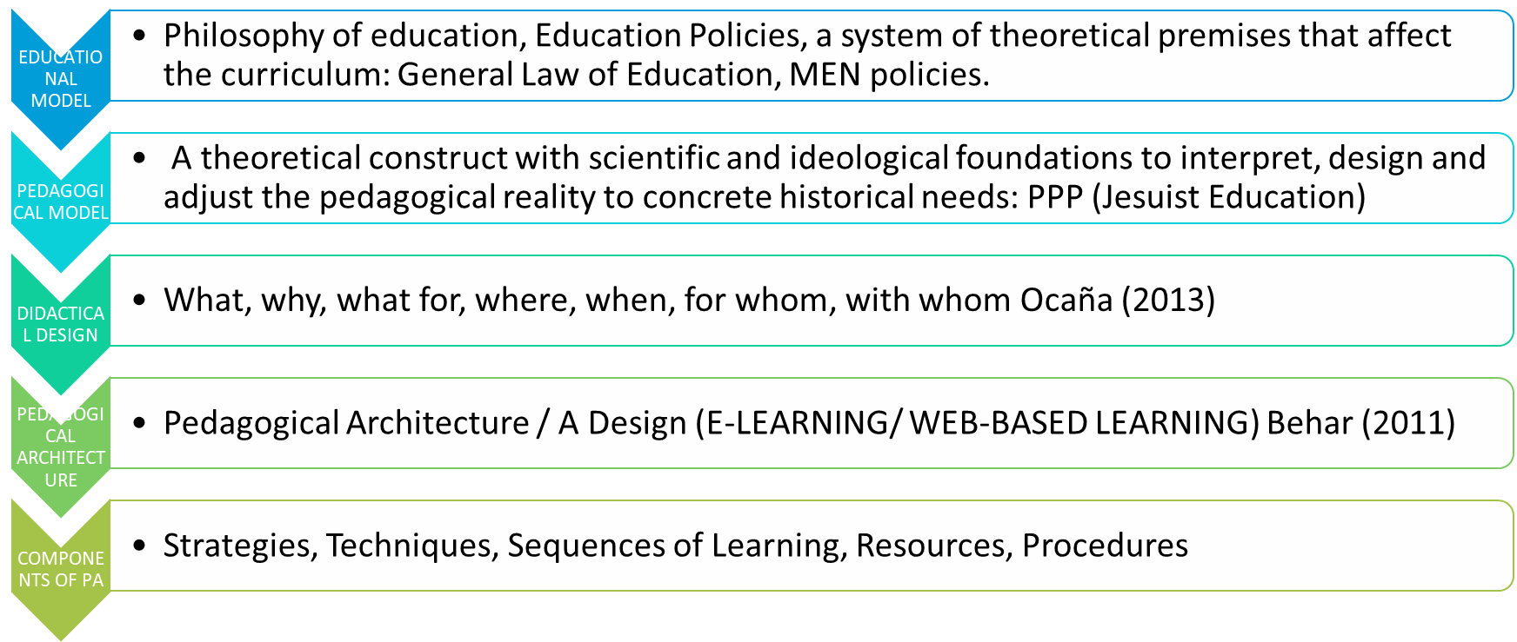

Source: Own elaboration

In conclusion and considering the former conceptual frame, “Web-based didactic design” is the most appropriate term to refer to the intention of this study. “Web-based” because the proposal is made of online and offline moments and intends to use web resources for English Teaching. “Didactic” because although the steps in the learning trajectory are founded on previously installed theories, they are concrete links to the practice through a pedagogical architecture that defines strategies, techniques, learning sequences, resources, and procedures. “Design” because the term implies a more active sense than the one of “model.” A deeper analysis of these concepts is included in the following section.

## 1.1.2 Web-based Didactic Design

### 1.1.2.1 Web-based Language Learning (WBLL).

Different terminologies exist to refer to the use of ICT for education. E-learning, Internet-based, and Web-based are used indistinctively. Elmabaredy et al. (2020) say that WBL is often called online learning or e-learning because it uses web resources, such as email, videoconferencing, live lectures or video streaming, and websites for course materials and information in general.

WBLL has gained popularity in the language education community since it has extended the practice beyond the language classroom. For Cong-Le

m (2018), WBLL brings many benefits to EFL:

* Students can practice without limits of time or space.
* It fosters collaborative learning with peers employing project work.
* It assists the language acquisition process through opportunities for scaffolding and ZPD enabling.

This author classifies WBLL into five groups: general websites providing linguistic input, blogging platforms, communication tools, project-based learning tools, and Learning Management systems (LMS). Davidson-Shivers et al. (2018) exhaustively analyze what WBL or Web-Based Instruction (WBI) means, its relation with Distance Education, the advantages and disadvantages, and the classification of online tools for learning. *Distance Education* is “... any type of education wherein students are enrolled at a distance from the faulty” (p. 6). WBL, WBI, e-learning, and online learning are related terms in Distance Education. E-learning refers to using any electronic device and processes for instruction, while WBI is the type of instruction via the Internet, Intranet, and Web. Some of the benefits and disadvantages of WBL and Online Learning instruction for institutions, instructors, and the learner are described in Table 20

**Table 20***.*

*Benefits and challenges of online instruction.*

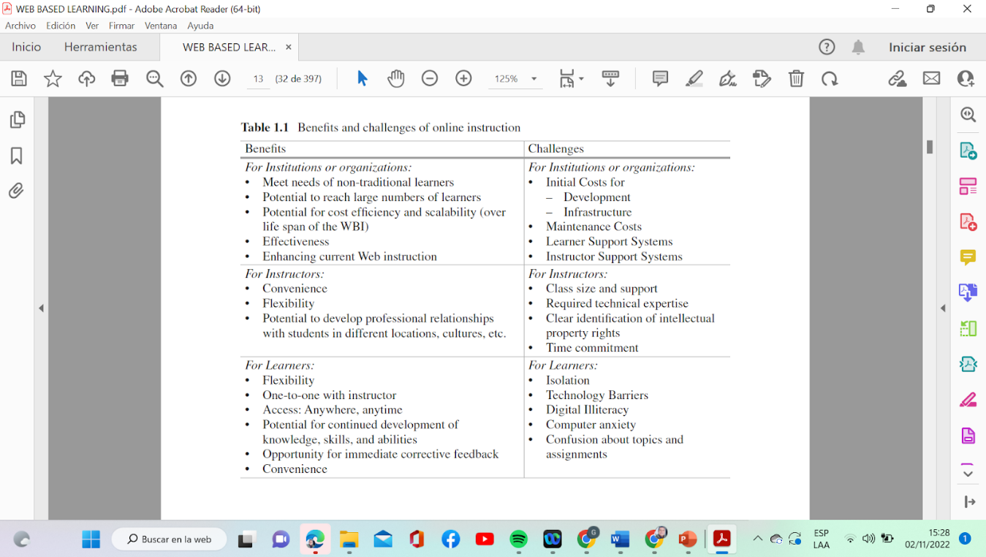

Source: Davidson-Shivers et al., 2018

There are paradoxes between the benefits and challenges. While, for institutions, online instruction meets learners’ differences, investing in learners' and instructors’ support systems is required. Although, for instructors, online instruction is flexible and convenient in terms of time and location, teachers need to dedicate more time to designing and adjusting resources and assisting larger groups of students. Whereas, for students, online learning is flexible, convenient, and more personalized than face-to-face instruction, it may provoke anxiety and isolation. Among all, we should also consider that online learning helps the environment (Yin et al., 2022, found that China’s online education during the pandemic reduced the scale of carbon emissions) and indeed contributes to developing autonomy in higher education (Ludwig & Tassinari, 2021; Pham, 2022; Edwards et al., 2019) since students need to make own decision, find answers to questions and doubts on their own.

### 1.1.2.2 Didactics

“Didactics” comes from the Greek “didáskein,” which means “teaching” according to Arnold (2012); for German-speaking countries, Scandinavian countries, Finland, and Russia, the term “Didactics” has to do with a significant theory in teacher education and syllabus development. For Spain, it is “General Didactics” and has to do with the overarching theory of decision-making about teaching and learning processes in societal institutions. “subject-matter-didactics” also refers to theories of teaching and learning a particular school subject. “General Didactics” and “subject-matter-didactics” are complementary. In France, the terms “didactique compare” and “algemene didactick” exist for Dutch. The term is also used from the perspective of “methodology” as decision-making in educational planning and is regarded as a prescriptive theory (Arnold, 2012).

Harjanne & Tella (2007) analyzed what Foreign Language Didactics is and its relation with Foreign Language Teaching. The first warning these authors announce is the dilemma explained previously, related to the various interpretations and terminology used in various language regions. These different definitions have in common that they consider “teaching” as the object of study; however, for the German tradition, “didactics” is related to theory, while in the Anglo-American tradition, the term has its origins in educational psychology. In short, the authors assumed Language Didactics as a “subject-didactic area of educational sciences, in which research is conducted on the teaching– studying–learning process of foreign languages and in which studying a foreign language is equal—not superior or inferior—to teaching and learning this language” (p. 8). In that way, didactics is more concerned with how the teachers get the learner to learn than with how the learner learns. The concept implies considering the complex reality of a foreign language with emphasis on planning, implementing, and evaluating the process, which comprises mainly purposiveness, context, interaction, content, and method. The most influential trends in ELT didactics throughout the history of language learning are discussed in the next section of this chapter.

As a result, didactics deals specifically with the way classroom practices are defined, planned, delivered, and evaluated according to the needs of a learning community, what determines the contents, the objectives, the learning and teaching sequence, the methods and approaches appropriated to reach the objectives, and the resources and materials that enable all the process.

### 1.2.1.3 Design

Innovation in education is related to the field of didactic design. When one thinks of design, immediately, the idea is associated with creativity. At the same time, the term does not originally belong to the educational field but to the industrial ground; it is more frequent nowadays in pedagogy to refer to didactic design or instructional design. The latter term may have emerged from the internet revolution, where designing a lesson, for example, implies using creativity to combine digital resources and web-based tools that enhance the achievement of specific objectives in that lesson. A research branch integrates arts and science into a Research Through Design (RTD) proposal. In this revolutionary proposal, designers create new products by experimenting with new materials and processes (Godin & Zahedi, 2014). This idea connects with Dohn, and Hansen (2014), who conceived the design as giving form to something, and in education, is to shape a focus and critical points for teaching and learning as a process to reach specific learning outcomes

However, significant controversy has been held about the nature of design and design research: Is it more related to arts or science? (Borgdorff, 2006; krippendorff, 2007). Bergström (2012) says that the concept of design is strongly influenced by the work of Simon (1996), who considers the term as a science seen from an engineering context through the idea of artifacts,

Whereas science is concerned with conceptions that worked so far, design is concerned with what could work in the future, a future that is more interesting than what we know today. A design is always a proposal, a conjecture. Whether it delivers what it promises and whether it will work in the foreseeable future cannot be known until it ceases to be a design and becomes part of its users’ history (Krippendorff, 2007, p. 11)

In this way, the idea of design in a research study has to do with proposing something new that may introduce some change to what already exists; and in education, it means changing didactics. As a result, didactics and design could be a formula that introduces true innovation in the language classroom. These innovations may be possible when conceiving a new manner of disposing of contents, teaching and learning sequences, or assessment procedures. The concept becomes more creative when technology is added since technology has a lot to do with inventing new apps, new video games, and new ways of communication that somehow impact the dynamics of education and language learning. The classical blackboard in the physical classroom has been replaced by interactive online platforms, like Google Jam boards, where students and teachers experience active cooperative learning.

The relationship of design with education is evident in two proposals to integrate them: the Logic of Sense and Design Thinking in Education (DTE).

Deleuze (2005) conceived the application of the Logic of Sense as a way to introduce newness by formulating problem questions. The Series of ideas is made for concepts in the discourses, habits of mind, beliefs, and statements that are taken as truths in the manner of “everybody knows” or “nobody can deny” (Deleuze, 2001, p. 130). Common-sense thinking belongs to this Series, where there is no mediation of thinking. The Series of Events or Happenings results from thinking differently or the unthinkable. A happening is not a routine or something that commonly happens; a happening is an accident, a turning point in ordinary life that makes us see from a different perspective. Going from the Series of ideas to the Series of happening is possible through the Series of Questions. The questions are the ones that doubt, hesitate, and suspect those established truths or presuppositions in the Series of ideas to envision a proposal, an innovation, or a new insight. Camacho (2017) exposes the didactic application of the Logic of Sense to boost the formulation of problem questions with undergraduate and graduate students.

Design Thinking in Education (DTE) is similar to the Logic of Sense. Both pursue fostering innovation by formulating questions, while the former looks for solutions to wicked problems (Rauth et al., 2010); for the latter, questions are not related to a solution. It means that questions are not answered to solve a problem but to generate more questions that keep it alive. Panke (2019) examined the implications of a Stanford Design Thinking Model at a Midwestern US University. He found that the exposure to the model enabled them to solve problems from their context and get benefits in valuing empathy, being open to uncertainty, and assuming teaching as design. Elsbach and Stigliani (2018) identify three categories in implementing DTE models. In need-finding, students map the community through ethnographic observations and interviews with agents. In Idea-generation tools, the mapping data is transformed into brainstorming ideas and creating or coding the product or intervention. In Ideas-testing -tools, experimentation is carried out by creating prototypes or testing some parts of the solution with internal testers. DTE has similarities with Community-Based Pedagogies in these procedures, which is amply described in the Web-Based Learning Didactic Design chapter.

**1.2.1.4 Digital Didactic Design (DDD).** Jahnke et al. (2014) say that digital didactic design situates teaching and learning in a new perspective, where teaching more than a cognitive activity becomes an activity for learning construction. An innovation introduced by technology in the classroom implies changes in three levels of didactics: the relation among students and teachers with content, the digital didactic design (how curriculum components are organized), and the curriculum development and academic staff development.

**Figure 2.**

*Three Layers of Digital Didactics*

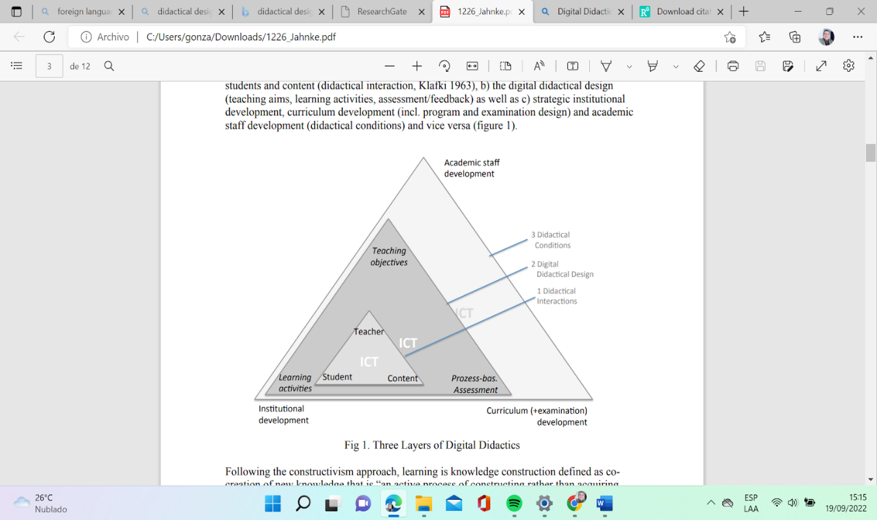

Source: Jahnke et al., 2014

In short, Jahnke et al. (2014) agree with Ocaña (2013) when determining that didactics comprise five elements that answer each to:

* What to learn: Curriculum and content (teaching and learning goals)
* When and what kind of situations and locations: Learning activities and cultural background.
* How to evaluate learning outcomes: assessment activities
* How learning is achieved: resources (web-enabled technologies), institutional strategies, academic staff development
* How the interactions are: Social relations and multiple social roles.

Jahnke et al. (2014) provide the digital didactic design coding scheme for studying designs-in-practice. In this study, the researchers focused on the use of media tablets and on observing face-to-face classrooms; however, the instrument can be adapted to any other technological gadgets or web-enabled resource and blended or virtual learning modalities. The scheme presents five DDD elements, assessed through descriptors with a weight of 1 to 5.

**1.2.2.5 Instructional Design.** Covadonga et al. (2020) conceive Instructional Design (ID) as a process that "consists of determining the needs of learners, defining the end goals and objectives of instruction, designing and planning assessment tasks, and designing teaching and learning activities to ensure the quality of instruction" (p. 37) The same as the TPACK Model has been a reference for teachers' training on the use of technology, the ADDIE Model is taken as the base for ID. In their systematic review, Stefaniak and Xu (2020) suggest that ID models, like ADDIE, should be only points of reference in developing learning plans and emphasize the systematic implications of ID practices and decisions. The Analysis phase of this model needs to focus on learning gaps that result from the needs assessment and contextual factors that affect learners' performance. The steps of the ADDIE model should not be applied automatically but adapted to real-world settings. Constancio et al. (2018) present an example of this adaptation and propose an extended X-ADDIE where a pilot experiment step is included for improving distance learning courses in a national school of public administration in Portugal.

The ADDIE Model (See Table 2) is applied in the current research study to accomplish the established objectives. The design of the implementation course is planned based on the exploration of needs that result from the administration of 300 samples of a survey that intended to know the level of TDC, the use of blogs, and other digital resources for ELT. Table 21 summarizes how the five stages of the ADDIE Model are applied in the current research study through concrete tasks.

**Table 21.**

*The ADDIE Model stages and tasks*

| **Stage** | **Definition** | **Tasks in the current study** |
| --- | --- | --- |
| Analysis | During this stage the problem is formulated. It may include a needs analysis, job analysis, or task analysis. This is the output for the design phase. | Design and peer validation of a questionnaire to explore the TDC and use of Digital tools for ELT.  Piloting of the instruments  Administration of the instrument and data analysis |
| Design | The output from the design phase is used to plan the instruction. There must be an outline for reaching the instructional goals, a delivery system must be chosen, and the sequence of instruction established. | LMS plan design.  Evaluation of LMS design by peer experts.  Adjustment to the platform.  Design of the implementation course and peer evaluation. |
| Development | It is built on the analysis and Design phases. In this stage lesson plans and resources are generated. The media to be used in the instruction is developed (hardware and software) | Platform assembly: materials and resources are created and uploaded.  Evaluation of platform by peer experts. |
| Implementation | It is the actual delivery of the instruction (classroom-based, lab-based, or computer-based). This is the stage where students approach the learning by understanding the material, mastering objectives, and transferring of knowledge to practice. | Administration of initial data collection instruments to the target population.  Analysis of data.  Students’ course enrolment in Moodle.  Delivery of learning sessions |
| Evaluation | In this stage the effectiveness of instruction is measured. The evaluation occurs during and after the implementation. | Evaluation of the platform and course development.  Consolidation of results and analysis |

Source: own elaboration based on McGriff (2000)

## 1.1.3 ICT and ELT

The relation between these two concepts helps to comprehend their meaning. Let us start by defining ICT and ELT before moving to see how they are related and the benefits this link has brought to language teaching and learning.

Etymologically, the word “technology” comes from two Greek words, “Techne'' and “logos.” The first means art, craft, or how a thing is gained; the second refers to words, utterances, and sayings to express an inward thought. "Technology" means words or discourse about the way things are gained. By the end of the First Industrial Revolution, the term was commonly associated with the idea of “tools'' and “machines,” being this an accepted definition: “the means or activity by which man seeks to change or manipulate his environment.” (Angus Bachanan, 2020). Although “technology” is defined as “the practical application of knowledge especially in a particular area” (Merriam- Webster, s.f.), it seems that after the invention of the Internet, the word “Technology” was associated with “Information” and “Communication” (Sánchez, 2020), and currently, ICT implies tasks related to accessing, storing, manipulating, exchanging and retrieving information from datasets, processed sheets or computer-designed images, audio or video. This evolution in how we process information gave birth to the term “web” and the corresponding numbers (Web 1.0, Web 2.0) to refer to the tools' progress. As Aşıksoy (2018) mentions, Web 1.0 was the first-generation web used to define pages that did not interact with the user. Web 2.0 is preferred in education because it provides users opportunities for communication, interaction, information sharing, easy access to information, content creation, storage, sharing, evaluation, and visualization. Web 3.0 is an extension of Web 2.0 and is assumed to be an organized, easy access, and comprehensible database.

Regarding ELT methods, their appearance is the consequence of reigning theories of language and learning theories in each historical age. Among these methods, which are broadly explained by Richards and Rodgers (2014), it is worth mentioning the ones that caused a positive impact on the way the language has been taught and learned throughout history.

The history starts with The Grammar-Translation Method, based on the idea that learning a language is mastering its grammar functioning and translating sentences into the learners' mother tongue. The Grammar-Transation Method provided procedures to learn classic languages like Greek and Latin; the so-called Reform Movement soon appeared to contradict its premises through the Direct Method. It considered learning a language as the result of interacting in the target language with no translation or grammar explanations.

The consolidation of structuralism as a theory of language and behaviorism as a theory of learning made The Audiolingual Method appear. It considers that learning a language requires repetition of sentences and patterns with appropriate stimulation or reinforcement; the boredom of these method procedures gave birth to Communicative Language Teaching, which is a product of Chomsky’s innatism theory. He assumes language is acquired through constructing meaning through effective interaction and communication. Then, four competencies should be developed: Grammatical competence, sociolinguistic competence, discourse competence, and strategic competence.

The Natural Approach proposed by Krashen and Terrell sees communication as the primary function of the language. Learning a second language should happen in similar conditions to learning our native tongue. Through the well-known five hypotheses, these authors demonstrate that a language is firstly acquired through its unconscious use in the natural context. Secondly, it is learned through the conscious knowledge of its grammar.

Finally, Kumaravadivelu (1994) took language teaching to a post-method era, where methods are seen not as constructing knowledge-oriented pedagogies but as making classroom-oriented theories of practice, which implies that teachers need to become producers of local, specific, and novel approaches for the massive use of Technology marked a revolution in the classical methods of language teaching. Post-methods have provoked the emergence of Community-Based Pedagogies.

The link between ELT knowledge and Technology knowledge makes it possible to introduce innovation in classroom practice, as Kumaravadivelu (2003) claims. Özel (2013) and Kavalaiuskiene and Anusiene (2009) (cited by As Aşıksoy, 2018) express that Web 2.0 enhances students’ fluency in all the language skills and subskills, helps students to control their learning, and improves students’ attitudes, motivation and self-stem towards the learning of the language. Other advantages mentioned by this author, based on conducted investigations, are that students become active learners, their sensory organs are involved, provide opportunities for collaboration, enable flexibility in the learning trajectories, keep students updated with the latest information, students and teachers can share information worldwide, results of learning are seen tangibly, and make students active inquirers.

Among the models for language learning that integrates Technology, it is worth noting Computer-Assisted Language Learning (CALL), Technology Enhanced Language Learning (TELL), Blog Assisted Language Learning (BALL), and Mobile Assisted Language Learning (MALL)

CALL is defined by Levy (1997) as “the search for and study of applications of the computer in language teaching and learning” (p.1). The growing number of publications that relate language learning to the use of technology proves the incidence of ICT in ELT. Fernandes (2017) states that Internet and Web 2.0 technologies allow teachers to provide students with flexible alternatives to foster interaction and develop language skills, especially speaking, without worrying about embarrassing classroom situations.

TELL was born as an alternative to CALL. According to Wulandari and Almendo (2021), TELL refers to using technological tools, such as Apps, hardware, software, and the Internet, as supplements to language learning, for example, using an electronic dictionary to look for an unknown word in a text. Some of the differences between CALL and TELL are that in the first, only desk-based computers are used for learning; in the second, Technology is available in the remote form at any time through different gadgets.

Ward (2004, cited by Fernandes, 2017) denominated BALL as any teaching and learning activities involving blogs as a computer-mediated platform where interactions within and beyond the classroom among members of the learning community occur through observable language activities. That means that interactions are between the learner and the computer and involve other community members.

For Shi et al. (2017) MALL results from the rapid development of network infrastructure, mobile network speed, and usage of 3G/4G network. It has to do with the use of mobile Apps for language acquisition through the use of smartphones, pads, or tablets and with the guidance of a tutor.  As Cakmak (2019), states, mobility refers to being connected anytime and anywhere, which implies that learners must fulfill technical and contextual requirements. The content delivered in the Apps for LL must be short and supported with appropriate media types. Some of the standard research in MALL involves using Duolingo, Instagram, and WeChat Instant Messaging.

## 1.1.4 Teachers’ Digital Competence

To understand what Digital Competence (DC) and Teachers’ Digital Competence (TDC) are, it is necessary to locate the concepts in their theoretical framework (See Figure 3). Both concepts and Mediatic Competence belong to the most ample one, Information Literacy (IL). For Horton (2008), IL is a means to “empower people in all walks of life to seek, evaluate, use and create information effectively to achieve their personal, social, occupational and educational goals” (p.5). Among these capacities to deal with information we can find the DC or Digital Skills. United Nations Educational, Scientific and Cultural Organization (2018, March 15) defines them as a range of abilities to use digital devices, communication applications, and networks to access and manage information. In this way, TDC has to do strictly with all those skills, attitudes, and knowledge required for teachers in a digital world (Cabero-Almenara et al., 2017; Marqués, 2014, cited by Cabero-Almenara & Palacios-Rodríguez, 2020).

**Figure 3***.*

*Teachers’ Digital Competence Framework*

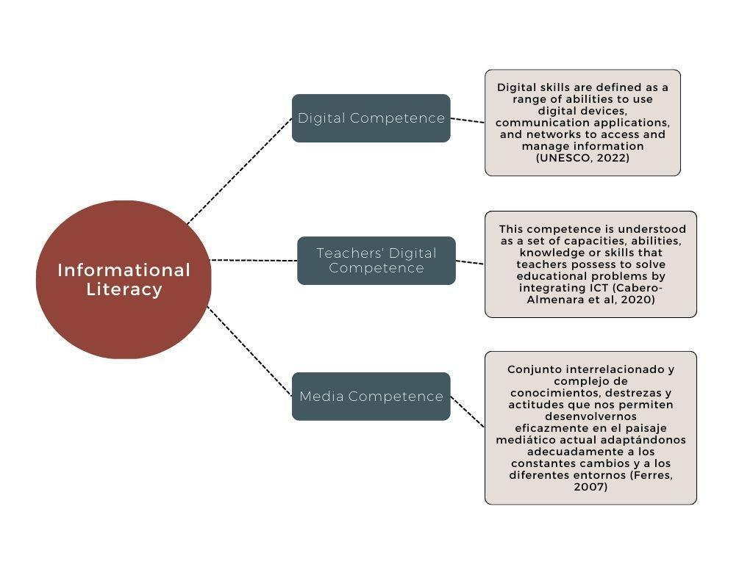

Source: Own elaboration based on Cabero et al. (2020) and UNESCO (2018)

The European Framework for the Digital Competence of Educators (DigCompEdu) assumes that educators are the role models of DC since they need to be professional and personally equipped with competencies transferred to students in the form of critical and creative use of technologies. This framework comprises six areas expressed in 22 competencies (Punie & Redecker, 2017)

**Figure 4.**

*Synthesis of Digcompedu Framework*

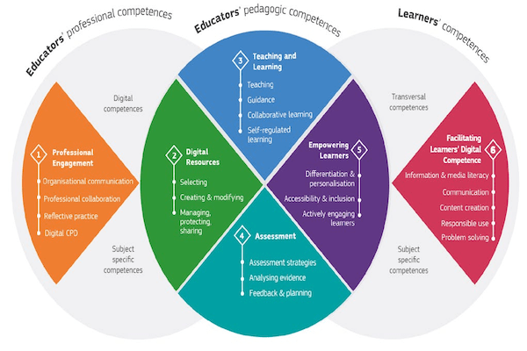

Source: European Commission (2017)

The first area is called "Professional Engagement," which involves using digital technologies for communication, collaboration, and professional development. The second area, "Digital Resources," is related to selecting, creating, and modifying digital resources. The third area is "Teaching and Learning," which manages and orchestrates the use of digital technologies in teaching and learning. The fourth is "Assessment," which uses digital technologies and strategies to enhance assessment. The fifth area is called "Empowering Learners." This aim is achieved using digital technologies to enhance inclusion, personalization, and learners' active engagement. Finally, the sixth area is "Facilitating Learners' Digital Competence." This purpose is reached by enabling learners to creatively and responsibly use digital technologies for information, communication, content creation, well-being, and problem-solving.

Each of the competencies that are part of each area is explained in Table 22.

**Table 22.**

*Digcompedu Areas*

| **Professional Engagement** | |
| --- | --- |
| Organizational communication | To use digital technologies to enhance organizational communication with learners, parents, and third parties. To contribute to collaboratively developing and improving organizational communication strategies. |
| Professional collaboration | To use digital technologies to engage in collaboration with other educators, sharing and exchanging knowledge and experience, and collaboratively innovating pedagogic practices |
| Reflective practice | To individually and collectively reflect on, critically assess, and actively develop one’s own digital pedagogical practice and that of one’s educational community |
| Digital Continuous Professional Development (CPD) | To use digital sources and resources for continuous professional development. |
| **Digital Resources** | |
| Selecting digital resources | To identify, assess, and select digital resources for teaching and learning. To consider the specific learning objective, context, pedagogical approach, and learner group when selecting digital resources and planning their use |
| Creating and modifying digital resources | To modify and build on existing openly-licensed resources and other resources where this is permitted. To create or co-create new digital educational resources. To consider the specific learning objective, context, pedagogical approach, and learner group. |
| Managing, protecting, and sharing digital resources | To organize digital content and make it available to learners, parents, and other educators. To effectively protect sensitive digital content. To respect and correctly apply privacy and copyright rules. To understand the use and creation of open licenses and open educational resources, including their proper attribution |
| **Teaching and Learning** | |
| Teaching | To plan for and implement digital devices and resources in the teaching process, so as to enhance the effectiveness of teaching interventions. To appropriately manage and orchestrate digital teaching strategies. To experiment with and develop new formats and pedagogical methods for instruction. |
| Guidance | To use digital technologies and services to enhance the interaction with learners, individually and collectively, within and outside the learning session. To use digital technologies to offer timely and targeted guidance and assistance. To experiment with and develop new forms and formats for offering guidance and support. |
| Collaborative Learning | To use digital technologies to foster and enhance learner collaboration. To enable learners to use digital technologies as part of collaborative assignments, as a means of enhancing communication, collaboration and collaborative knowledge creation |
| Self-regulated Learning | To use digital technologies to support learners’ self-regulated learning, i.e. to enable learners to plan, monitor and reflect on their own learning, provide evidence of progress, share insights and come up with creative solutions |
| **Assessment** | |
| Assessment Strategies | To use digital technologies for formative and summative assessment. To enhance the diversity and suitability of assessment formats and approaches. |
| Analysing Evidence | To generate, select, critically analyze and interpret digital evidence on learner activity, performance and progress, in order to inform teaching and learning |
| Feedback and Planning | To use digital technologies to provide targeted and timely feedback to learners. To adapt teaching strategies and to provide targeted support, based on the evidence generated by the digital technologies used. To enables learners and parents to understand the evidence provided by digital technologies and use it for decision-making. |
| **Empowering Learners** | |
| Accessibility and Inclusion | To ensure accessibility to learning resources and activities, for all learners, including those with special needs. To consider and respond to learners’ (digital) expectations, abilities, uses and misconceptions, as well as contextual, physical or cognitive constraints to their use of digital technologies. |
| Differentiation and Personalisation | To use digital technologies to address learners’ diverse learning needs, by allowing learners to advance at different levels and speeds, and to follow individual learning pathways and objectives. |
| Actively Engaging Learners | To use digital technologies to foster learners’ active and creative engagement with a subject matter. To use digital technologies within pedagogic strategies that foster learners’ transversal skills, deep thinking, and creative expression. To open up learning to new, real-world contexts, which involve learners themselves in hands-on activities, scientific investigation or complex problem solving, or in other ways increase learners’ active involvement in complex subject matters |
| **Facilitating Learners’ Digital Competence** | |
| Information and Media Literacy | To incorporate learning activities, assignments and assessments which require learners to articulate information needs; to find information and resources in digital environments; to organize, process, analyze and interpret information; and to compare and critically evaluate the credibility and reliability of information and its sources |
| Digital communication and collaboration | To incorporate learning activities, assignments and assessments which require learners to effectively and responsibly use digital technologies for communication, collaboration and civic participation |
| Digital content creation | To incorporate learning activities, assignments and assessments which require learners to express themselves through digital means, and to modify and create digital content in different formats. To teach learners how copyright and licenses apply to digital content, how to reference sources and attribute licenses |
| Responsible use | To take measures to ensure learners’ physical, psychological and social wellbeing while using digital technologies. To empower learners to manage risks and use digital technologies safely and responsibly. |
| Digital problem solving | To incorporate learning activities, assignments, and assessments which require learners to identify and solve technical problems, or to transfer technological knowledge creatively to new situations |

Source: European Commission (2017).

Furthermore, as a way to provide a scale that indicates the progress reached by teachers throughout their professional training, it a CEFR is established with specified levels of expertise with its corresponding descriptor for each of the six areas (Figure 5)

**Figure 5.**

*DigCompEdu Progression Model*

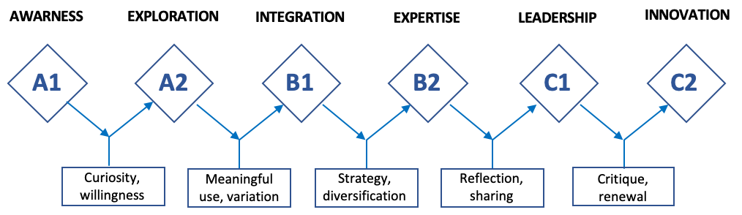

Source: European Commission (2017)

Cabero-Almenara and Palacios-Rodríguez (2020) translated into Spanish and adapted the questionnaire called “DigCompEdu Check-in,” aiming to provide a tool to assess personalized teaching assessment plans and improving TDC

## 1.2 State of Knowledge

This section analyzes the state of knowledge about research studies related to pedagogical models, didactic designs, and TDC assessment. The idea is to determine the purposes of the Pedagogical Model (PM) or Didactic Designs (DD) that have been created in the last five years, specifically, to revise if there exist proposals in the ELT field, teachers’ professional development, and teachers’ digital competence development. Besides, the author revises published studies that intend to determine TDC by analyzing the type of instruments used, the objectives, and the findings regarding performance levels and behavior of the areas and competencies. The analysis of published works that pursue self-assess TDC goes from macro studies to regional studies conducted worldwide, starting from productions in Spain and moving to other countries to conclude with publication in Latin America and Colombia. The analysis follows the order of studies carried out at the university level to secondary and primary education productions.

## 1.2.1 Pedagogical Models

The TPACK Model proposed by Mishra and Koehler (2006) is a common denominator when conceiving new methodologies or procedures that integrate technology into education. The model conceives teachers’ professional development in technology from three types of Knowledge that need to be integrated: pedagogical, technological, and Content Knowledge. Pedagogical Knowledge is the different methodologies or teaching approaches applied in the classroom; technological Knowledge is the technological resources and tools used to teach the content, and the content is the specific subject area or discipline.

When these three types of Knowledge are combined, they become Technological Pedagogical Content Knowledge presented in Technological Pedagogical Knowledge, Technological Content Knowledge, and Pedagogical Content Knowledge. The Venn Diagram below lets us see these relations (See Figure 6)

**Figure 6.**

*The TPACK Model*

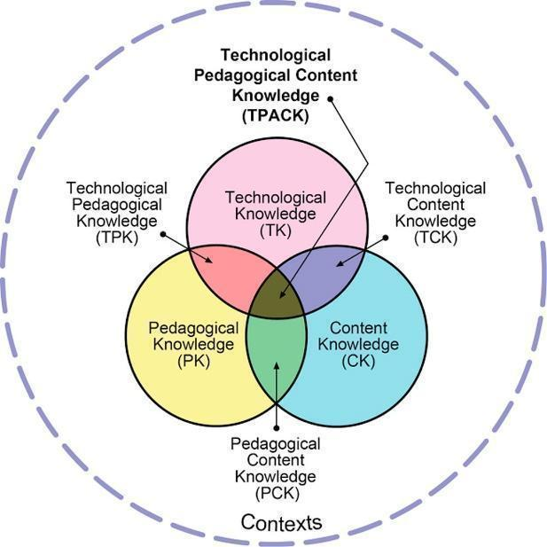

Source: Mishra and Koehler (2006)

It has been seen that most of the pedagogical models focused mainly on Technological knowledge because it is taken for granted that educators already manage the content and the pedagogical knowledge; however, this latter becomes an obstacle when teachers intend to move the same didactic strategies, they use in the physical classroom to a virtual learning classroom. That is where the SAMR-TPACK Model, proposed by Puentedura (2014), gains validity.

**Figure 7.**

*SAMR Model*

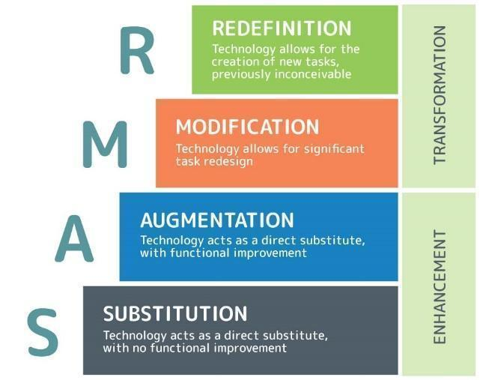

Source: Puentedura (2014).

Puentedura's model organizes classroom technology implementation in four stages. Substitution is the most straightforward stage, where EdTech (Educational Technology) is used as a substitute for traditional classroom practices. One example of substitution could be when the blackboard or the whiteboard in the classroom is changed by a Google Jam board, where students can write for the whole group and work in collaboration when visiting other classmates' boards and adding comments or suggesting ideas. It is important not to substitute only because of the fashion of technology but because the new source adds something else to the learning process (Puentedura, 2015). Augmentation deals with this aspect. Having students inquire on the World Wide Web about concepts of a particular subject or project theme, instead of the mere teachers' input, trains them in using self-regulated learning strategies, allows them to grow in autonomy, and gives them lifelong learning strategies. In the Modification stage, technology is used to design interactive and dynamic tasks beyond the limits of the physical classroom. Introducing changes to the traditional pen and paper activity called "Find Someone Who" enables students to ask questions to their classmates and use WhatsApp to interact with students worldwide by voice or text messages according to the communicative skills the English teachers intend them to practice. Finally, in the Redefinition stage, teachers design new tasks, introducing new learning chances. Technology is integrated meaningfully through engaging activities that connect students' senses and train them to use soft skills when exposing them to multiple cultures, literacies, and multi-modal resources. Using Canva implies mastering and combining texts, illustrations, photos, mental maps, and icons to construct a presentation project, an infographic, or a video presentation using one's own voice and image.

Among the literature production that seeks to design PM that integrates technology into education in general, it is noteworthy to mention the Introduce, Demonstrate, Develop, Implement, Revise, and Reflect (IDDIRR) Design Model, the Technological pedagogical content design (TPCD), and the The Spiral Model of Collaborative Knowledge Improvement (SMCKI) Model. Lee & James (2018) propose the IDDIRR Design Model, which integrates T-PACK and Professional Learning Community (PLC) in 6 steps that define the trainer's role and students' role during the process. The central role of the trainer is to introduce the TPACK methodology and demonstrate how to integrate it into lesson planning. The learners follow the provided model to develop and implement their lesson plans, which are revised by the tutor and self-evaluated by the learner through personal reflections.

**Figure 8**.

*The IDDIRR Design Model*

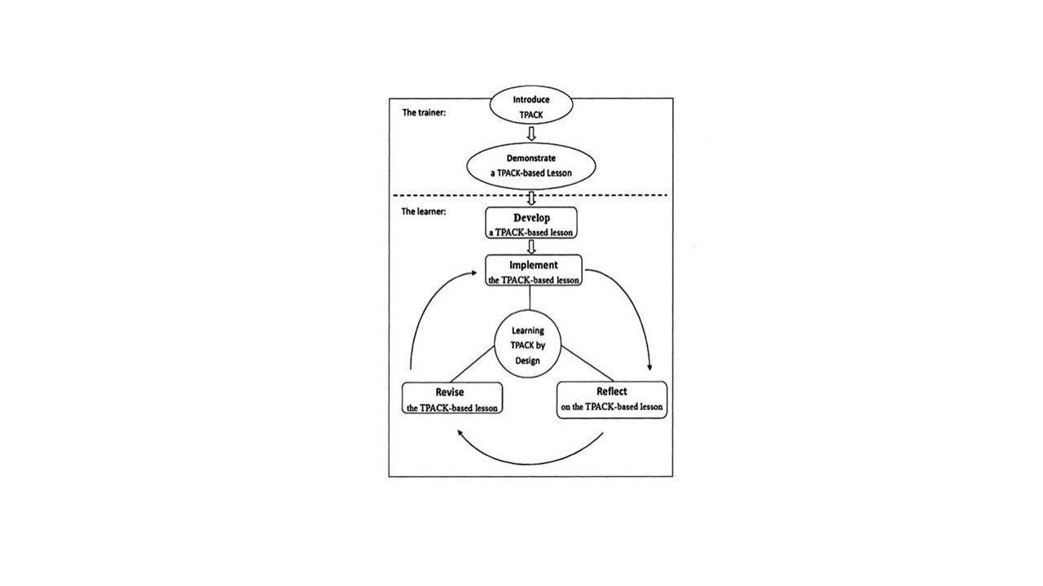

Source: Lee and James (2018)

In the same track, the TPCD Model, suggested by Hosseini et al. (2021), shed light on incorporating technology into pedagogy and pedagogy into technology. The author's intention in this former idea is to create a framework for using the model for designing a website. While the TPACK model seeks to integrate technology into pedagogy and content, the TPCD proposes integrating pedagogy into content and technology in educational and noneducational platforms. As in the TPACK Model, Hosseini conceives content, pedagogy, and technology as the main components of the model that are integrated to set the goals and the outline of the website based on the content and user analysis. Content analysis involves content objects and materials that are designed using different formats. In contrast, the user analysis gets educators to define the appropriate learning theories, learning styles, and learning psychology to fulfill the learners' needs.

**Figure 9.**

*The TPCD Model*

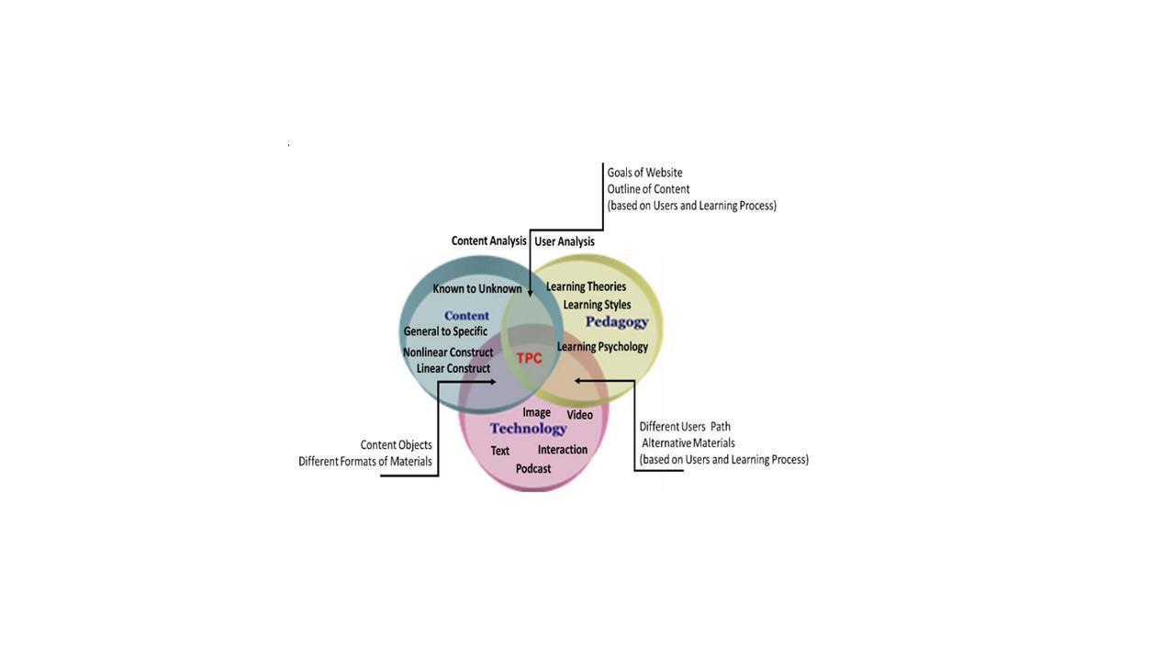

Source: Hosseini et al. (2021)

The SMCKI Model (Chen et al., 2021) is a five-phase pedagogical model to support the collaborative learning of a networked classroom. It focuses on democratic knowledge sharing and the individual, group, and class-level knowledge improvement processes. The model presents five phases: inter (individual) and intra-learning moments (group and class). Once the task or the inquiry has been proposed, students do individual searches and post ideas online; afterward, in the group, students study the individual posts and make a synthesis that represents the idea of the group. In the third phase, students visit the posts of the other groups in the class to gain knowledge and make comments or suggestions in a Gallery Walk activity. Next, students go to their home groups, read the comments posted by members of other groups, and make the adjustments. Finally, students close the cycle by writing a reflection about their role during the collaborative learning activity. As can be seen, this model follows principles of the CHAT Theory of Vygotsky and Constructivism. It may be beneficial because accurate scaffolding processes are involved when the students move in inter-intra- psychological procedures.

**Figure 10.**

*SMCKI Model*

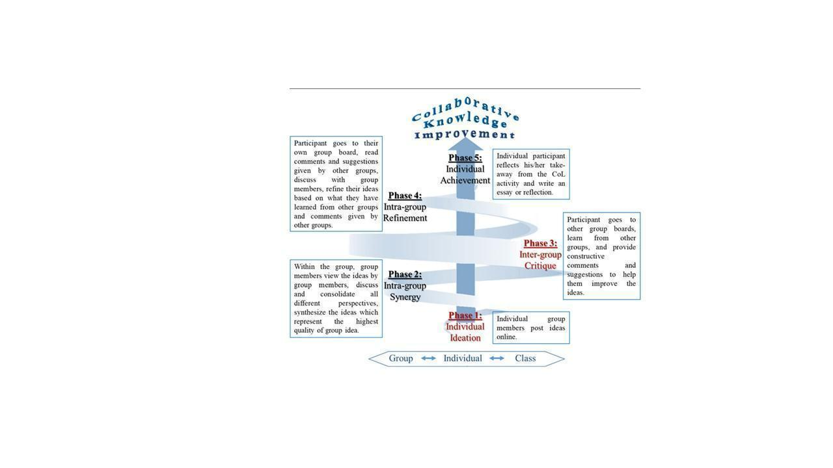

Source:Chen et al. (2021)

One of the biggest concerns in the integration of technology into education is the motivation, disposition, and attitude of users (Tarchi et al., 2022; Alsaied, 2016; Aşıksoy, 2018; Lai & Hashim, 2021); that could be the reason why some researchers have made attempts to design models that intend either measure or develop the acceptance of technology for educational aims. Cabero-Almenara et al. (2018) apply the TAM Model (Technology Acceptance Model), which was initially developed by Davies (1989), to measure the degree of acceptance and satisfaction of a group of teachers from Universidad de República Dominicana. The model considers two factors influencing an individual's intention to use new technology: perceived ease of use and usefulness. Similarly, Shelton (2018) used an ecological model of university faculty members' knowledge and beliefs about technology. This model considers contexts influencing university faculty members' thinking about technology uses. The contexts in the model are society and culture, higher education sectors, institutional context, department context, and the self.

The Unified Model of Task-Specific Motivation (UMTM) de Brabander & Glastra (2021) integrates several motivation theories to provide a framework of constructs needed to describe qualitatively and quantitatively the motivation for a course of acting at a specific time. The authors use it to explore the readiness of teachers to learn about ICT use. Finally, Tabatabaee-Yazdiet al. (2018) designed and validated a model to determine students' Continuing Professional Development factors contributing to EFL teachers' success. Although it is a model applied to language students, it is not committed to developing language skills but digital competence.

Songkram and Chootongchai (2020) and Agélii et al. (2019) introduce models to develop innovation and creativity. The first authors examine the consistency of a causal innovation model based on the SECI Model in undergraduate students in 12 universities in Thailand. The model idea was initially proposed by Nonaka and Takeuchi (1995). They believe that students' creativity development is fostered by going from socialization, externalization, combination, and internalization of knowledge. The SECI model is founded on four pedagogies, brainstorming technique, inquiry-based learning, cooperative learning, and project-based learning. Students are exposed to two knowledge-sharing activities: explicit knowledge in documents such as research papers, reports, and books and tacit knowledge that includes insights and intuitions. Students' knowledge converts from explicit to tacit knowledge through workshops and hands-on experiences.

**Figure 11.**

*The SECI Model*

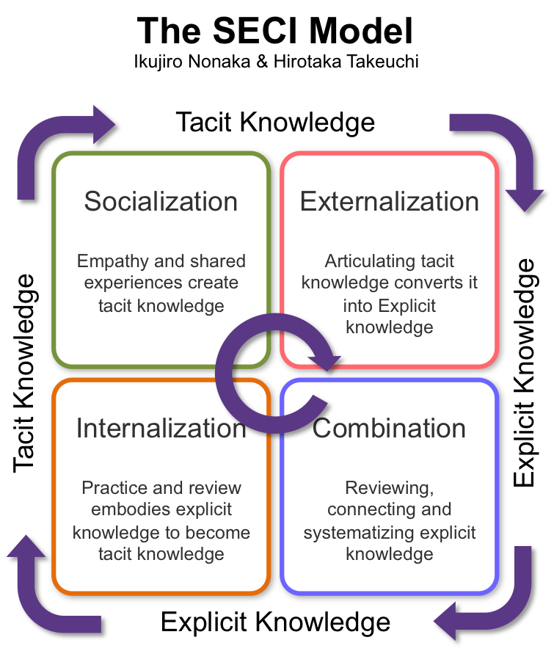

Source: Nonaka and Takeuchi (1995)

Agélii et al. (2019) present a write-to-learn method as an example of how a community communicates, communicates, and adopts innovation. They express supporting ideas for the integration of ICT to clear pedagogical objectives. Success in adopting second-order change innovation depends on motivation, skill, positive learning, organizational conditions, infrastructure, and culture. A transparent methodology with specific procedures and techniques is not described.

Of the models that integrate technology into ELT, three are addressed to be used with students, and two are not models but an initiative to join existing theories to implement a new mode of using technology for ELT. Drugova et al. (2021) describe a platform that integrates Mishra and Koehler’s TPACK (2006) and Puentedura (2014) Substitution, Augmentation, Modification, and Redefinition (SAMR) models for analyzing the process of educational technology integration. Vázquez-Cano et al. (2016) use discourse analysis to determine the effectiveness of PLE (Personal Learning Environments) and OER (Open Educational Resources) in affecting digital competence, fostering content creation and learning skills. PLEs seem to be a valuable theoretical background for developing actual scaffolding learning, as the SMCKI Model proposed. Attwell (2010, cited by Vasquez-Cano et al., 2016) defines PLEs as “the spaces in which people interact and communicate and whose ultimate result is learning and the development of collective know-how” (p. 65). The authors see blogs as a unique opportunity to develop PLEs; however, PLEs are conceived as a collection of digital tools selected for learning, reflecting, and collaborating with others. For ELT, it would be beneficial to establish a taxonomy of learning resources organized for developing language skills and sorting out suggested actions for constructing learning outcome statements and corresponding suggested activities. Teachers may use Symbaloo as a starting page on their computers, where they can set up suitable web tools and resources for language teaching, as shown in Figure 12.

**Figure 12***.*

*Configuration of PLEs using Symbaloo*

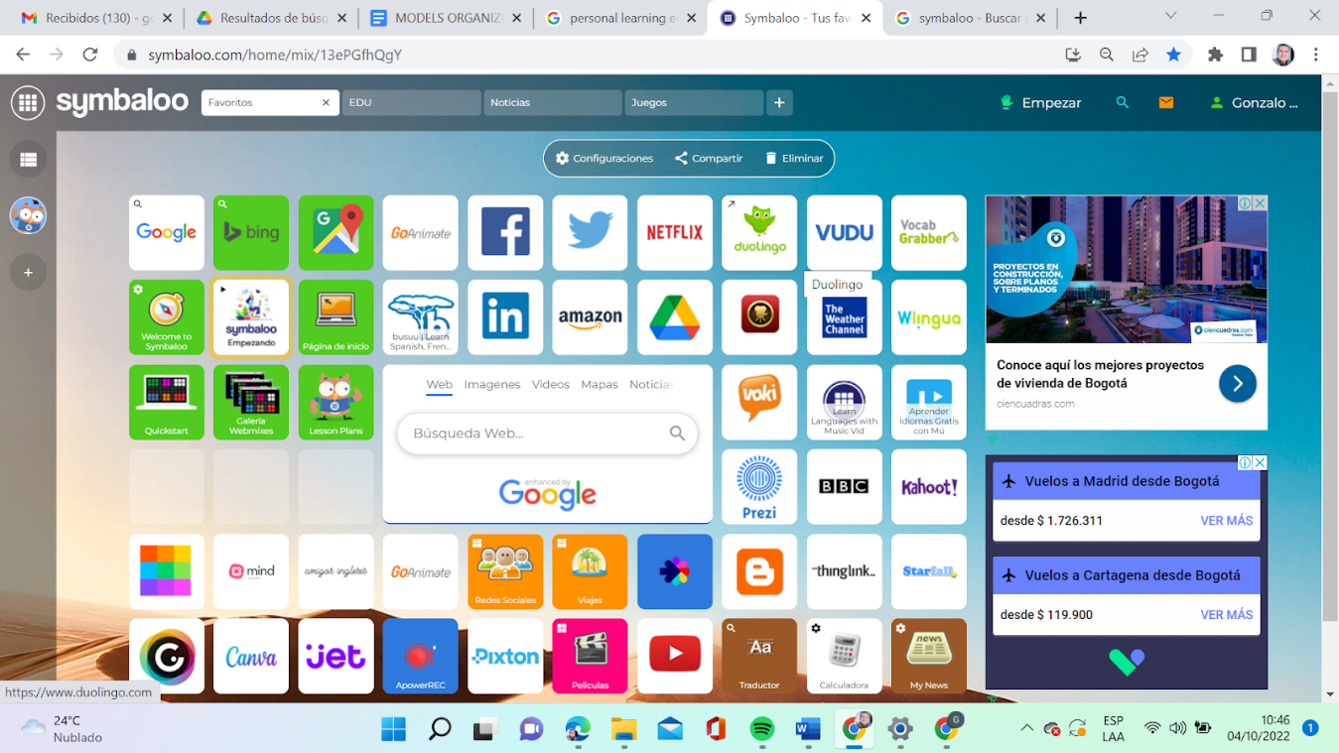

Source: Symbaloo Webmix Library (2022)

Wang & Zhang (2022) developed a blended instructional model based on SPOC (Small Private Online Courses) to improve autonomous learning in college English students. The teaching process is divided into three stages: teaching preparation, teaching implementation, and teaching evaluation, while blended learning based on SPOC consists of three parts: autonomous learning before class, face-to-face communication in class, and knowledge expansion after class. The proposed model follows the steps of the instructional model ADDIE and a 7-step procedure as a pedagogical method. Through their research study, the authors could prove that autonomous learning moments become beneficial in moving from explicit to tacit knowledge, as proposed in the SECI Model.

One of the most exciting proposals regarding its theoretical foundation and the response to learning in the XXI Century is the SOSE Model proposed by Salem (2019). It is a new web-based model comprising three main stages: preparation, data refinement, cooperation, and publishing. It is “an internet-based environment in which students investigate a topic, try to answer some set questions, or solve a problem in collaboration with their peers” (Salem, 2019, p. 2505). Pupils are actively involved in their learning, take risks, learn from their errors, and assume responsibility for their learning. Another essential point related to SOSE is that its main components cope with the requirements for developing hard skills (i.e., cognitive skills), soft skills (i.e., higher-order thinking skills and twenty-first Century Skills), and HOT skills (i.e., collaboration) in addition to its positive impact on developing academic achievement and performance. The model is founded on well-known theories and approaches to learning like Web-Based Learning, Constructivism, Scaffolding strategies, Project-Based Learning, Inquiry-Based Learning, and Discovery Learning. Unfortunately, there is not much theory that describes the method in depth. The steps established in the learning trajectory seem insufficient to demonstrate the application of the founded theories that provoke its emergence.

**Figure 13.**

*SOSE Model*

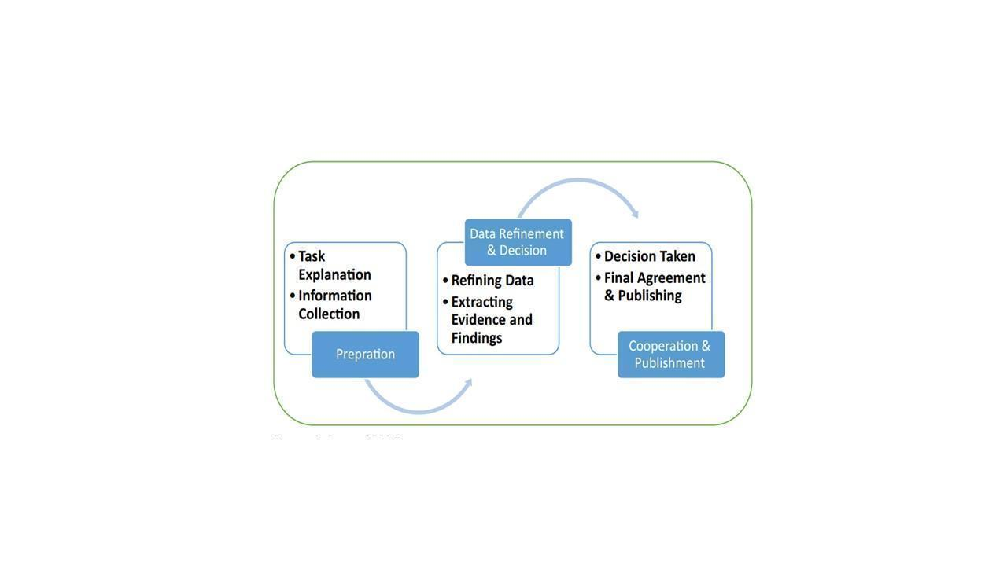

Source: Salem (2019)

Wu (2018) introduces the idea of the “ecological teaching model” and “internet plus.” Internet Plus refers to the in-depth interaction of Internet innovation with various economic and social fields to promote technological advancement. According to the author, The Ecological Teaching Model is entirely different from traditional teaching and uses various information tools, such as multimedia, network, and speech recognition. It focuses on autonomous learning and cultivates students’ storage ability, multimedia skills, emotional ethics, collaborative learning, and self-learning ability. Multimedia and network-based activities are the core of this model. The author suggests using Sci-fi movie clips, such as Star Trek, to introduce scientific concepts and arouse students’ interest, or English film clips to develop communication skills. Ruckynski J. (2011) demonstrates how The Simpson in EFL classes enhances language acquisition and develops critical thinking skills. Camacho G.C. (2017) exploits this material to lead preservice teachers to formulate problem questions by integrating the Logic of Sense and Inquiry as an orientation for learning.

**Figure 14.**

*The Internet Ecological Teaching Model*

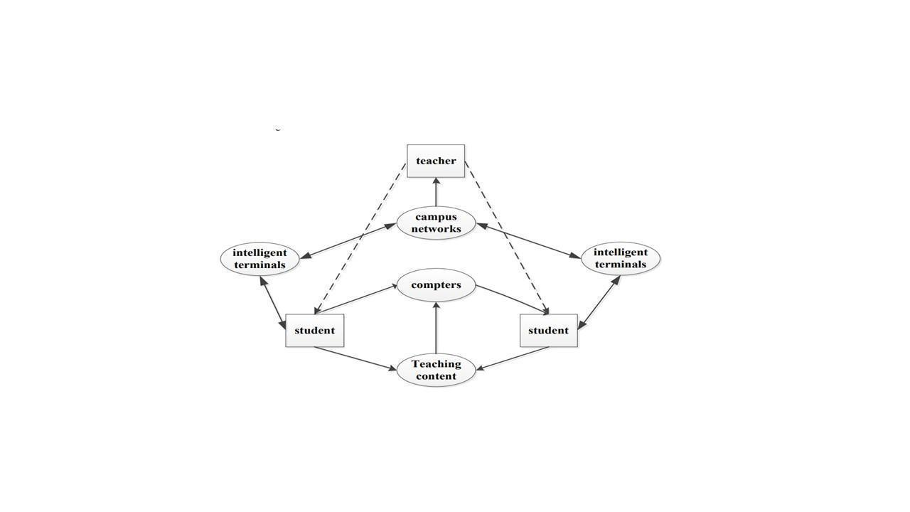

Source: Wu (2018)

Finally, three models intend to develop TDC. Two are addressed to develop DC in general education and one in primary education.

The Active teacher training Model (ATM) projected by Rodrigues (2020) is a cross-curricular training method that seeks to integrate digital technologies into teacher education. It adopts collaborative work, is supported by a socio-constructivist approach, and combines a face-to-face component and autonomous work. The author says that the ATM can be used by students and teachers in any discipline; however, there are areas of knowledge, like language teaching, that demand pedagogical models that respond to particularities, like the specific integration of web tools to develop language skills and intercultural aspects.

**Figure 15.**

*Method of Active Teacher Training Model*

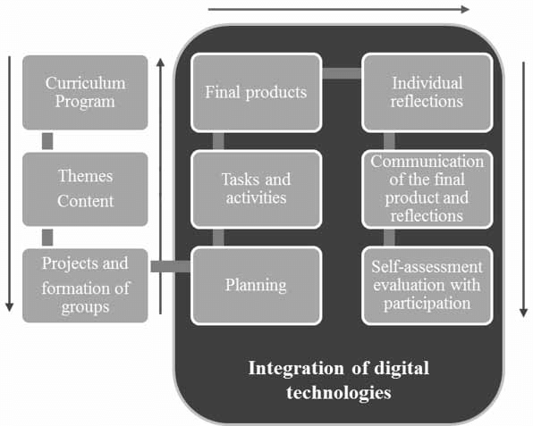

Source: Rodrigues (2020)

As shown in Figure 15, the first step is to include the subjects and contents in the curriculum and present them to trainees; after that, groups are made, and the thematic areas are assigned. This teamwork may be done using an LMS platform in a blended or flipped classroom form. Then, learners move to plan the work by organizing individual tasks for the members of each team. This independent work is monitored online by the tutor. The final products resulting from the collaborative teamwork, the individual reflections, and the online communications are taken as summative evaluations.

Zimmer et al. (2022) wanted to test the efficacy of a virtual coaching model of professional development to increase teachers' digital learning competencies based on a previous model conceived by Alaniz and Wilson (2015). This model presents cyclical moments like establishing the need, creating partnerships, targeting differentiated projects, assessing the progress, and reflecting on the integration.

The Model of Holistic Competence for the Digital World (Esteve et al., 2018) is addressed to primary education teachers and intends to surpass the definition of Digital Teacher Competence by assuming the concept not from an instrumental vision of technology but responding to an integral teacher. Concerning the Teachers' Digital Competence, the authors say that educators need to have the ability to use ICT to enrich classical didactic models that respond to students' learning needs (p. 108). They also insist on the idea of using Design-based Research (DBR) or Educational Design Research (EDR) to assume research as a teaching practice (p.110).

**Figure 16.**

*Holistic Model for the Digital World*

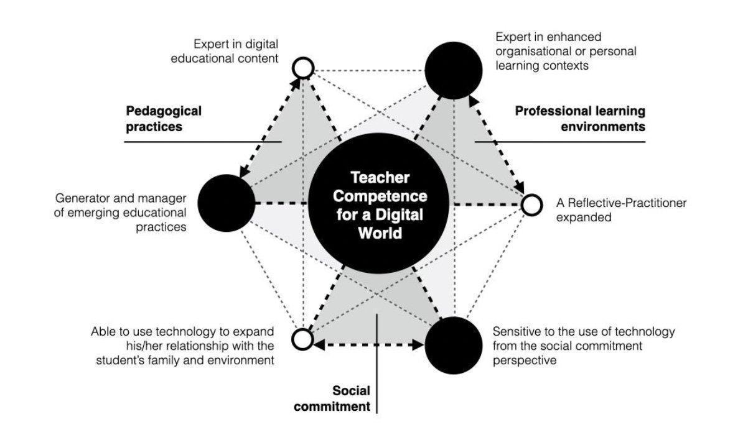

Source: Esteve et al. (2018)

This model adds new components that no other of the above mentioned include explicitly: the use of technology for expanding family relations and students’ background and the social commitment perspective. This remarkable relationship with the community gives sense to the use of technology to foster local values and impact local communities, which has been a claim of the Pedagogy of the Oppressed (Freire, 1970), ELT post-method theory (Kumaravadivelu, 2003) and Community-based Pedagogies (Sharkey, 2012)

## 1.2.2 Didactic Designs

In exploring existing knowledge, didactics and design are commonly related to technology. Jahnke et al. (2017) and Bergström (2012) established a theoretical framework for didactic design. The first authors see the Digital Didactic Design (DDD) framework based on the European Tradition of Didactics, which integrates teaching, learning, and technology into three components: the teacher, the student, and the content. This framework is valuable for studying designs-in-practice that involve web-enabled technologies. In this case, they studied using media tablets in the classroom by defining the five elements of Digital Didactic Design (DDD): teaching goals, learning activities, assessment, social relations/roles, and web-enabled technologies. The second author conducts a study of the development of education through the innovative use of process-based assessment in technology-rich learning environments in teacher and nurse education. The study was designed in three iterative didactic design cycles for process-based assessment in which the first and third cycles were analyzed. Each of the three cycles presents a particular design according to the proposed objective. Cycle 1 deals with processing diaries in distance teacher education, cycle 2 builds upon a local course development project at the department, and cycle 3 develops a design that explicitly illustrates the teachers’ and students’ points for interaction and communication during the process.

Regarding content subjects, studies were found incorporating didactic design into mathematics, robotics, computing science, pedagogical hypermedia, and music. Rønning, F. (2021) designed two teaching sequences in primary school using the principles of the theory of didactic situations to discover the opportunities a teaching design gives a teacher to realize students’ language use and use this knowledge to establish mathematical acceptance in the group of students. Bergström & Mårell-Olsson (2018) examine student perspectives on teachers’ different didactic designs from lessons in the one-to-one computing classroom. The designs consist of three clusters showing different teacher and student interactions. The findings report on three clusters of didactic designs in the one-to-one computing context:

* Traditional practices where teachers make the decisions
* Practices where students could make decisions to some extent
* Student-active practices where students, to a great extent, make decisions

The concept of didactics used belongs to the German Tradition, which is based on cultivating social relations.

Busetti et al. (2007) present an approach to the design of learning objects (LO) for a distributed Web-based environment for robotics education at the university level.

Technology is applied in the design of didactic units implemented as LO with a pedagogical orientation. These pedagogical modules were organized into two types of LO: The structured LO and the available LO. The first ones are based on a learning objective that determines its organization. In contrast, the second ones do not include a specific pedagogical orientation but have a general-purpose or context-related function. Candel (2018) intends to innovate music teaching in English in secondary education by designing a blog incorporating didactic resources using CLIL Methodology. The author designed a blog to teach English through music, incorporating digital resources such as PowerPoint, WebQuests, MiniQuests, Treasure Hunt, Flashcards, and sheet music. Candel's work is not a didactic design but the design of activities to teach music subjects in English by using a blog where digital resources are integrated (considering the Theoretical Framework constructed in this study).

A more recent study sought to find how a pedagogical design for teacher education gives meaningful learning chances for ESL and EFL preservice teachers enrolled in the course of technology collaborative teacher training in two partner universities in the USA and Europe (Dooly, M., & Sadler, R., 2020). The authors created the “FIT” design (flipped instruction, in-class instruction, and telecollaboration, which follows this sequence of learning in the two groups:

1. The course program is written in collaboration by the two teachers.
2. Flipped materials are prepared in agreement. These materials may include audiovisuals, resing texts, and interactive documents.
3. An activity is posted on an online bulletin board. Students read the text, highlight relevant ideas, search and post new information and ideas, and post a “burning question”
4. A few weeks are dedicated to telecollaborative discussions of the questions.
5. Small groups prepared a mini-lesson for the classmates who had not read the text.
6. Small groups teach the lesson.
7. Groups discuss issues that emerge from mini-lessons and discussions.

Results show that there are periods when student teachers take responsibility for their learning. They can verbalize what they do in practice and put into practice what is written in the theory. Besides, there is dialogic learning to understand complex pedagogical theories and models. This seems to be one of the few designs to create an online learning methodology with a structured sequence. However, this design does not consciously pursue to affect TDC, but didactics.

Likewise, Smith and Johnson (2021) used game simulators to increase TDC in a group of 216 Ukranian future foreign language teachers. Researchers use games like the Langua Magician, Unicampus, Minecraft, Sim4, Voki, and Class Dojo. The results show the effective use of a game simulator to form subject skills and didactics of language teaching in the control group. More than a didactic design or model, this is an interesting strategy to improve language teaching abilities. Drajati et al. (2021) also showed results in increasing teachers’ didactics by adopting the TPACK-21 Century Learning skills.

The population was English pre-service teachers in a teaching practicum for 16 weeks. Results revealed that pre-service teachers need more support to enhance three of the five dimensions in the TPACK-21CL: ICT-based active learning activities, ICT-based constructive activities, and ICT-based authentic materials.

In conclusion, few studies relate the didactic design to the LT or ELT field. Some of these studies focused strictly on designing pedagogical models or didactic designs to train English teachers to incorporate ICT into ELT and develop their DC. It is taken for granted that everybody knows what they are; moreover, most of these proposals are founded on something other than solid learning approaches that support their creation or fail at explaining clear didactic procedures to land the theory in the physical or virtual classroom. The T-PACK models become a joint base for developing new proposals that demonstrate the research concern by considering the three knowledge in the design.  García et al. (2022) also found in a systematic review of TDC in higher education that most of the articles they analyzed are based on the description of classroom experiences. However, there is no emphasis on experiences that research the development of TDC, the appropriation of tools to transform technology scenarios, the design of activities to share knowledge by combining different types of technologies that enable teacher to go beyond their initial level of DC.

Most of the studied models or designs integrate technology into teachers’ education or general training. From these studies, it is worth mentioning the contribution they make in the purpose of designing a proposal to train English Teachers in the adaptation of ICT to ELT: The SAMR Model creates awareness of the four possibilities of integrating technology into education, from substituting traditional practice to redefining them through the creation of new tasks; the IDDIRR Model shows a path to a natural integration based on lesson planning, implementation, and reflection; the TPCD Model provides a framework for designing websites for learning based on student’s needs, and the SMCRK Model shows how to promote democratic knowledge construction using alternating inter and intra psychological processes in the independent and collaborative work.

The models that sought to determine disposition and attitude towards adopting technology may be taken as a reference when assessing the grade of acceptance of the users of a proposed model. The TAM Model suggests considering perceived easiness and usefulness as crucial factors to increase acceptance, attitude, and motivation.

The SECI Model stands out among the proposals that seek to introduce innovation and creativity because it presents solid theoretical foundations to provoke learning through the incentive of explicit knowledge and tacit knowledge, while the incorporation of PLEs in OER merge as a beautiful possibility at organizing available web resources in the construction of a taxonomy for language teaching and learning.

From the models that add technology to ELT, it is worth mentioning the SOSE Model. However, it was not initially conceived to train teachers exclusively; it is fascinating not only because it is founded on contemporary teaching and learning theories to develop XXI-century competencies in students but also because it presents clear methodological and didactic procedures. The Ecological Model targets a crucial issue in adopting technology for educational purposes: the use of multimedia resources available on the web to develop language skills. The FIT Model presents an engaging online learning methodology based on teachers’ peer collaboration to approach pre-service teachers from different latitudes to improve their teaching skills.

Regarding the objective of affecting TDC in the field of LT, the models found general trace guidelines to train teachers in the use of technology based on integrating the three TPACK knowledge, but without defining the didactic procedure for classroom instruction. The Holistic Model for the Digital World creates awareness of not only considering content, pedagogy, and technology but also the effective and practical link of these components with the background of students and the impact on the learning community.

## 1.2.3 Teachers’ Digital Competence

This segment is devoted to reviewing research studies that pursue to assess TDC. The review focused on detecting the types of studies, the population, and the instruments used. It also examines the results by seeing the global classification of teachers and the behavior of the areas and competencies. The analysis starts with Spain, the country with the most significant research production in this field, moves to other world regions, and ends in Latin America and Colombia.

Most current studies using Digcompedu as a reference for teachers to self-assess their DC seem to originate from Spain. Cabero-Almenara et al. (2023) conducted a macro inquiry with a cross-sectional research design that intends, among other objectives, to find out the TDC of a sample of 6664 teachers from different Ibero-American universities. In all, most of the teachers have an intermediate proficiency level. They found that female teachers have a higher level of self-assessment competence than male teachers and that years of experience have an incidence in the increase of TDC self-assessment. Esteve et al. (2022) tested a non-probabilistic sample of 558 Spanish University teachers to conclude that teachers perceive themselves as having an intermediate level of competence. The Professional Engagement area obtained the highest percentages of answers; the Digital Resources, Teaching, and Learning and Assessment areas were at an intermediate level, and the areas of Facilitating Students DC and Empowering Students were the lowest. Pérez López and Yuste Tosina (2023) also assessed a group of 220 teachers from a Spanish public university through a descriptive and inferential cross-sectional research design, but using the INTEF (2017) questionnaire, which has five areas and 21 items. Most teachers are placed in an intermediate level of DC with differences among the areas. Fernandez Morante et al. (2023) developed a non-experimental design with a descriptive approach study to determine the DC of 610 Galician university teachers using the DigcompEdu questionnaire. Most teachers have a medium-low level with significant differences among age groups, profiles, and areas of knowledge. Similarly, Torres Barzabal et al. (2022) conducted another non-experimental research design to find the perception a group of 214 Pablo de Olavide University teachers (Sevilla) had about their DC. In short, teachers with more than ten years of experience see themselves at an acceptable level of DC. The Professional Engagement area stands out, and assessment and feedback have the lowest scores. As can be seen, most of the University teachers assessed utilizing the Digcompedu framework seem to self-evaluate their proficiency at an intermediate level, being the areas related to assessment and students’ DC development the ones with the lowest scores.

Two studies intend to determine school teachers’ DC in two Spanish regions. Rubio-Gragera et al. (2023) conducted a quantitative, descriptive, and correlational study to assess the level of digital proficiency concerning experience and use of ICT in the classroom of 104 official language teachers in Andalucia (Spain). In general, the self-assessment placed teachers in a low level of performance in areas related to facilitating the students' DC. Specifically, more attention should be paid to cybersecurity, the reliability of information on the Web, and digital tools for collaborative learning. García-Delgado also did a descriptive study with a non-probabilistic sample to self-assess TDC in 150 Spanish school teachers. The results say that teachers from all educational levels are located in an intermediate level of competence (B1-B2).

Two other studies pursue to compare the TDC of two foreign universities. Sánchez-Caballé and Esteve-Mon (2022) used the DigCompedu questionnaire to place the DC of 910 teachers in two universities from Spain and Poland to have a perception of both universities and analyze the results in terms of gender, professional category, and areas of knowledge. Results show that teachers see themselves at an intermediate level of competence. The area with the highest score was Professional engagement, while the area with the lowest was Students' Empowerment and Digital Competence. The Spanish University got a slightly higher average than the Polish University, but not in all the areas. Martín-Párraga et al. (2023) analyzed the level of DC in 2455 university teachers that belong to the University of Sevilla (Spain)and the University of Arequipa (Peru). The highlighted competencies are in Professional Engagement and Digital Resources, while the least developed competencies correspond to assessment areas, Empowering students, and Facilitating Learners' Digital Competence. There were significant differences between teachers from both universities. Teachers from the University of Arequipa got the lowest level of competencies due to contextual conditions, such as access to technology and poor TPD programs’ projection.

It is worth mentioning individual studies conducted in other countries, such as Turkey, Sri Lanka, The United Arab Emirates, and Portugal. Haşlaman et al. (2023) did a holistic single case study with 40 pre-service teachers through a 14-week course, aiming to describe this competence based on analysis of artifacts, like e-portfolios and reflection reports. The results demonstrate that pre-service teachers are at a C2 level in digital resources, C1 in Teaching and Learning, and B2 in assessment and empowering students. Karunaweera and Lee (2021) assessed 40 public English teachers in Sri Lanka to establish to what extent they are digitally competent. Most teachers are at the B1 Integrator level, and almost all the areas are at an intermediate level. Muammar et al. (2023) evaluated TDC in 19 universities in the United Arab Emirates through a quantitative study. Fifty-one teachers answered the adaptation of the Digcompedu questionnaire designed in Google Forms and sent via e-mail. The authors present a detailed analysis of each of the six areas but do not mention a global placement according to the framework levels or compare the areas to show weaknesses and strengths. They say that all the faculties are digitally competent in all the assessed areas. The studies from Portugal seek to analyze TDC in 695 higher education professors (Santos et al., 2021) and 434 primary and secondary teachers (Dias-Trindade et al., 2021). The first collected the data in three dimensions: personal, teaching, and institutional. Results demonstrate an intermediate level of competence with no significant differences among the dimensions. Master's and doctorate professors seem to have a higher level of competence. The results of the second study conclude that teachers have a global B1 level. Pedagogical competencies and students’ competencies were the weakest. Professional engagement seems to be the most substantial area, and assessment has the lowest scores.

Recent studies have researched the effects of different methodological proposals on TDC and Teachers’ Professional Development (TPD). Some of these studies are referenced in this segment.

Hämäläinen et al. (2020) conducted a large-scale study seeks the variations and relations between measured skills of teachers from 11 European countries based on the Teaching and Learning International Survey (TALIS; n = 50,800) and the Programme for the International Assessment of Adult Competencies (PIAAC; n = 2590) This research assume TDC as the congruence of three factors: Knowledge about digital technologies, digital skills and attitudes, and beliefs about digital technologies. Results suggest that there are variations between teaching professional skills and teaching knowledge. Older teachers tend to be weaker in skills but conscious of the importance of continuing professional training. This study shed light on essential factors in understanding teachers' digital skills in the three factors above.

Microlearning and Blended Learning are used to affect TDP more than assessing TDC. Kohnke et al. (20223) tested the effects of microlearning in TPD in 67 high school teachers in Hong Kong. Micro-learning is every learning a person gets from chunks of videos, tutorials on YouTube, or any other resources to fulfill immediate information needs to solve a concrete problem, for instance, how to make groups in Microsoft Teams. Results show that microlearning enables the development of teachers' technological competence and digital teaching. Morata-Garrido et al. (2023) carried out a non-experimental design to determine aspects to be improved in adopting blended learning in language teaching.

Two hundred sixteen in-service English teachers familiar with blended learning were surveyed using a Likert scale-adapted questionnaire. Results demonstrate that although TDC benefited from adopting blended learning, more extensive training is needed.

Moving the Latin America, we can find inquiries that use the DigCompEdu Framework, make an adaptation of it, or just intend to validate the instruments to be applied in other different contexts.

From the ones that use the DigCompEdu, it is worth mentioning Santos et al.’s (2023) descriptive statistical macro study, which evaluated digital competence in 30,407 academics from 403 higher education institutions in Argentina, Brazil, Central America and the Caribbean, Chile, Colombia, Ecuador, Spain, Mexico, Peru, and Portugal. In general, 70% of the surveyed are at an intermediate level of competence. No differences were found between young and senior academics or between males and females. The authors claim that pedagogical approaches have adapted to the digital era. Results show that the area of "Facilitating the Digital Competence of Learners" scored the lowest, while the lowest competencies were Self-regulated Learning and Differentiation and Personalization. The most potent competencies were Accessibility and inclusion, Digital CPD, Guidance, and Collaborative Learning. Gallardo-Echenique et al. (2023) intended to validate the DigcompEdu instrument in a population of 1,218 teachers from different areas in a private university in Perú. Since the primary objective is not to analyze the results in terms of teachers' performance in the framework's areas and competencies but to validate the instrument, the authors do not present a further analysis in this regard. However, it is said that empowering students to use digital tools is a need for integral learning.

Two significant studies make adaptations to the DigCompEdu questionnaire.

Rioseco Pais et al., (2023) designed and validated the Digital Competency in Pedagogy Assessment instrument (COMPDIG-PED) in 841 education students in 3 universities in Chile. The results conclude that the COMPDIG-PED is a valid instrument to measure DC in any university program. Alarcón et al. (2020) self-assesses 509 educators from Spain and Latin America by using the DIGIGLO questionnaire. The instrument comprises eight areas, the six in the Digcompedu plus the Digital Environment area and the Extrinsic Digital engagement area, which are assessed through a Likert scale with 29 items. The results say that the instrument is valid and reliable to assess TDC.

There were two studies that used two different tools to evaluate TDC. Silva et al. (2019) tested 568 preservice teachers from Chile and Uruguay. A validated test with 4 dimensions (curricular and didactic methodology, planning, organization and management of facilities and digital resources, ethical legal and security aspects, and personal and professional development) was administered to the participants. The test consisted of 40 items that were written using problem situations that students needed to solve. In general, students were evaluated as being at a basic level in the four dimensions. The results were discussed in terms of gender and educational level. Male students obtained a higher level. Primary education students have the lowest scores compared to other education programs. Silva-Quiroz et al. (2022) determined the digital competence level of 239 pre-service teachers at seven universities in Chile. They used an instrument of evaluation of theoretical knowledge instead of a self-assessment test to establish differences in sex, training program, and participation in professional teaching practice. Results can not be compared to Digcompedu descriptors since the instrument comprises other dimensions.

Among the studies that intend to determine TDC in Colombia, we can mention the following ones:

Paz et al. (2022) sought to ascertain the TDC, attitudes regarding the use of technologies, and specific activities that a group of 162 university lecturers does by using two online questionnaires. For the first purpose, they administered the COMDID-A questionnaire (Lázaro-Cantabrana & Gisbert-Cervera, 2015), which consists of four dimensions (D1: Didactics, curriculum, and methodology, D2: Planification, organization, and management of digital resources, D:3 Relational issues, ethics, and security issues, D:4 Personal and Professional issues), that are assessed using 22 items in a Likert scale to place contestants into four levels (True beginners, false beginners, intermediate, experts, and transformers). The second purpose is reached via a self-assessment rubric based on the SABER-TIC items (Taquez et al., 2017). The question that arises is, why use a rubric and a questionnaire when more integrative and reliable exist? The study results show that most teachers belong to the intermediate level (50%). For the first dimension, teachers are placed In the expert (35%) and intermediate (34%) levels, while for the other dimensions, they are in the intermediate level (47%, 46%, and 46, % respectively). The analysis was done using IBM SPSS Statistics Software for Windows from two perspectives: descriptive results of central tendency to establish the level of CDD and frequency of educational actions and correlational analysis using Spearmen’s Rho coefficient.

Pinto-Santos et al. (2022) used the same test validated by Silva et al. (2019) to evaluate DC in 1,344 full-time teachers at Universidad de La Guajira. The study is an empirical-co-analytical with a non-experimental, transactional, descriptive design. Results show that 78.2% of the tested teachers are in the beginning and Middle levels. As well as in the previous study, dimension 1 scored the highest average (2.3%).

Roa et al. (2021) use in their study the University Teachers’ Digital Competence Model (*Modelo et al.*) proposed by Prendes et al. (2018). This model is similar to the model presented by the Ministry of Education of Colombia. It comprises five dimensions (Social-ethical, Analytical, Educative, Interactional/communicative, and Technical) and three levels of progress (explorers, integrators, and innovators). The data analysis concludes that 77% of the teachers belong to the integrator level in all competencies. The authors used a factorial analysis on the principles of Kaiser (1974) through the statistical tests of Kaiser-Meyer-Olkin (KMO) and Bartlett’s test of sphericity (BTS)

Torres-Flórez and Diaz-Betancourt (2021), also conducted research at the university level to analyze digital competence in faculties of economic and administrative sciences in Colombia, using the “survey to diagnose tertiary education staff members” The instrument designed by Gazca et al. (2020), consists of five dimensions (D1: Information, D2: communication and collaboration, D3: Digital Citizenship, D4: Use of Digital Tools and Devices, D5: Content Creations), and four levels of performance (Nule, Low, Intermediate, and High). The authors conclude that most teachers have a high level of digital competence but do not show global results to establish clear scores for each dimension. The statistical software SPSS was used to determine the descriptive association elements.

Finally, it is worth mentioning Gomez’ study (2017), which intends to determine the TDC index for a University in Colombia by implementing the Pentagon of TIC competencies for the Development of teaching, presented by the Colombian Ministry of Education. The scores of each dimension were classified into five levels (from A to E), demonstrating that most of the teachers reached level B in most dimensions. The author remarks that the obtained results underwent a cross-check or triangulation to compare different data analysis types; however, a specific statistical analysis tool is not mentioned in the manuscript. Table__ summarizes the main studies carried out in Colombia that intend to determine TDC levels by using different instruments.

Table

*Studies to determine TDC in Colombia*

| **STUDY** | **Gómez (2017)** | **Roa et al. (2021)** | **Torres-Flórez and Díaz- Betancourt (2021)** | **Pinto-Santo et al. (2022)** | **Paz et al. (2022)** |
| --- | --- | --- | --- | --- | --- |
| **INTRUMENT USED TO DETERMINE TDC** | **The Pentagon of TIC competencies** | **University Teachers’ Digital Competence Model (Prendes et**  **al., 2018)** | **Instrument designed by Gazca et al. (2020)** | **COMDID-A questionnaire (Lázaro & Gisbert, 2015)** | **COMDID-A questionnaire (Lázaro & Gisbert, 2015) / a self-assessment rubric based on the SABER-TIC** |
| **RESULTS** | The scores of each dimension were classified into five levels (from A to E), demonstrating that most of the teachers reached level B in most dimensions. | 77% of the teachers belong to the integrator level in all competencies | University-level research to analyze DC  Faculties of economic and administrative sciences in Colombia.  High level of digital competence  Do not show global results to establish clear scores for each dimension. | Most teachers are classified as beginners (40.5%). Assess TDC in a population of 252 teachers. | The study results show that 50 % of the teachers belong to the intermediate level. |

Source: own elaboration

The state-of-the-art results reveal the need to design PM and DD with concrete didactic strategies for remote training of English teachers in incorporating ICT to ELT through Web tools. In this regard, Moreira et al. (2017) state that TDC development is achieved through a pedagogical design focused on didactics and dealing with lesson planning, use of resources, and opening spaces to discuss issues such as digital environment learning quality and teachers’ training programs.

García et al., in their systematic review of literature, found that most of the research studies focused on describing teaching and learning experiences based on theoretical foundations. However, no didactic intervention in institutional or classroom practices allows the development of high levels of TDC (p. 194).

Taking into account state-of-the-art pedagogical models and learning design to train teachers in the adoption of technology to education and specifically to ELT, research proposals should be based on solid theoretical learning and language foundations, as well as concrete actions that involve the development of the T-PACK knowledge and teachers’ learning competencies for the XXI Century. The progress in the TDC through the use of existing frameworks needs to be considered as a source of reference in determining the effectiveness of models to conceive without forgetting to affect teachers’ motivation, disposition, and beliefs to make this integration real. On the other side, the research analysis done to determine TDC demonstrates that the DigCompEdu Framework is valid and reliable for assessing TDC worldwide (Garcia-Ruiz et al., 2023). Most surveyed teachers assessed in the reported studies self-place their performance in an intermediate level of competence, with the areas related to teaching and learning the strongest and the areas that have to do with enhancing students’ DC the weakest. These results are similar to those obtained with the exploratory questionnaire applied before the current research study. When designing and applying a WBLDD to train English teachers in the incorporation of technology into ELT, the methodology must emphasize the improvement of these weak areas, which implies the use of technology to enhance self-regulated learning strategies, to provide opportunities for accessibility and inclusion, differentiation and personalization of learning, and active engagement of all students. Moreover, this proposal has to make students aware of the importance of cyber security, the responsible use of technology, and the promotion of students’ content creation.

**1.2.4 Use of Digital Tools for English Teaching**

Different systematic reviews of the literature have demonstrated that emergency teaching during the pandemic times increased teachers’ digital competence and the use of digital tools in education worldwide (Velandia Rodríguez et al., 2022; Cachón-Zagalaz et al., 2020; Gómez Junior et al., 2022; García et al., 2022; García Ruiz et al., 2023). The current section revises recent publications that assessed the use of digital tools for English teaching. There were analyzed different studies with productions in Europe, Asia, and Latin America.

Spain is also the country with more published studies that seek to determine the use of digital tools for ELT. Albero-Posac (2019) proposes to enrich CLIL subjects from Biology and Geology courses in a secondary school in Spain. A prior needs analysis was conducted through interviews to select the digital platform and tools. Made decisions include the use of Moodle to embed resources for close answers (Moodle glossaries, Flippity, and Educaplay), resources for open tasks (Edpuzzle and -moodle), resources for collaborative tasks (Tricider, Padlet, Canva, and Bubbl.us), and other tools like Google Forms. Mosquera Gende (2023) also studied secondary education in Spain. He used a survey-based research with a snowball sampling questionnaire administered to 110 secondary education English teachers, emphasizing the attitudinal and emotional effects of digital tools on students’ learning. From a list of well-known digital tools, responders selected Canva, Genially, and Kahoot as the most used to incentivize learning and Book Creator, Flippity, and Booklet as the least used. However, Flip seems to be the tool that better contributes to students’ participation and autonomy development. Wakelet also stands out from the other tools. Moving to Ukraine, Matviyenko et al. (2022) used empirical and statistical methods to test a new approach based on the use of Google machine translators and a Multitran online dictionary to enhance language skills and translation in two groups of 45 students (experimental and control) of an aviation course in the National Aviation University of Ukraine. Results demonstrate a positive influence of the approach in terms of the effectiveness of online dictionaries and translation machines in improving students’ foreign language skills. Alakrash and Razak (2021) experimented with a quantitative study, with a descriptive approach, in a population of 150 students and 40 teachers at Arab international schools in Malaysia to find out the level of digital literacy and the differences between EFL teachers and students concerning the use of technology and digital competence. They used two questionnaires made of three dimensions. Thirty-four items were about the use of digital technologies, and ten items related to digital literacy. Results demonstrate that students use technology the most to acquire vocabulary and the least to improve reading skills, while teachers use it the most for teaching practice and the least for reading skills. The questionnaire about the use of digital technologies was adapted for the aims of the current study. It was used in the exploratory stage and as a pre-test and a post-test to measure one of the main variables in the problem statement. The only work found in Asia was carried out by Moorhouse and Yan (2023). They used a mixed-method design to inquire about the use of digital tools by 83 English teachers in Hong Kong. Specifically, researchers wanted to know the digital tools used, the reasons for using them, and how they were used. Data was collected using firstly a survey with quantitative and qualitative items and in-depth semi-structured interviews to get a deeper understanding. There were established fourteen categories of tools used by the teachers, and core digital tools were determined for each category. The most common digital tools were Kahoot, Padlet, and Google Classroom. The less common were EPIC and Google Forms.

Three research studies were conducted in Latin America, and all of them belong to Brazil. Souza Pinto and Menezes (2019) did a meta-analysis research report to examine theses and dissertations related to the integration of language and technology and the use of digital tools that have been produced by graduate programs in Northern Brazil from 2008 to 2018. Data was collected from research platforms. The research presents global results of the research works that were examined. The authors stand out for using Virtual Learning Objects, virtual Learning environments, the Orkut social network platform, and WhatsApp. Perna et al. (2021) wrote a reflection article that explores some of the digital tools used by teachers. It reckons the importance of using technology in education and makes a historical review of models from 1.0 to 5.0. The author mentioned some benefits of using technology for educational purposes: active learning, formative assessment, retrieval practice, feedback-driven metacognition, emotional skills awareness, deeper learning, and adaptive learning. The authors also present an overview of the tools used by elementary, high school, and college students during remote emergency learning in Brazil: Peardeck presentations wizer.me, interactive worksheets, and gamification. Gomez Junior et al. (2022) intended to find the most used digital tools by 123 English students and 277 teachers in Brazil. The data was collected by using an online survey that was analyzed by comparing 2018 year with 2019. In 2018, the most used digital tools by students and teachers were Duolinguo, online dictionaries, and Google products, while the least used were Busuu, Hello Talks, and Podcast. In 2019, the least used tools varied: Memrise, Podcast, and Tandem.

In reference to the use of blogs, there were found five significant studies that sought to determine the effectiveness of blogs in English language learning and teaching. These studies were conducted in Kwait (1), Portugal (2), and Spain (2). Four literature reviews also focus on analyzing the relationship between blogs and ELT and ELL.

Al-Qallaf and Al-Mutairi (2016) investigated through a mixed-method study the influence of blogs on teaching English as a Foreign language to elementary school students in Kuwait. The authors used an adapted questionnaire to identify students’ attitudes and perceptions about blogs. They also used focus groups to go deeper into students’ answers to the survey. 95.7% of students said blogging is fun and interesting. Only 65.2% like to read their classmates’ posts. All students manifested that blogging helped them to improve their writing and vocabulary. Also, they improved their spelling and grammar mistakes when the teacher provided corrective feedback to the comments in the blog. In all, students see writing in blogs as a challenging activity, but they agree on saying that blogging improve their writing, vocabulary, and oral fluency. They also increased motivation towards learning, improved critical thinking skills, and learning independence. Fernandes (2017), in his Master’s in the pedagogical use of TIC’s thesis, used also a mixed method designed based on implementing a questionnaire in three different moments: exploratory, pilot, and final. The main objective was to explore the perceptions of primary and secondary teachers about the strengths and weaknesses of working with weblogs in their classrooms. The results show some benefits, like blogs fostering students’ autonomy, better used as an extension of class work, and learning support. Blogs also benefit the development of reading and writing skills and raise students’ motivation when creating entries and sharing them with the outside world. Among the constraints, teachers are aware of the importance of blogs, but many of them are inactive or are not used for EFL purposes. Teachers report that some Portuguese schools are not equipped with technological gadgets, infrastructure, or technological support. Teachers lack motivation, time, and adequate training for blog activity. The questionnaire used in this study was adapted to inquire about the perceptions of teachers about the use of blogs in English teaching in the current thesis study.

Pascual (2019) presents a teaching proposal consisting of developing students’ communicative and digital competencies through the implementation of travel blogs. This proposal is addressed to EFL classrooms in secondary schools in Spain. The study makes a selection of travel blogs to proceed to identify linguistic and discursive features. Then, lesson plans were designed based on principles of communicative language teaching and task-based approach. Results show that the proposal brought insights to improve students’ digital genre travel blogs. Jiang and Lu (2019) developed a case study research by surveying 112 students from an International Trade Practice Course in China using video blogs. The results show that 63.3 % of students favor using blogs in blended learning, 36.62% are on the fence, and no one is against it. Dealing with the improvement in learning by using vlogs, students manifested that most of the vlogs (78.64%) are consistent with what is learned in class. Besides, teachers give predominance to use videos that last from three to four minutes. For the purposes of seeing the videos in the blogs, the majority do so just out of interest (45.63%) and watch them to clarify doubts (45.63%). Finally, the authors conclude that using video blogs in teaching is beneficial since they are renewed frequently and are an excellent strategy to improve timeliness and increase interest.

The first of the aforementioned literature reviews was done by Reinhardt (2019). This author examined a corpus of 87 articles published from 2009 to 2018 on using social media for second and foreign language teaching and learning. The author analyzes the importance of blogs by specifying four stands of research: blogs for cultural learning and exchange, blogs for literacy and identity development, blogs for learning autonomy, for audience awareness, and the importance of task design. In sum, this research review shows evidence that blogs enhance cultural learning, foster reflection, and enable students’ deep learning.

Iredale et al. (2019) also explore the use of social media in pre-service teacher education (ITE) in research qualitative articles and proceedings issued from 2009 to 2016. The population comprises new teachers in primary, secondary, ELT, and lifelong learning. The authors include Facebook, Twitter, blogs, and wikis under this definition of social media. In a corpus of 55 papers, 11 were devoted to blogs. Some of the found affordances established that blogs enable peer engagement and reflection, develop academic writing skills, allow the sharing of resources and ideas, foster community formation, and provide evidence of professional development.

Meanwhile, some limitations concern teachers’ reluctance to provide student feedback and factors that demotivate the design of academic writing blogs. Jara (2021) inspected 52 selected articles using the Prisma methodology. From this corpus, only two articles are devoted to reviewing the use of blogs. Álvarez (2012) shows that blogs develop reading and writing skills in university students in Spain. He conducted a qualitative study whose outcomes present some limitations in using blogs: Students’ participation is reduced to entering the blogs, reading the content, and posting comments. Students are not required to dig into the information or use other resources to contrast information. Materials in most blogs are made of texts and a combination of text and multimedia. Few blogs include characteristics such as video format and the use of different programs and digital media.Álvarez y Bassa (2013) developed a qualitative case study focusing on analyzing the use of blogs in an Argentinian university. The outcomes demonstrate that blogs motivate students learning and encourage the development of writing skills through self-learning and collaborative strategies. Finally, Arslan (2023) also used the Prima methodology to analyze 53 articles qualitatively to find if the use of blogs improves 21st-century skills and English Language skills. Blogging implementation yielded the following outcomes: it benefits the acquisition of most XXI-century skills (collaborative, reflective thinking, and autonomous learning), and it seems to be more effective in developing writing skills. Results dealing with the effectiveness of blogs for English learning are divergent. Some studies report positive results, and some others do not.

In conclusion, there is a variety of digital tools that can be used for language learning. Google Products, Kahoot, Canva, and WhatsApp seem to be the most commonly used while reading and vocabulary tend to be the skills that are most favored with their use. About the use of blogs, the studied research works demonstrate that there seem to be more benefits than disadvantages. Among the benefits, teachers mention that blogs foster the development of XXI-century skills like collaboration, communication, and creativity. Besides, they become valuable learning support, enhance cultural learning, and incentivize reflection and knowledge sharing. The development of reading and writing skills tends to be privileged when using blogs. Some of the mentioned disadvantages have to do with the reduced participation of students when accessing blogs and the lack of teachers’ training to improve their design and effective use for language learning purposes. Video blogs seem to be a more valuable option since they dynamize the presentation of content and allow the development of productive skills.

The results of the different studies also allow us to conclude that there is a tendency to use digital resources for English teaching and learning. The growing offer of digital tools and websites constitutes an opportunity to enrich didactics, but it also becomes a challenge for teachers to be constantly updated with innovations. This is precisely what the second area of the DigCompEdu deals with: teachers’ capacities to select, create, modify, share, and protect digital resources. To grow in this specific area, it is necessary that teachers self-assess the use they do of technology in the classroom, and it is where Puentedura´s SAMR Model makes sense. A teacher needs to be aware of the way traditional classroom practices, like using a printed atlas to locate a place in the world, are substituted by the use of Google Earth. In this example, what changes is the tool but not the lesson objective.

As mentioned before, this literature review allows us to realize the amount of digital tools and resources available on the Web. It demands teachers to keep in mind language learning objectives to select the appropriate resources that enable their achievement instead of going somewhere else to favor the use of digital resources.

# Chapter 2. Research methodology

The current chapter is divided into two parts. The first seeks to set the research objectives, describe the target population groups, support the research design and methods, and define the data collection instruments and analysis procedures. The second part presents the results and analysis for each research question after the implementation.

To make sense of the description of the methodological framework exposed in this chapter, it is worth recalling the research problem, aims, and hypothesis. The research problem is defined through the inquiry that asks if there are any effects on Teachers’ Digital Competence and the use of ICT when a Web-Based Didactic Design to train English teachers in using technology for ELT is implemented. In that order of ideas, the main objective is to determine the effects of implementing a Web-based Learning Didactic Design to train ELT in the use of technology. The specific objectives expect to assess the influence of implementing the Web-based Design on teachers’ Digital Competence, register the incorporation of ICT in ELT didactics after implementing the model, and compare the results on Teachers’ Digital Competence and ICT use in ELT among the population groups.

## 2.1 Research objectives

A research problem that links technology integration to English teaching didactics employing the formulation and application of a Web-Based Learning Didactic Design becomes a relevant issue for contemporary times. As shown in the literature review, there exist several models that shed general light on the integration of technology into pedagogy (the TPACK Model, Mishra & Koehler, 2006; the SAMR-TPACK Model, Puentedura, 2014, among others); however, there are no didactic proposals that land these models to the field of classroom didactics. Moreover, there are no attempts to formulate didactic designs to incorporate technology into English Teaching. This link between ICTs and ELT after the pandemic allows for harvesting the fruits of lived experiences during emergency remote teaching. It becomes innovative to think of a didactic design that introduces flexibility in the traditional curriculum and prepares teachers to face the challenges of teaching in the XXI Century. Choi and Chung (2021) suggest that language teachers should be provided with continuing professional development to encourage learning in their students in post-pandemic times. For these authors, training should be based on giving teachers enough opportunities to get familiar with digital tools and develop the capacity to integrate them into language teaching.

Consequently, the current research seeks to determine the effects of implementing a Web-Based Learning Didactic Design on Teachers’ Digital Competence and English Teaching Didactics. As a result, the specific objectives pursued to assess the influence of the WBLDD in specific areas and competencies of the Digital Competence Framework -DIgCompEdu-, to find out the upshots in the implementation of the WBLDD in English Teaching Didactics, and to discuss the results of the influence of the WBLDD in Teachers’ Digital Competence and English Didactics among the target populations.

## 2.2 Target population

Three target groups of the population belong to English teachers in Colombia. The first group comprises pre-service teachers from the BA in Foreign Language Teaching at Universidad del Tolima, the second group are University English teachers, and the third group is English teachers from public and private schools that instruct elementary, media or high schoolers.

Pre-service teachers

Thirty-five pre-service teachers from the BA in English Teaching are in the ninth and tenth semesters. These students take the course of implementation as a graduation requirement according to local regulations (Universidad del Tolima, 2002)

University English Teachers

35 English teachers from private and public universities in Colombia registered voluntarily for the implementation phase through the exploratory survey administered at the study's beginning.

 School English Teachers

Thirty-five public and private school English teachers registered voluntarily for the implementation phase through the exploratory survey administered at the study's beginning.

## 2.3 Research method

This inquiry uses a mixed method design, combining quantitative and qualitative data collected through surveys, tests, and questionnaires. Closed-ended questions, in the form of multiple-choice answers, Likert Scales, and rankings, enable accurate data analysis by using statistics; and open-ended questions make it possible to inquire deeply about the participants' reasons, causes, perceptions, and ideas in their answers to these closed-ended questions. In the following lines, the quantitative and qualitative characteristics of the study are supported by the existing theory.

### 2.3.1 Quantitative.

Taking into account the classification of research methods presented by Mackey and Gass (2005), the current study is a quasi-experimental design because there is neither an experimental nor a control group. However, the results of the intervention are compared and contrasted among the three target population groups to see the results that the implementation provokes in the three educational levels (pre-service teaching education, university education, and elementary, media, and high school education) in the dependent variables, which are “teachers’ Digital Competence and incorporation of ICT to ELT”; besides, quantitative data collection instruments, such as surveys, test and questionnaires with closed-ended questions are administered to the participants to measure the TDC, the use of ICT to ELT, the self-assessment, the course and LMS assessment.

### 2.3.2 Qualitative.

Obeying the organization of methods provided by Creswell and Creswell (2018), the study includes a qualitative design since it analyzes data resulting from open-ended questions in the collection instruments that inquire about the participants' points of view, perceptions, and comments. A suitable definition of Grounded theory is:

A design of inquiry from sociology in which the researcher derives a general, abstract theory of a process, action, or interaction grounded in the views of participants. This process involves using multiple stages of data collection and the refinement and interrelationship of categories of information. (p.50)

Qualitative data is analyzed by creating codes to distinguish commonalities and group them into categories that enable their interpretation.

## 2.4 Research design

This study is a mixed-methods quasi-experimental (intervention) design since the researcher collects and analyzes quantitative and qualitative data and integrates the information within an intervention to capture the participants' personal experiences (Creswell & Creswell, 2018). Qualitative data becomes a secondary data source in the pre and post-data collection. Figure 17 shows the three phases in implementing the study with its corresponding tasks.

**Figure 17.**

*Mixed Method Intervention Design*



Source: Elaboration of the author based on Creswell and Creswell (2018)

## 2.5 Data collection instruments

The following data collection instruments are used in the exploratory, convergent, and explanatory core phases of the study, as illustrated in Figure 17:

### 2.5.1 Exploratory questionnaire.

It intends to diagnose the possible needs of English teachers in Colombia concerning Digital Competence, the use of blogs, and the incorporation of technologies into ELT. The questionnaire has three dimensions with 52 items and an optional section where survey respondents may register to participate in the implementation stage. The Teachers’ Digital Competence Test makes the first dimension, the second is the use of blogs, and the third is related to using Digital Technologies for ELT.

### 2.5.2 Teachers’ digital competence test.

It is an adaptation of the Almenara and Palacios-Rodríguez (2020) questionnaire that measures the six areas of Digital Competence through 13 items. (See Appendix A)

### 2.5.3 Use of digital technologies questionnaire.

It is an adaptation of the questionnaire designed by Alakrash and Razak (2021). The original instrument comprises students’ Use of Digital Technologies and Teachers’ Use of Digital Technologies. The current study considered only the second dimension, specifically the items that have to do with the development of the four skills that are part of the objective of this research project: listening, reading, speaking, and writing. (See Appendix B)

***2.5.4 Use of blogs***

It is an adaptation of the questionnaire used by Fernandes (2017). The original test is structured in five parts with a total of 26 closed ended questions followed by two open questions. The adapted version took 7 out of the 26 closed ended questions and one of the open ended questions.

### 2.5.5 WBLDD assessment.

This instrument seeks to evaluate the effectiveness of the WBL Didactic design through a form that assesses each of the moments in the Digital Didactic Design, from 1 to 5, regarding their contribution to incorporating technology into ELT and the development of TDC. The instrument allows student teachers to write comments for each assigned score and final remarks about the whole design if it applies. (See Appendix C)

### 2.5.6 Self-assessment form.

This form pursues that teacher students assess their performance in the eight moments of the learning trajectory that comprises the didactic design by scoring from 1 to 5, providing written support for each of the scores and final comments. These data contribute to assessing the influence of implementing the Web-based Model on teachers’ Digital Competence. (See Appendix D)

### 2.5.7 LMS assessment survey.

This survey is an adaptation of Nguyen’s (2021). It intends to measure the effectiveness of the LMS through six dimensions (System content, instruction information, interaction, technology quality, perceived learning management system usefulness, and perceived students’ satisfaction). Thirty-seven items in total are assessed in a five-criteria Likert scale. (Appendix E)

### 2.5.8Videos of implementation.

Student teachers share with the group and the community the concrete manner in which they have applied the digital competence gained throughout the course in the classroom or a specific setting. Videos are assumed as artifacts that support the integration of ICTs into ELT didactics. Czerwinski (2017) defines an artifact as an object of study used in critical and qualitative research made of humans rather than a product of a natural phenomenon. They are symbolic, purposeful, and intentional things. Final videos are assessed with a rubric that comprises multimedia Recording Quality, Language Skills, Organization of video, Mastery of the Subject, Capacity to integrate Digcompedu competencies, and overall impression. (See Appendix K)

**Table 23.**

*Data Collection Instruments per Stage*

| Exploratory Core Design | | |
| --- | --- | --- |
| Research Objective | Data Collection Instruments | Method of analysis |
| To determine the effects of implementing a Web-Based Learning Didactic Design on Teachers’ Digital Competence and English Teaching Didactics | Exploratory questionnaire | Quantitative. SPSS analysis.  Qualitative. Grounded Theory analysis |
| To assess the influence of the WBLDD in specific areas and competencies of the Digital Competence Framework -DIgCompEdu | Teachers’ Digital Competence pretest (See appendix A) | Quantitative. SPSS analysis.  Qualitative. Grounded Theory analysis |
| To find out the upshots in the implementation of the WBLDD in English Teaching Didactics | Use of Digital Technologies questionnaire (Appendix B) | Quantitative. SPSS analysis.  Qualitative. Grounded Theory analysis |
| Convergent Core Design | | |
| To assess the influence of the WBLDD in specific areas and competencies of the Digital Competence Framework -DIgCompEdu | Teachers’ Digital Competence test (See Appendix A)  WBLDD Assessment (See Appendix C)  Self-assessment form (See Appendix D) | Quantitative. SPSS analysis.  Qualitative. Grounded Theory analysis |
| To find out the upshots in the implementation of the WBLDD in English Teaching Didactics | Use of Digital Technologies questionnaire (See Appendix B)  LMS Assessment survey (See Appendix E) | Quantitative. SPSS analysis.  Qualitative. Grounded Theory analysis |
| Explanatory Core Design | | |
| To assess the influence of the WBLDD in specific areas and competencies of the Digital Competence Framework -DIgCompEdu | Teachers’ Digital Competence post-test (See Appendix A)  WBLDD Assessment (See Appendix C)  Self-assessment form (See Appendix D) | Quantitative. SPSS analysis.  Qualitative. Grounded Theory analysis |
| To find out the upshots in the implementation of the WBLDD in English Teaching Didactics | Use of Digital Technologies questionnaire (See Appendix B)  LMS Assessment survey (See Appendix E)  Videos where ICTs are incorporated into ELT | Quantitative. SPSS analysis.  Qualitative. Grounded Theory analysis |
| To discuss the results of the influence of the WBLDD in Teachers’ Digital Competence and English Didactics among the target populations. | Results of all the instruments during the exploratory, convergent, and explanatory core design stages | Quantitative. SPSS analysis.  Qualitative. Grounded Theory analysis |

Source: own elaboration

## 2.6 Data Analysis Procedures

Quantitative data is analyzed using the SPSS (Statistical Package for Social Sciences) software. Although its name suggests a specific use for social science, Hilbe (2003) says that nowadays, this software is mainly used for statistical analysis in other different areas. For analytical purposes, the basic module of SPSS is used. Multinomial proportions are applied to determine intervals among the variables in an inferential level of analysis. ANOVA is used to compare the behavior of competencies in the analysis of Digital Competence. The use of the software allows one to answer questions like these regarding the analysis between the two variables and the three target populations:

At which level of Digital Competence are the surveyed teachers?

What are the percentages of teachers located in each of the levels of the DigComp Framework?

Which is the highest and the lowest competence area?

Which is the highest and lowest competence in each competence area?

This set of questions is answered in the educational levels, years of experience, and teaching modalities where teachers are grouped. Data is crossed to establish relations among the different target populations.

Qualitative data is analyzed using Grounded Theory. The analysis process follows the scheme in Figure 18, based on the model of Charmaz (2014). The sampling data is gathered by respondents’ answers to open-ended questions included in the collection instruments as support and deepening to closed-ended questions. Codes in the form of color to underline the produced concepts are used. The initial categories are established during the analysis depending on the concepts and ideas expressed by respondents. It means that an a priori definition of categories is not conceived. Once the categories are defined, comments are added as memos that lead to the final theory.

**Figure 18***.*

*Grounded Theory Analysis Process*



Source: adaptation of Charmaz’s GT Model

# Chapter 3. A Web-based Learning Didactic Design

As discussed in the theoretical framework and based on Jahnke et al. (2014) and Ocaña (2013), a Digital Didactic Design (DDD) or Web-Based Didactic Design (WBDD) is made of three layers that define its Pedagogical Architecture (PA). The first layer states the relationship between students and teachers with content and learning, which answer the questions “what to learn,” “when and what kind of situations and locations,” and “how the interactions are”; the second layer is concerned with the design and answers to the question “how learning is achieved”. It involves teaching aims, learning strategies, learning sequences, use of resources, technology integration, and assessment activities. The third layer concretes curriculum development and academic staff development. It is related to program examination design and didactic conditions and vice versa. In other words, the DDD needs to be assessed to adjust the didactics, and the didactics must also be assessed to make changes in the design.

Besides, the literature review allows us to conclude that a DDD to train teachers in the use of ICT to ELT needs to have the following components: solid theoretical foundations that define its procedures as the SOSE Model shows, awareness of the way teachers integrate technology into their practice using the SAMR Model as a reference, knowledge processing from individual to group interactions and from the elaboration of explicit knowledge to tacit knowledge as recommended by the SECI Model, use of PLEs to achieve the before mentioned purposes, use of multimedia web-available resources, take into account teachers’ background as the Holistic Model for the Digital World, and consider teachers’ beliefs and contextual issues as the Ecological Model recommends.

As such, this chapter pursues to describe the WBLDD by defining what it is, stating its learning aims, explaining its learning sequence and the connection among its stages, setting its theoretical foundations, and defining its strategies to assess the digital design and the Learning Management System used for the instruction.

## 3.1 Definition of the Web-Based Learning Didactic Design

The Web-based Learning Didactic Design is an eight-step methodological proposal for teachers’ training in the incorporation of ICTs to ELT with online and offline moments (which are specified in the description of each of the stages in the learning sequence), founded on solid pedagogical theories and approaches, and intending to develop TDC. A Safe Creative protects the intellectual property of the WBLDD certificate granted under a registration document issued on February 3rd, 2023. (See Appendix F)

**Figure 19.**

*Web-based Learning Didactic Design*

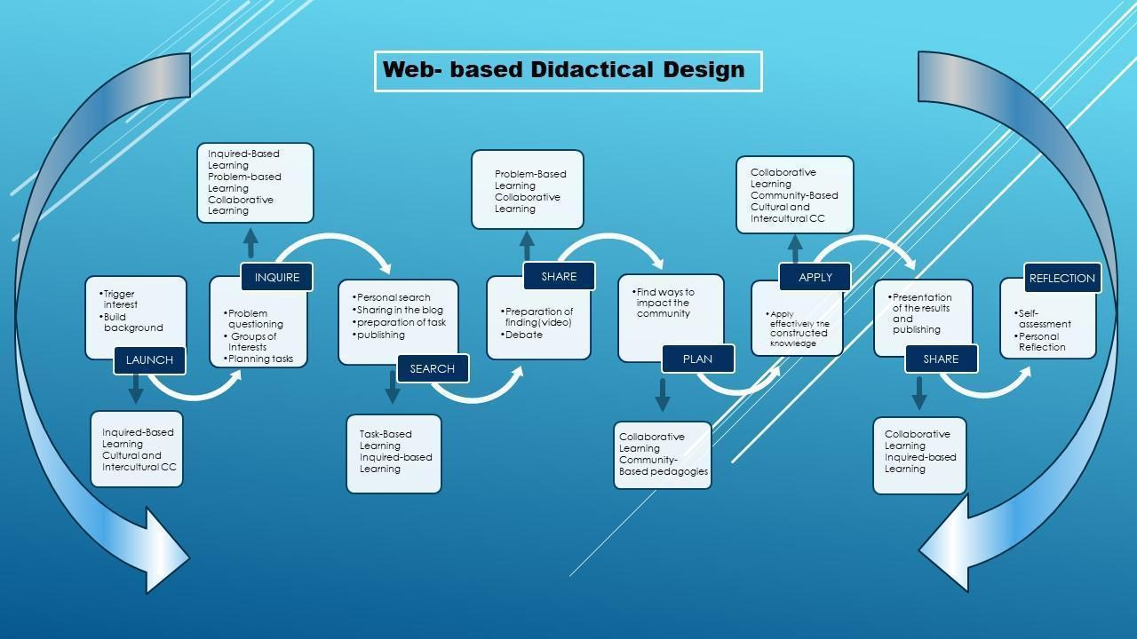

Source: own elaboration

Diplomado Course on Digital Competences for ELT

Before starting the execution of each learning moment described in this chapter, decisions about contents, sequencing, group formation, learning outcomes, and resources depend on the needs analysis results. The needs analysis is based on two questionnaires administered two weeks before the beginning of the 200-hour course. The first questionnaire places teacher learners into the appropriate digital competence level according to the standards of CompudigEdu; the second illustrates the competence they have to integrate digital tools into ELT didactics. These two questionnaires provide input to organize the modules and provide entry and exit data to determine the influence of the WBLDD in teachers' Digital competencies and incorporation of digital tools into ELT didactics.

The 200-hour course on Digital Competence for ELT comprises four modules (see Table 5). The course organization is contained in a public document that describes the objectives of the course, methodological and assessment strategies, and four Course curriculums, one for each of the modules that details pedagogical strategies for each learning unit. The first module is called "Introduction and Preparation for the Course'' This learning unit plans to instruct teachers on using MOODLE-LMS, guide them on the construction of their sites, and provide an overview of the course. Module 2 focuses on TDC for developing receptive skills, and Module 3 on TDC for developing productive skills. Finally, module 4 is devoted to the assessment and closing of the course. Appendix G shows a sample curriculum corresponding to module 2. It is essential to mention that these skills are not separate in a CLT scenario. In a natural life setting, skills and subskills are integrated. This separation is done for teacher-learners to differentiate the digital tools they may use when using specific language skills and sub-skills in a learning unit. The idea is that every teacher-learner contributes to feeding the English Teaching Digital Taxonomy Wheel that is introduced at the beginning of the second module (See Figure 20)

**Table 24***.*

*Organization of modules for Course on Digital Competence for ELT*

| Module | Time |
| --- | --- |
| Module 1. Introduction and Preparation for the course | 40 online hours – 20 offline hours |
| Module 2. Teachers’ Digital Competence for the Development of Receptive Skills | 40 online hours – 25 offline hours |
| Module 3. Teachers’ Digital Competence for the Development of Productive Skills | 40 online hours – 25 offline hours |
| Module 4. Assessment and Closing of the course | 10 online hours |

Source: Own elaboration

**Figure 20***.*

*English Teaching Digital Wheel*

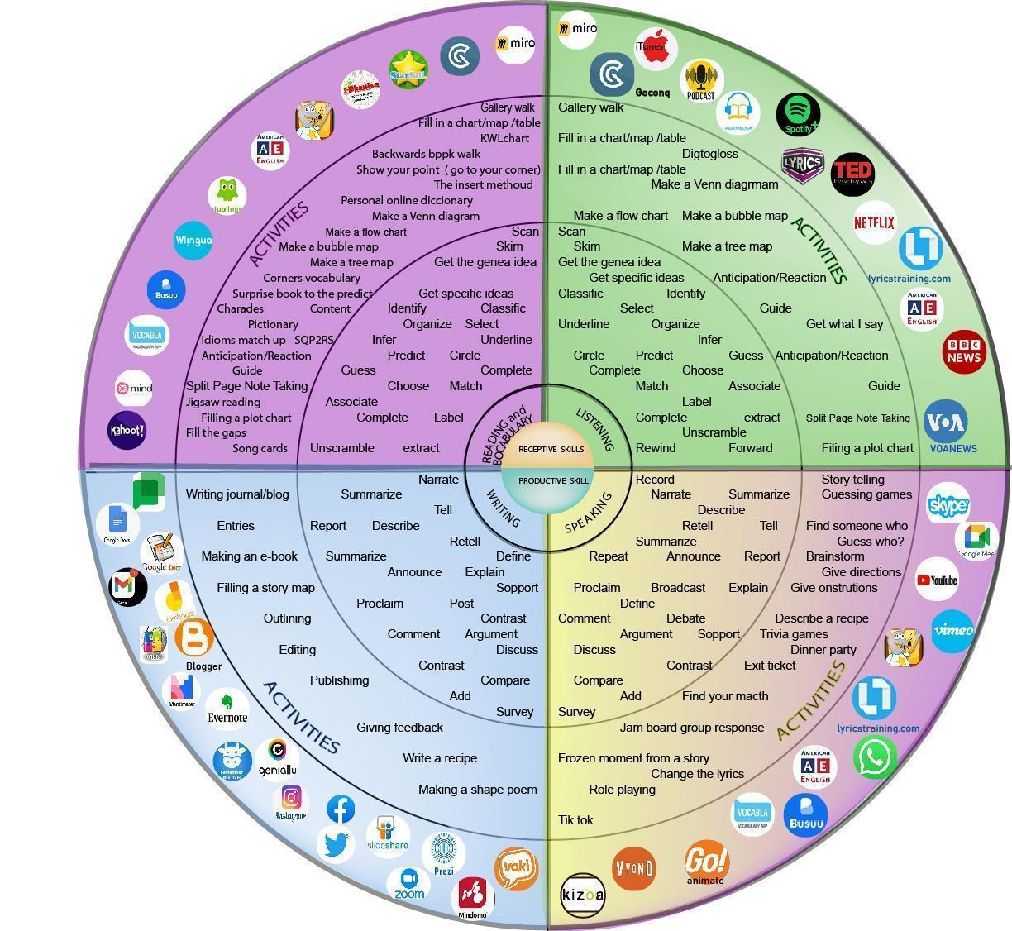

Source: own elaboration

## 3.2 Learning Aims of the Design

The WBLDD intends to:

* Develop teachers’ digital competence (TDC) by incorporating ICT tools into ELT through a process of substitution, augmentation, modification, and redefinition of technology.
* Train language teachers on the adaptation of ELT didactics to technology-mediated environments.
* Foster collaborative and autonomous learning skills by implementing project-based, task-based, and collaborative-based learning strategies.
* Boost teachers’ critical thinking in LT through problem-based and inquiry-based learning strategies.
* Trigger teachers’ capacities of relating constructed knowledge to local contexts via community-based pedagogies strategies.
* Awake teachers’ interest in using web-based learning materials to make students aware and develop cultural and intercultural competence.

## 3.3 Learning sequence

### 3.3.1 Launch (online).

Learning is a Happening in the way Deleuze defines it in one of his axioms: *The event is of a different regime than the actions and passions of the body, even if it results from them*.’ (Badiou, 2007, p. 38).

In this way, an event is different from what happens every day, something out of the ordinary and familiar: a sunset that makes us turn our eyes to the Sun, a movie plot that occupies our minds after the function ends.

The Launch must be an activity that affects students’ minds and senses from the first moment of the teaching act. This stage demands the teacher be tuned with students' interests, likes, and preferences and find creative ways of connecting all this with the contents, the aims, and other curriculum components. To teach a lesson about past habits, the teacher may use photos from his albums to tell the class what he used to do when he was a child or prepare a PowerPoint presentation with real pictures of activities he usually does in a day.

Besides triggering interest, the teacher builds background for the new learning in this first stage. It means helping students connect what they already know with what they will learn. Vogt and Echeverria (2006) explicitly mention three forms of building background. The first links concepts to students’ experiences (family, neighborhood, community in general), the second links past learning to new concepts, and the third emphasizes key vocabulary (write, repeat, highlight). The class about past habits may continue with students trying to say similar sentences like the ones introduced by the teacher to tell the class what they used to do when younger or when they lived in a different town or neighborhood. The teacher needs to highlight new expressions and new vocabulary so that students grasp their meaning to be used later in the lesson.

To introduce sitcoms or TV Series sites to develop listening skills and critical thinking, the teacher of the training Course may model a lesson/unit plan (See Appendix H) or part of a lesson plan using the chapter of Homer’s Phobia (Groening et al., 1997), build background by asking questions like: Do you know who the Simpsons are? Have you seen the Simpsons? Have you used the Simpsons in your classes?

## 

## 3.4 Inquire (online)

Cuando creíamos que teníamos todas las respuestas, de pronto cambiaron todas las preguntas

Mario Benedetti

In the traditional school, questions are part of a test, are a strategy to confirm students’ learning, and are a kind of control over the knowledge that the teacher owns. Questions are part of a dialectical thought that seeks truths. These “truths” are in the books or are part of the teacher’s speech. For Deleuze (2005), knowledge does not exist but is continuously constructed through questions. As shown in the figure, when the installed knowledge or believed truth is quizzed by problem questions, it is possible to make the Happening emerge. In that way, the Happening is that idea, that proposal of a different thought that allows us to see what we did not see or what we deny to see; that is, thinking what was unthinkable. In this regard, Velásquez (1993) concludes:

Al guiar el pensamiento a través de preguntas se ingresa en otra zona que no es la de la búsqueda de soluciones sino en un espacio de investigación, de experimentación. Se facilita la producción de un trabajo creativo en cualquier espacio de la vida social (p.35)

In this way, “Inquire” is the moment in the learning trajectory when the teacher learners pose questions provoked by the event in the “Launch” They are guided to write a list of questions and transform them into problem questions through the guide of the Logic of Sense. These questions must include a proposal and the “What if…” type or “What could happen if.” After experiencing the demonstration of a lesson using the Simpsons, teacher-students may ask: What type of TV series could I use with my students? What other visual materials or resources from the English Teaching Digital Taxonomy Wheel may I use? What if I use a movie trailer to introduce the lesson about past tenses? In the Sample Unit Plan (see Appendix H), students see the episode of Homer’s Phobia, and they are guided to ask questions about American Civil War history, Sexual differences’ rights, famous people mentioned in the episode: Jackie O’, Lupe Mendez, etc., music in the episode. After writing the list of questions, students post them on individual boards using Google Jamboard, PLEs or blogs, or any other interactive board. Students visit each other’s boards to read the questions. In language learning, this is an appropriate moment for students to provide corrective feedback about grammar or vocabulary used by classmates. Once students read the questions, they make interest groups according to the categories previously given by the course teacher. Inside each team, teacher-students reread the questions; they filter them to select the most interesting and avoid repeating ideas with the same sense. Once they agree on selected questions, they plan to search by assigning groups of inquiries with the same topic to one or two people. The course teacher needs to provide students with a checklist of a rubric that sheds light on aspects to assess the quality of the searched information, for instance: “There were used trustful and reliable sources”, “The information presented is clear and contributes to elucidate the problem in the question(s),” “A list of references is shown at the end of each presentation, and copyrights are taken into account.”

## 3.5 Search (offline)

After defining the individual tasks, each team member does an individual search. Students may need a teacher’s guidance on this concern by training them to do trustful and reliable quests using well-known web browsers like Google or Bing, or Yahoo, or more academic sites like Google Scholar, Web of Science, Springer, or any other databases. Once students refine the searches and have the information ready, they publish it in their PLEs and alert the team members to start the virtual visits. Students may include comments about the posted information, and they may also suggest corrective feedback for language use. Every student needs to visit the PLEs and write a summary of the main ideas contributing to elucidating the problem in the questions.

Students hold an online meeting to plan the presentation of findings to each question. They may prepare a short video presentation of a guided tutorial for the whole class. In the case of teacher-students who asked about the application of resources from the English Teaching Digital Taxonomy, they may present, for example, a tutorial to illustrate what “Tik Tok” is, the tools it has to edit videos, and make suggestions on its use to develop a sub-skill of skills. In the case of the sample lesson about the Simpsons, students create video material to present facts about the American Civil Wars, the profile of famous people mentioned in the episode, or laws for sexual rights.

## 3.6 Share 1 (online)

In an online session, teams present their findings to the whole group. Each team must remember the problem questions to make connections with the new information. After each presentation, the group has time to clarify possible doubts or debates based on the relation problem questions and information searched. When all the teams present the information, students self-assess and assess each other to decide if the information is clear enough to give hints about the problems. A rubric with assessment criteria is afforded before the Search for students to make informed decisions (See Appendix I). If the class decides that the team needs to repeat the search, the team is given time to accomplish the aim of the activity. If necessary, team tutorials with the course teacher are programmed. In the case of the lesson plan about the Simpsons, students may see the episode again.

## 3.7 Plan (online)

Students gathered again to find concrete strategies to impact the community or to put into practice the constructed learning. The course teacher affords a guide for students to organize the planning with the following information: problem-question(s), description of the context and population, objectives, tasks, resources, expected results, and achieved results (see Appendix J- Guide For Planning)

In the case of the teachers’ training course, student teachers may plan to incorporate digital tools into the development of language skills and subskills.

## 3.8 Apply (offline)

Teams work to execute the plan with the constant support and assistance of the course teacher. Students need to collect evidence of each one of the steps in the plan to consolidate the data for the final oral report. Teams may hold video conferences with the course teacher to receive feedback and recommendations whenever required.

Once the implementation is done, look for a creative way to present the results to the class. The course teacher needs to inform the time each team has for the presentation and the assessment criteria.

## 3.9 Share 2 (online)

The course teacher may put on a school event, like a project fair, to present the results of the learning projects. Teams take turns to present the results of their application. In the end, there should be time for questions, comments, and debate with the participation of the community and guest experts in the themes. Feedback is provided based on the rubric for presentations in the sharing moments (Appendix I). In the case of the Diplomado Course, the videos that evidence the implementation are assessed through the rubric in Appendix K.

## 3.10 Reflect (offline-online)

Students self-reflect on their participation and collaboration in each learning moment based on a checklist or rubric (See Appendix D). They may write a reflection paper that can be taken as a learning outcome of the unit/module/course. This is another chance to provide corrective feedback about writing abilities.

In an online session, students assess the development of the learning trajectory and may share their reflections. They also answer an assessment survey of the didactic design and suggest improvements.

**Founding Theories**

This section defines the theories that support each stage in the learning sequence. A theory or an approach may appear as a foundation of one or more stages in the form of an activity, a strategy, a technique, or a tactic.

### 3.11.1 Constructivism.

In the history of pedagogy, Constructivism is recognized as the theory that marked a shift from the behavioral perspective, which assumes that learners are empty vessels that need to be filled with the knowledge that teachers and books own, to a learner-centered conception where knowledge does not exist, but is constructed through active interaction with the environment involving senses to gain experience (Suhendi, 2018). This idea of learning is rooted in Piaget’s and Vygotsky’s theory. Piaget introduced the idea that learning happens when individuals interact with their real-world gaining experiences as new knowledge fits their cognitive capacities. In his Cultural Historical Activity Theory (CHAT Theory), Vygotsky believes in a more social-focused process where learning results from the active interaction of individuals with their community and culture (Rosa and Montero, 1990). Altogether, in language learning, for example, teachers need to consider the mental capacities of the learners, their interests and likes, and expose them to meaningful learning settings. To develop oral skills and acquire food-related vocabulary, the teachers changed the classroom into a restaurant where students order meals from a menu and interact using realia. In developing the WBLDD, authentic learning in meaningful contexts is prioritized. Teachers appropriate the technological or pedagogical knowledge and decide what to learn depending on their needs. More importantly than the final product, the awareness of the learning process through personal reflection is emphasized. Learning occurs by applying the constructed knowledge to solve didactic language acquisition problems in their classrooms.

## 3.12 Web-based Learning

Zheng (2008) defines Web-based learning as “the type of learning that uses the internet as an instructional delivery tool to carry out various learning activities” (p. 752) WBL may be pure online learning, which has no face-to-face mediation between teachers and students, or hybrid, in which the instructors meet students half of the time online and half of the time in the classroom. In this case, the WBL Didactic Design is pure online learning with online gathering activities and offline individual and group tasks. Kalaian (2017) says that WBL is “an innovative student-centered instructional method for teaching/learning of the digital course content delivered in the distance via the internet and mediated by computer communications and web-based technologies.” (p. 23). This author mentions that WBL is also referred to as e-learning, Cyberlearning or online learning

Some of the advantages of WBL that this author mentions and that are relevant to the current WBDD are:

* Students’ development of self-regulated learning strategies and development of collaborative skills since they have the chance to do synchronous and asynchronous activities that fit personal learning differences or physical disabilities.
* Development of interpersonal and communication skills with classmates from different locations using video conferencing, emails, wikis, blogs, online chat rooms, and discussion boards.
* Development of lifelong learning skills like problem-solving, critical thinking, metacognitive, logical and reflective, and high-order thinking skills.
* Opportunities to access the online course resources at any time and from any place with internet connection availability.
* Opportunities for own and social construction knowledge based on previously learned knowledge and experiences
* Development of digital skills through the Internet, LMS tools, and Computer-mediated communications.
* Ability to search, refine, and classify reading materials from the World Wide Web and digital libraries.
* Opportunities to develop oral skills using debate/comment/discuss controversial issues in online settings that reduce anxiety and personality traits that affect class participation.
* Development of writing skills due to frequent interactions and communication through emails, interactive boards, and drive-shared documents.

There are also several disadvantages of WBL that Kalaian (2017) sorts out and are necessary to tackle as much as possible. Lai and Hashim (2021) prefer to call these issues challenges and summarize them into three categories: technical challenges, attitudes and beliefs, and performance expectancy and effort expectancy. Among the technical issues, it is crucial to consider the lack of TDC and access to computers and the Internet. These are issues that may be out of the researcher’s hands. That is why participants are asked to accomplish technical conditions like having connectivity and appropriate equipment as a requirement to get enrolled in the course.

Regarding initial TDC competence, the participants are grouped in the course cohort based on the result of the starting TDC test. From the challenges dealing with beliefs and attitudes, the planning of the learning sequence considers teachers’ needs in terms of time availability, classroom needs, and practical application of technological, pedagogical, and content knowledge. Performance and effort expectancy challenges are tackled by grading the level of difficulty of the tasks depending on the level of DC the teachers have. The course is planned on real and concrete learning tasks with corresponding output at the end of each module. Teachers are provided with constant technological and pedagogical tutoring to solve the problems they may encounter throughout the development of the course.

## 3.13 Inquiry-based learning

Inquiry-based Learning (IBL) is often associated with Problem-based Learning or Discovery Learning (Oguz et al., 2018). It may be defined as an educational strategy mainly used in science to guide students to discover learning through constant questioning and formulation of hypotheses tested by conducting experiments or making observations (Pedaste et al., 2015). Three types of inquiries exist Open vs. Closed Inquiries, Discovery-Focused vs. Information-Focused Inquiries, and Individual vs. Team Inquiries.

In an open inquiry, students identify the problem and the ways to solve it, while in a closed inquiry, the teacher introduces the problem and establishes the route to be solved. In a discovery-focused inquiry, the aim is to create innovation by designing something original, like a product or academic knowledge; in an information-focused inquiry, the objective is to explore and acquire existing knowledge, for instance, a literature review. Finally, an IBL could be used for individual inquiry or as team-based learning.

In inquiring, formulating the questions plays a fundamental role in the learning sequence. Camacho (2017) carried out a research study to improve the construction of research questions by linking Inquiry as Orientation for Learning with the Logic of Sense (Deleuze, 2005). As a result, he came up with a question-formulation design that conceives three moments: the Series of Ideas, the Series of Questions, and the Series of Happenings.

**Figure 21.**

*The Problem for the Logic of Sense*

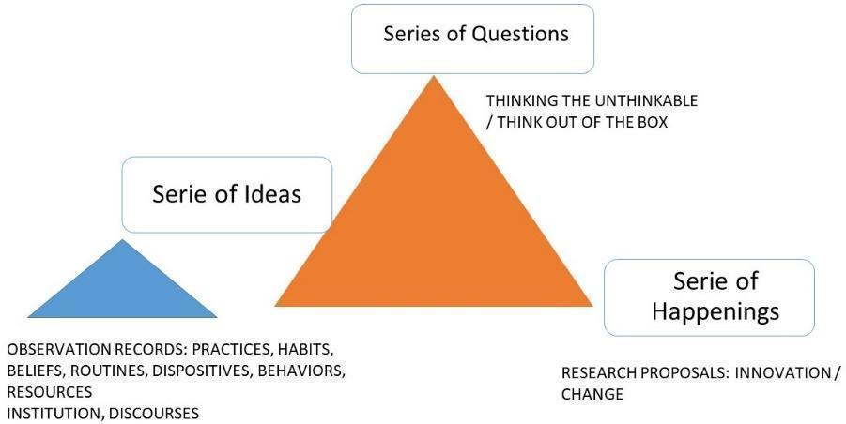

Source: own elaboration based on Deleuze (2005)

In the Series of Ideas, students are led to create awareness about the state of mind or collective ideas people usually have about an issue or problem. For example, TikTok is a social network used basically for entertainment. In the Series of Questions, students are encouraged to formulate questions that hesitate/doubt/suspect about the installed concepts in the Series of Ideas: What If TikTok is used for other purposes different from entertainment? What could happen if TikTok were used for English learning? The Series of Happening concrete what is formulated in the question by describing an innovative proposal: Teach Tok, a video-based social network for English learning.

In the WBLDD, IBL is put into practice in the " Inquire " steps and “Plan ”In “inquire,” students formulate problem questions based on the experience lived in the “Launch” step. In this way, open inquiry is used primarily; but it does not mean that the teacher appeals to close inquiry at the beginning while students get expertise. Discovery-focused is used to lead students to formulate innovative proposals that conceive the incorporation of ICTs into classroom didactics. Individual inquiry is fostered before the team-based inquiry, allowing students to process and approach Knowledge from intra-psychological to inter-psychological process. In the “Plan,” students think about the possibilities of linking the constructed Knowledge or acquired skills to the classroom by asking problem questions that formulate innovative proposals. Deleuze’s idea of a problem is very different from common sense. A problem is not related to a solution but to the questions. Solutions make the problem disappear, and what is intended in the Logic of Sense is to keep the problem alive to produce more questions that become “Happenings,” which are not ordinary things that happen every day but new insights, new dispositions of mind, innovative proposal introduce change by thinking the unthinkable.

## 3.14 Problem-based learning

It is significantly related to inquiry-based Learning; the difference is that in IBL, the problem can be given to students (Close inquiry), or students may make it up independently (open inquiry). In contrast, in PBL, the problem is close-inquiry type. The teacher gives the problem, and students search for information and get back to the problem to solve it (Leal y León 2017, cited by Arías Masa, J. *et al.*, 2019)

To accomplish the objectives of the WBLDD, it is worth noting the following features of PBL (Luengo Caballero, 2014, cited by Arías Masa, J. *et al.*, 2019): it is a student-centered methodology, problems are realistic and are the core component of instruction, students work collaboratively in small groups what implies commitment and autonomous Learning, the teacher becomes a facilitator of knowledge construction, students develop critical thinking, problem management skills, and self-directed learning skills; finally, PBL can be used to teach any subject area. Some experiences incorporated PBL into technology, what is called ePBL. Arias and Martin (2015, cited by Arías Masa, 2019) combined PBL with synchronous virtual classrooms (SVC) in higher education. The authors remark that the most meaningful fact in the experience is not the technology used but the methodology to develop it. This methodology is proposed in three basic actions: teaching planning, teacher management, and technical management tools. Among these tools, the authors mention: audio communication tools, direct instant messaging, user profile configuration, which can coexist in the virtual room, presence control, interactive whiteboard, monitoring and evaluation tools, and shared and remote desktops.

Regarding ELT, Othman & Shah (2013) investigated the effects of the PBL approach on students’ language classes in course content and language development. They found benefits of PBL in the latter aspect, specifically in writing composition. Their manuscripts were richer concerning the group that did not intervene in terms of support and arguments.

Ansarian & Teoh (2018) assert that there have been many failed attempts to incorporate PBL into ELT. Implementing PBL in language classes is notably different from implementing it in other disciplines since, in an English classroom, language is both the means and the target of instruction. Teachers must be aware of students’ content learning and language development simultaneously. This fact makes it necessary to design PBL models that fulfill these specific characteristics of the language classroom in terms of the particularities of students’ cultures and backgrounds.

They formulate a PBL model for language learning based on the models of Savery and Duffy (1995, cited by Ansarian & Teoh, 2018), Hmelo-silver (2004, cited by Ansarian & Teoh, 2018), and 3C3R (Hung, 2006, cited by Ansarian & Teoh, 2018) Savery and Duffy propose a model that focuses on the formulation of authentic problems that are relevant to students’ life. This model seems practical, but it requires a deeper look at how each step is delivered; besides, it does not consider how students’ culture and mother tongue may affect the acquisition process. Hmelo-silver proposes a model around the belief that students learn collaboratively in small groups. Although it presents clear learning stages in the Application of PBL, it still fails at fulfilling the conditions of culture that a PBL design for ELT demands. The 3C3R model optimizes PBL components for problem presentation. This model comprises two main components with their specific steps. The core component comprises content, context, and connection, and the support component includes researching, Reasoning, and reflecting.

The Problem-Based Language Learning model describes a cyclical process made of nine steps. The first step is the creation of the problem. In this step, the teacher has to define the relation of the problem with the content, culture, and context of students; besides, it is crucial that the challenge, within the problem question, be appropriate to motivate students toward its solution. In the second step, students expose the problem to the group by using a strategy adjusted to their language level. In the third step, students research information about the problem by using different resources. After this, students process the collected information through conversations or discussions to decide which information is relevant to be included in the answer to the question. This step is called Reasoning. The fifth step is synthesis. Students solve the problem. The Application is in the production stage, where students use the new language learned in the previous steps to resolve a task through a conversation or a role play. In this stage, students receive feedback. If the Application is approved without any amendment, students skip the seventh step, Reapplication. In the eighth step, students self-reflect on their performance during the cycle to end with the final step called Knowledge.

From these steps of the Problem-Based Language Learning model, the Web-Based Learning Model shares the idea of Knowledge as a problem and as a collective construction through teamwork; however, the teacher or students do not create problems, but they are the result of an initial activity that triggers interests and provoke the formulation of questions. On the other hand, problems are not inherent to a practical solution. Instead, they are ways of conceiving new dispositions of thinking and conceiving already established Knowledge. The WBL Model understands that students need to process it individually before going to a collective work to discuss the information searched. Reflection is also a common final step in both models. Students self-evaluate their performance, and in the case of the WBL model, they also evaluate the different moments in the learning trajectory.

**Figure 22***.*

*Problem-based Language Learning Model*

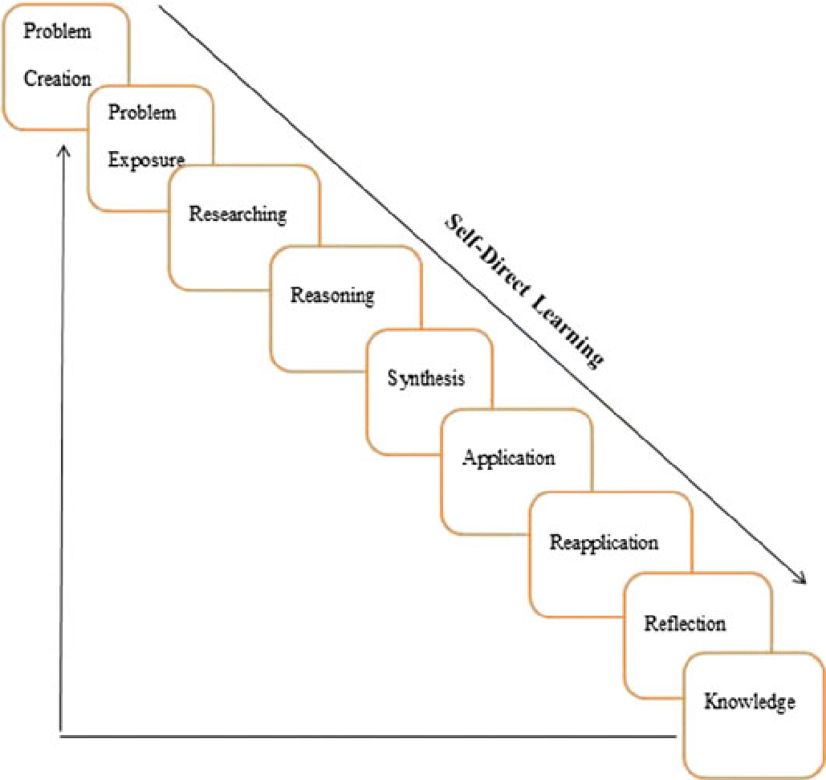

Source: Ansarian and Teoh (2018)

## 3.15 Collaborative learning

As with any other theoretical foundation analyzed in this section, CL results from knowledge construction through research from different human disciplines, especially psychology, sociology, and motivational theories. Moreover, collaboration is one of the XXI Century competencies, and “Personal, Social and Learning to Learn” is one of the lifelong learning competencies. According to the European Commission (2019), developing these competencies implies skills like “the ability to learn and work both collaboratively and autonomously and to organize and persevere with one’s learning, evaluate and share it, seek support when appropriate and effectively manage one’s career and social interactions” (p.13). It also includes the development of attitudes like respecting the diversity of others, showing tolerance, expressing and understanding different points of view, and creating confidence and empathy.

As can be seen, CL is more than a theory or a classroom strategy or activity, it has a lot to do with enhancing the human dimension. Collaborative Learning is frequently used instinctively to refer to Cooperative Learning or Peer collaboration Learning. Smith and MacGregor (1992, cited by Cross et al., 2014) provide the following definition:

Collaborative Learning is an umbrella term for various educational approaches involving a joint intellectual effort by students or students and teachers together. In most collaborative learning situations, students are working in groups of two or more, mutually searching for understanding, solutions, or meanings or creating a product. (p.10)

Bruffee (1995, cited by Cross et al., 2014) makes some distinctions between cooperative Learning and Collaborative Learning based on their aims. The goal of cooperative Learning is “to work together in harmony and mutual support to find the solution,” while CL seeks “to develop autonomous, articulate, thinking people, even if at times such a goal encourages dissent and competition that seems to undercut the ideals of cooperative learning” (p.6)

The invention of the Internet has also broadened the limits of that collaboration beyond the four classroom walls. Talking about “collaboration” in an e-learning environment means unlimited approaches to people worldwide, what is called “Online Collaborative Learning” (OCL). Cross et al. (2014) distinguish three features of OCL. The first one is intentional design. Using technology for CL demands planning. It requires educators to know and manage the interaction tools of platforms like Google Meet or Cisco Webex. Adapting an onsite jigsaw reading activity to online conditions is possible. However, teachers need to know how to create groups, switch members of teams or jump from group to group to provide feedback. The second feature is the co-laboring of individuals. It means that in OCL, more than onsite Learning, students and teachers need to be committed to the learning process by contributing somewhat to group processes and products. There is no eye contact or body language to encourage participation as in the classroom; the teacher may use emoticons or call random participation to ensure involvement in the team activities. The third feature is Meaningful Learning. It has to do with students’ authority and control over their Learning. In emergent Learning, teachers do not have much control over students’ participation, which demands some flexibility and trust.

On the other hand, Collaborative Online International Learning (COIL) happens when two or more learning communities in different regions of the world get in touch to develop common projects. King de Ramirez (2021) conducted a study between students from the Arizona-Sonora Megaregion that intended to explore the use of COIL to remedy a general lack of knowledge and communication within 70 miles of the United States–Mexico Border. The professors of second language courses from two universities on the border of the two countries paired students to share mutual interests and multiple perspectives of the borderlands.

In the proposed didactic design, CL plays a fundamental role in constructing knowledge from tacit to explicit and its final Application. After making the interest groups based on the formulated questions, students search for information individually and publish the result in their PLE. The group members visit each other’s PLE before the Share moment, where students work collaboratively to discuss the findings and prepare the team presentation for the whole group. That way, knowledge is approached individually, in teams, and then in the whole group. Feedback is given in the last two moments, and students are given a chance to make adjustments. Online team and group discussions are done by subdividing students using a video conference platform that allows it. In the LMS, there is a space for “Guest Speakers” where foreign lecturers and learners are invited to share their experiences in using technology for ELT.

## 3.16 Task-based learning

From a Communicative Language Teaching (CLT) perspective, acquiring a language goes beyond understanding grammar or memorizing vocabulary. The primary purpose is to use the language for effective communication in natural settings. Grammar and vocabulary are sub-skills underneath the main transactional aim of managing skills. One of the well-known methodologies for CLT is Task-Based Learning and Teaching (TBLT), whose main idea is to learn through real-life activities or “learn by doing” (Laurillard 2002: 67, Ellis 2003, Willis y Willis 2009, cited by Blake, 2018). Long et al. (2019) define TBLT as

the use of a syllabus whose content is a series, not of linguistic forms, but of pedagogic tasks sequenced in terms of increasing tasks, not linguistic, complexity, and lessons whose primary focus is communicative use of the L2 to complete those tasks. (p.501)

Rod Ellis (2003, cited by Thomas & Reinderst, 2010) suggests six criteria features for TBLT: tasks contain a plan students need to follow, activities are focused on making meaning, they engage students in real-world, authentic language use, they are focused on language skills, students make use of cognitive skills to solve the tasks, tasks have a communication-based learning outcome. By the same token, Ellis (2009) says that to be considered a task, an activity must meet these criteria: focus on meaning, have a gap that students need to fulfill to accomplish the task, students need to rely on linguistic and non-linguistic sources the need to use, and have an outcome or a product to show as evidence of task achievement.

From a macro perspective, implementing TBLT (Long, 2015) starts with a needs analysis that provides input for teachers to design a syllabus that targets students’ interests, likes, and necessities. With this syllabus design, teachers must develop task-based materials and plan a methodology to implement the tasks. Finally, the learning process is assessed in two ways. One is through the exit tasks according to the proposed learning outcome (in the case of ELT, it could be the progress students reach in language skills or subskill) and the course evaluation from a macro perspective.

From a micro level, a typical TBLT lesson plan should distinguish at least three moments: pre-task activities, task activities, and post-task activities. Santos (2007) presents a TBLT Lesson plan for “A Day at the Fair” After reading a text called “State and County Fairs,” students are challenged to practice their speaking skills. Students make groups of 6 to pretend they are an American family that plans to spend a day at the county fair. Each team is given role cards for each family member with an individual interest in the visit. For example, the older brother, aged 16, wants to see the demolition derby at the race track, while the younger brother, aged 10, wants to see the farm equipment display at the exhibition hall. Students are asked to report a schedule to visit the different fair stands and activities. In the pre-task activities, the teacher activates students’ interests and prepares them for the task through an activity that involves the five senses: Students make a list of things they can smell, see, taste, hear, and touch in a fair. In the task, students use the role cards to perform a role-play activity where they assume the given role to organize a schedule to visit the fair and the corresponding oral report to the class. In the post-task, students are given a set of questions to reflect upon their performance in the lesson. Finally, a list of extension activities is provided in the lesson plan.

We can refer to integrating TBLT into online learning conditions as a challenge. Doing a face-to-face task like the one of “A Day at the Fair” in online conditions implies adapting the activity to technological conditions without losing the essence and communicative purposes. Baralt and Morcillo (2017) attempt to make this adaptation using Willis’s (1996, 2012, cited by Baralt & Morcillo, 2017) original framework for doing TBTL online via video-based interaction. The authors introduced video-based online meetings in the task cycle report stage and the language focus analysis. The other sections of the lesson are done individually by the learners. In the case of the lesson plan about “A Day in the Fair,” the pre-test stage can be done online. The teacher may take advantage of computer-based connections to use suggestopedia elements. The teacher may ask students to close their eyes and imagine they are visiting a fair with authentic sounds in the background. For the task stage, it may be done online, as well, if it is used as a video conference platform that allows group subdivision. Another option is to use separate WhatsApp video chat rooms for each group. The sharing of the tasks may be done using video recordings previously edited to report each team's outcome.

For teachers’ training in using ICTs for ELT, activities in the learning trajectory arise in the form of tasks. The first task comes from the construction of the question and the creation of interest groups. Students look for information to answer the set question(s) to share this knowledge with the class. The second task is the Application of constructed knowledge in the community, which demands thinking a “how,” planning the execution, collecting the evidence, and sharing the experience with the class again. As most of the Application of digital tools for English teaching is related to its incorporation to enhance the development of language skills and subskills, TBLT is mainly applied in lesson planning that describes the preparation and build background activities in the pre-task stage, Application of technology in the development of the task and final reflection of students about the use of the tool and self-evaluation performance in the post-task stage.

## 

## 3.17 Cultural and Intercultural Communicative Competence

Being a proficient second or foreign language speaker is not only being language competent but also communicative and intercultural competent.

Balboni (2006) defines *language competence* as generating validation or falsifying correctness. He refers to those grammar rules that make a statement to be accepted—for example, the order of words in a sentence. Communicative competence is at a higher level because it does not only include language competence but also sociolinguistic (social factors that influence language use), pragmalinguistics (strategies for realizing speech intentions and the linguistic items used to express these intentions), and extralinguistic grammar (non-verbal signs and clues), what allows comprehension, production and interaction in the target language. Intercultural communicative competence deals with managing at least two communicative competencies in two languages and cultures to allow interaction between the two.

For Byram et al. (2002), developing intercultural competence in language teaching

involves recognizing that the aims are to give learners intercultural competence as well as linguistic competence, to prepare them for interaction with people of other cultures, to enable them to understand and accept people from other cultures as individuals with other distinctive perspectives, values, and behaviors; and to help them to see that such interaction is an enriching experience. (p.10)

Deardorff (2002) proposes a model for developing intercultural competence based on five elements: Attitudes that she summarizes into respect, openness, and curiosity; knowledge that is cultural self-awareness, culture-specific knowledge, deep cultural knowledge, and sociolinguistic awareness; skills like observing, listening, evaluating, interpreting and relating, which are required for processing knowledge; internal outcomes understood like the attitudes, knowledge, and skills transformed into flexibility, adaptability, and empathy; and external outcomes, which are the behavior and communication skills that are the product of a person’s attitudes, knowledge, skills and internal outcomes.

How do students develop intercultural cultural and intercultural competence in a foreign language environment? The answer seems obvious: by exposing students to native, native-like speakers or speakers of English from other languages either personally or through mediated technology. In the proposed WBLDD, the cultural and intercultural development is a transversal component that is evident in the “launch” experience by the use of authentic multimedia materials and in the “search” where students approach written and audio resources; besides the LMS platform contains a “Guest Speaker” section and links to online dictionaries. In the sample lesson about the Simpsons, the “launch” presents multiple manners of approaching students the American Culture; for example, the reference to the American Civil Wars, famous people in the American culture, like Jackie O’ and Lupe Méndez, American Festivals and traditions, and music among others. These types of series, movie trailers, new podcasts, YouTube, and TED Talk videos are options teachers have to involve students in natural target language environments and develop cultural and intercultural communicative competence.

## 3.18 Community-Based Pedagogies (CBP)

Linking classroom knowledge to communities is something that has been introduced previously. Freire (2005), Giroux (1992), and Kumaravadivelu (2003) made sense of pedagogy by developing critical thinking in students about their home communities. Freire proposes a problem-posing education where humans perceive the world critically as a reality of transformation. Giroux claims a border pedagogy that equips students with the disposition to think of their communities beyond the limits of reigning discourses through multiple narratives in the form of critical reading and denouncing writing practices. Kumaravadivelu criticizes traditional classroom English Teaching methods by proposing a post-method pedagogy founded on three parameters: particularity, practicality, and possibility. The first parameter posits that any language pedagogy must be sensitive to a specific sociocultural context; the second involves a teacher-generated theory of practice, and the third pursues identity formation and social transformation through continual participants’ quest.

Committed to the purposes mentioned above, a CBP teacher is a social activist who can involve the knowledge, beliefs, constructs, and perceptions of local communities in the teaching practice (Lastra et al., 2018) and enacts those knowledge traditions to make meaningful connections with children and their families (Murrell, 2001, Cited by Clavijo et al., 2016). Developing CBP projects implies that teachers become sensitive to the community where they work, being able to transform the posed curricula into a meaningful curriculum by knowing and integrating the socio-cultural and economic realities of his/her students.

There are many experiences on how social, cultural, and economic problems in a community inspire to propose and carry out CBP projects that promote language learning through social interventions. Clavijo and Ramírez (2019) compiled pedagogical practices conducted by teacher researchers from Universidad Distrital Francisco José de Caldas in Bogotá, who were guided by these two authors in the Master in Applied Linguistics. In the published works, it is evident how teachers start mapping the community by walking around and taking pictures; then, they describe the context with this photographic evidence and write a reflection. From this last activity, teachers establish a link between the mapping results and the curriculum to design a lesson plan, a unit plan, or a project that targets both objectives: promote language learning and impact the community (students, parents, and community members in general). As can be noticed, this methodology has commonalities with the Logic of Sense proposed by Deleuze (2005). Mapping the community involves being aware of ideas, feelings, beliefs, or people in a social group, expressed through discourses (oral speeches, written concepts in graffiti, publicity ads, etc.). Connecting this mapping with concrete classroom strategies by inside reflections involves questioning that observed reality and proposing an event that impacts the community. In CBP, the role of the questions is not explicit. Adding the formulation of problem questions in the reflection stage can make teachers aware of innovative proposals.

CBP is evidenced in the WBLDD Plan, Application, and Reflection stages. Students are encouraged to think about problem questions that link the acquired content and knowledge with their context. In the sample lesson plan, students may formulate problems for the four areas of intervention the teacher suggests: American Civil Wars, famous people in the episode, music in the episode, and sexual differences. They may pose initial questions like: Why are there wars? How similar and how different are the American Wars from the civil wars Colombia has been through? How can wars determine the future of our nations? Are there wars in our communities/families? Is violence a way of war? How to reduce violence in our homes and schools? Is there music made explicitly for homosexuals? How can music influence people’s identities in our community? How respectful of sexual differences are people in our community? How would it be a Simpsons episode using Colombian culture and famous Colombian people?

Regarding the teachers’ training course, teacher-learners are led to apply the technological content knowledge to solve a language problem, a language learning problem, or even a social problem they encounter in their classrooms or communities. For example, students may lack oral comprehension skills. The teacher may formulate a unit project to use song lyrics to train them on listening for general understanding or detailed information and being aware of the specific area and competence in the DigCompEdu they may potentialize. Although the emphasis could be on understanding, students may also participate in karaoke activities to improve their pronunciation. The teacher may also incorporate different digital resources to tackle problems students may have with reading and writing. Students may make an e-book incorporating multimedia, social networks, and animated tools to narrate family stories and write about their neighborhoods, hometowns, or personal expectations for future careers. The most important thing here is to listen to the students who are the ones who know their communities better and guide them on the formulation of problem questions and the planning of community interventions.

## 3.19 Learning Management System

There are numerous learning and research experiences that involve using MOODLE as a 100% virtual learning environment, support for blended learning classes, or face-to-face courses. In the field of ELT, recent studies report benefits in language acquisition when MOODLE is used as a means of instruction. Acar &Kayaoglu (2020) demonstrate how the LMS is an effective online tool to support blended Learning in EFL classes. Ghouali & Ruiz (2021) revealed that online assessment provided through MOODLE has a substantial upshot on the writing composition of Algerian English as a Foreign Language students. Gluchmanova (2022) demonstrates how integrating MOODLE with other technologies influences the language learning process at the Technical University of Kosic. Among all these studies, Yuksel’s quasi-experimental research design (2022) is concerned with discovering how Moodle-integrated learning environments may affect pre-service teachers’ pedagogical knowledge and performance. Results show that Moodle has a significant influence on the way students build general pedagogical knowledge. The results also highlighted that Moodle effectively prepared students for learning by building general pedagogical knowledge. Those who have had the opportunity to learn independently through this LMS may have experienced how the platform fosters the development of self-regulated learning skills. Facing oneself in a Moodle lesson is having the chance to read the instructions, watch the videos as many times as needed, or maybe focus on aspects of the lesson that are more difficult to understand or internalize.

Learning organization and administration are done through Tu Aula Media, the official MOODLE platform from Universidad del Tolima. The four modules of the Diplomado Course are nested in a general site, whose purpose is to provide students with tutorials, resources, and materials needed to develop the whole course (figure 23). Specifically, this main page contains a dashboard for announcements of the course in general, the course guidelines that include the document that describes the course, and the four microcurriculums in the official formats of Universidad del Tolima. It also provides students with tutorials on managing Moodle, tours around the main page and the modules, and guided instructions to access and set up Microsoft Teams video conferences’ resources. There are also tutorials, graphs, and infographics that illustrate and exemplify the eight moments of the WBLDD. The DigcompEdu Framework is also explained using direct links to the European Commission and UNESCO resources. Finally, students have easy access to the questionnaires, tests, and formats used to assess the didactic design, the LMS platform, the development of TDC, the use of ICT tools in ELT, and the self-assessment forms. A permanent forum is available for any comments or doubts students may have about the development of the course.

**Figure 23.**

*Diplomado Course Moodle Tu Aula Media main site*

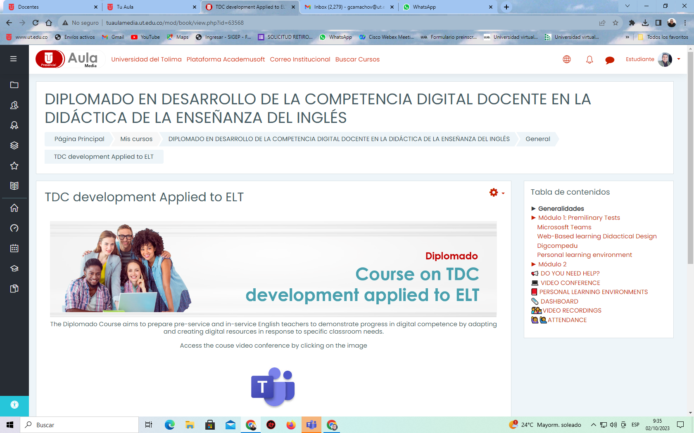

Source: own elaboration of the author using Moodle

The organization of a module is shown in Figure 24. Every module has a dashboard for specific announcements of the course units. There is a direct link to the video conference sessions, the recording of already-held sessions, and the sequence of the learning trajectory in the eight moments of the didactic design (figure 25). By clicking on “Guest Speaker,” students may know the academic profiles of the experts invited to the last activity of the course. Besides, there is a spot for resources and materials of the module, suggested digital tools for developing communicative skills, and a link to upload the assigned tasks in the “share” moments taken as an assessment of the module. In the Digital Tools for ELT part, students find an infographic with direct links to tutorials and websites for each resource (See Figure 26). A permanent chat under the “Do you need help?” is available for students to type any comments or doubts about the module.

**Figure 24.**

*Organization of a module in Diplomado Course Moodle Tu Aula Media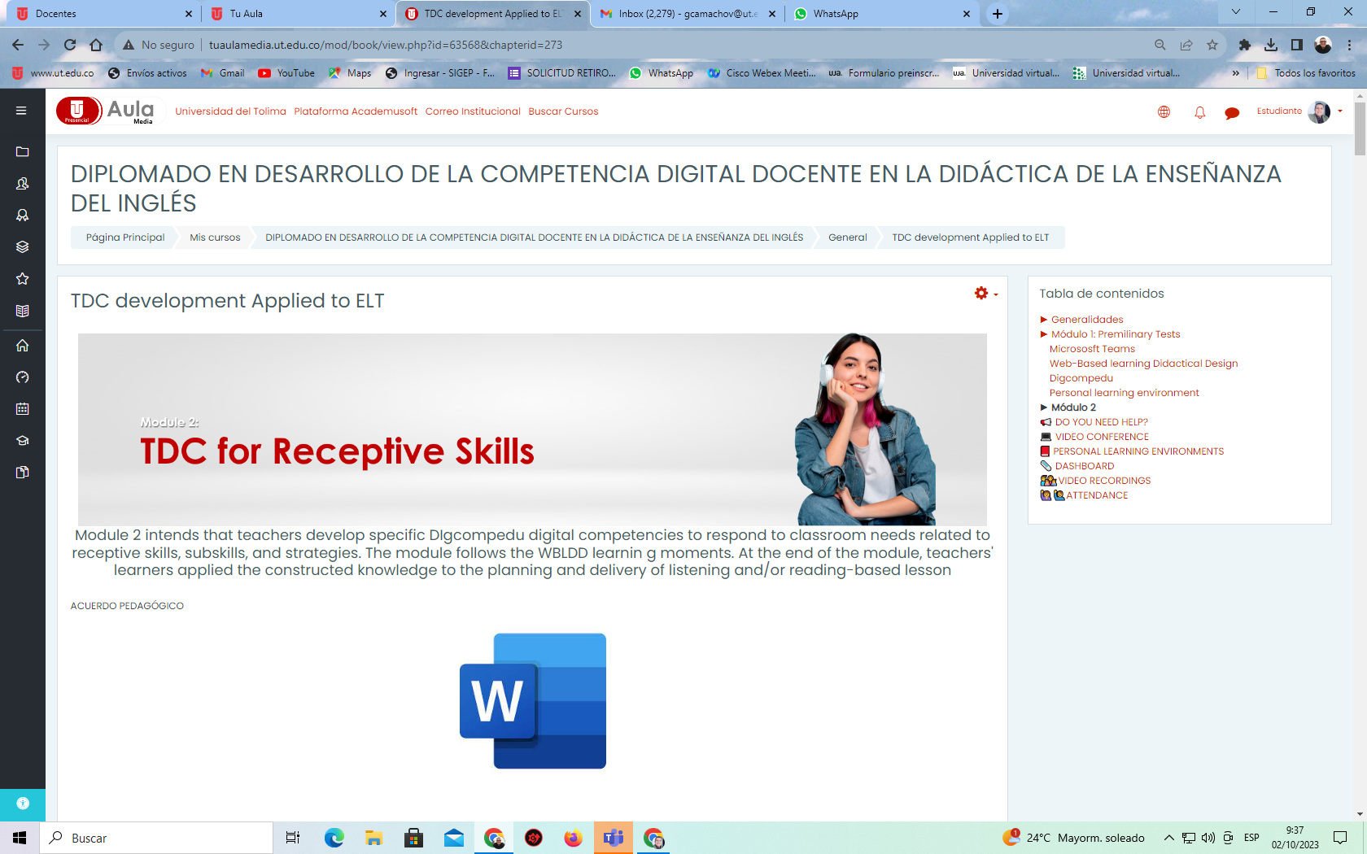*

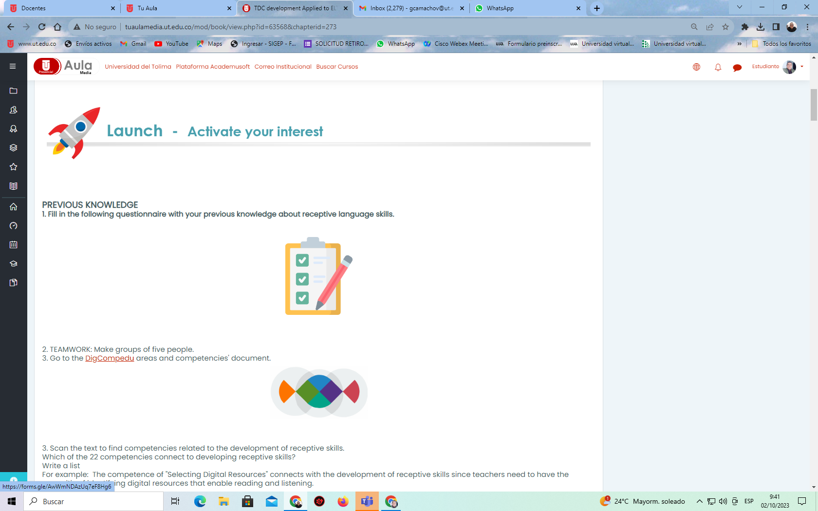

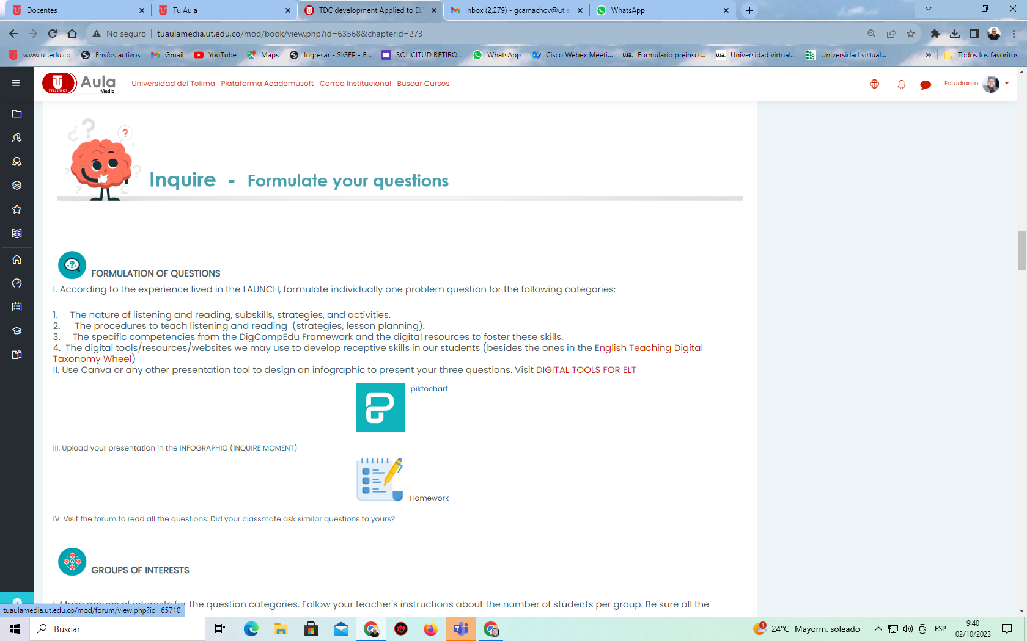

Source: own elaboration of the author using Moodle

**Table 25.**

*Learning trajectory of Module 2*

| Learning moments | Activities | Time |
| --- | --- | --- |
| Launch 1 (online) | Course teacher demonstrates a receptive skills-based lesson that incorporates digital resources/technology and the corresponding competence from the Dig compEdu that is fostered. | 2 hours |
| Inquire 1 (online) | Teacher learners formulate problems questions based on the experience in the “Launch”. Course teacher leads teacher-learners to formulate questions dealing with   1. The nature of listening and reading, subskills, strategies, and activities. 2. The procedures to teach listening and reading (strategies, lesson planning). 3. The specific competencies from the DigCompEdu Framework and the digital resources to foster these competencies.   Teacher learners make groups of interests for the three categories of questions | 2 hours |
| Search 1 (offline) | Teacher learners look for information for the questions in the group category they belong, to and post the information in their PLEs.  Teacher learners visit each other PLE, read the information, make comments, and provide feedback to their peers.  Teacher learners organize the information and plan a strategy to share with the whole class | 5 hours of independent work |
| Share 1 (online) | Interest groups take turns to present the information to the group. (After each presentation, the class provides feedback and participates in the online debate  The class provides feedback)  Teachers’ learners participate in the online debate with questions and comments about the new learning. | 3 hours per category  The nature of receptive skills (3 hours)  Procedures to teach listening (3 hours)  Specific competencies of the framework (3 hours)  12 hours |
| Lunch 2 (online) | Course teacher demonstrates the use of one or more digital resources from the wheel to develop receptive skills. | 2 hours |
| Inquire 2 (online) | Teacher learners formulate questions inspired in the launch activities: How can I use “Lyrics.com” for my students to practice listening? How can I incorporate “Miro” to enhance listening/reading comprehension?  The course teacher presents the classification of digital tools per skills in the wheel. Teacher learners visit the wheel and select digital resources they would like to explore, and according to their selection and questions, make interest groups. | 2 hours |
| Search 2 (offline) | Teacher learners look for information for the questions in the group category they belong, and post the information in their PLEs.  Teacher learners visit each other PLE, read the information, make comments, and provide feedback to their peers.  Teacher learners organize the information and plan a strategy to share with the whole class: How the selected resource works, the possible use of the resource for listening and reading practice, and the possible activities I can plan by incorporating the resource into my lessons. | 8 hours of independent work |
| Share 2 (online) | Interest groups take turns to present the information to the group. After each presentation, the class provides feedback.  Teachers’ learners participate in the online debate with questions and comments about the new learning.  A guest speaker who is an expert in the topic may be invited to this term. | 8 hours |
| Plan (online) | Course teacher makes a wrap-up activity to treat aspects of receptive skills and use of resources that may have not been discussed previously.  Course teacher presents the lesson plan of the demonstration he/she did at the beginning of the module | 2 hours |
| Apply (offline and online) | Teacher learners work individually to plan the receptive skills-based lesson that incorporates digital resources and develop the specific competencies from the DigCompEdu, according to the need of each teacher’s classroom.  Teacher learners hold an online session with the course teachers to provide feedback about the lesson plan.  Teacher learners make adjustments to the plan.  Teacher learners deliver the lesson in their classroom and prepare evidence to be shared with the class (2 minutes video clip) | 12 hours of independent work |
| Share (online) | Teacher learners present their videos to the class.  Guest experts may be invited to provide feedback and assessment. | 9 hours |
| Reflect (offline and online) | Teacher learners reflect upon their experience and share impressions with the class  Teacher learners assess their performance in the module (Appendix D) and the development of their DigCompEdu-specific competence (Appendix A) and the use of ICT resource to develop ELT (Appendix B) | 1 hour |

Source: own elaboration

**Figure 25.**

*QR to Digital Resources for ELT*



Source: own elaboration using Piktochart

## 3.20 Assessment activities

### 3.20.1 Assessment strategies for the WBLDD.

The WBLDD is assessed through a Likert scale form that assesses each of the moments in the Digital Didactic Design, from 1 to 5, in terms of their contribution to incorporate technology to ELT, and the development of TDC (See Appendix C)

### 3.20.2 Assessment of learning management system.

The effectiveness of the LMS is assessed by taking into account the following dimensions: system content, instruction information, interaction, and technology quality (See Figure 26)

**Figure 26.**

*Nguyen’s dimensions*

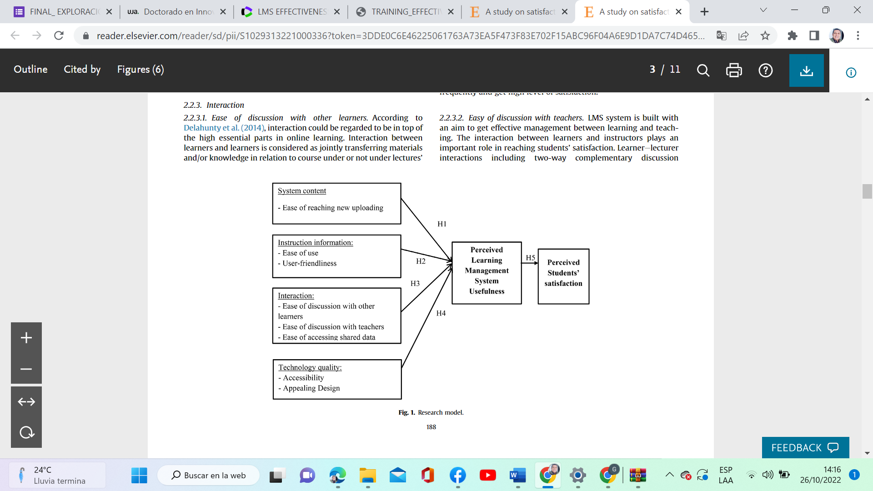

Source: Nguyen (2021)

The instrument is a Likert-scale survey with 6 dimensions (See Appendix E) adapted from Nguyen (2021)

**Chapter 4: Analysis of results**

**4.1 Results of exploratory Questionnaire**

During the Analysis stage, an exploratory questionnaire was administered to a group of 304 English teacher to find out the level of Digital Competence, the use of blogs, and the incorporation of ICT into ELT. The theoretical framework that comprises the constructs and the state of knowledge is also part of the *Analysis stage*. The input obtained from the first stage was used for the *Design stage* where the WBLDD was formulated, validated, and registered for intellectual property aims. The Design of the Diplomado Course and the LMS Moodle Tu Aula Media belong to the *Development stage*, while its application is part of the *Implementation Stage.* The Evaluation stage is transversal to the previous ADDIE stages and includes the evaluation of the proposed methodology, the course of application, and the LMS platform.

**Participants**

The population belongs to a non-probabilistic convenience sample. Three hundred-four surveys were answered, and 299 were valid for the study. 43,5% were female, 56,2 were male, and 0,3% preferred not to mention the genre. The participants work for public and private basic, media, high schools, private and public universities, and language institutes. 20.4 % had 1 to 5 years of teaching experience, 31.6% had 6 to 10, 19.1% had 11 to 15, 11.0% had 16 to 20, and 17.7% had more than 20 years of experience.

**Instrument and Data Collection**

Data for this study were collected through a questionnaire that included an explanation of the study, a consent letter participants need to agree with, a section about demographic information, and three dimensions: Teachers' Digital Competence, the use of blogs for English Teaching, and the use of Digital Technologies for English Teaching. Data was collected via a Google Forms questionnaire sent through e-mail or personal request during school visits and recess times in two national English Teaching events.

* + 1. **Teachers’ Digital Competence Analysis**

This section presents the results of the first dimension of this questionnaire (items 8 to 21), which assessed 5 of the six areas and 13 of the 22 areas of the DigCompEdu translated into Spanish by (Cabero-Almenara & Palacios Rodriguez, 2020). Table 1 shows the areas and competencies that were evaluated. The first column includes the area's name, and the second column identifies the questionnaire's question item (QI) and the competence number given for this study. The third column defines the name of the competence, and the fourth is the item descriptor as it appeared in the instrument.

**Table 1.**

*DigCompEdu assessed areas and competencies*

| **Area** | **Question item & competence** | **Competence** | **Item descriptor** |
| --- | --- | --- | --- |
| Area 1: Compromiso Profesional. | QI 8  COMP 1 | Comunicación Organizacional | Durante el desarrollo de mis clases, uso sistemáticamente diferentes canales digitales para mejorar la comunicación con el alumnado, las familias y mis compañeros/as. |
| QI 9  COMP 2 | Práctica Reflexiva | Desarrollo activamente mi competencia digital docente |
| QI10  CMP 3 | Formación Digital | Participo en cursos de Formación online |
| Area 2: Recursos Digitales | QI 11  COMP 4 | Selección | Durante el desarrollo de mis clases, utilizo diferentes sitios de internet y estrategias de búsqueda para encontrar y seleccionar una amplia gama de recursos digitales. |
| QI 12  COMP 5 | Creación y modificación | Durante el desarrollo de mis clases, creo mis propios recursos digitales y modifico los existentes para adaptarlos a mis necesidades como docente en formación. |
| Area 3: Pedagogía Digital | QI 13  COMP 6 | Enseñanza | Considero cuidadosamente, cómo, cuándo y porqué usar las tecnologías digitales en mis clases de inglés, para garantizar que se aproveche su valor añadido. |
| QI 14  COMP 7 | Guía | Durante el desarrollo de mis clases, superviso las actividades e interacciones de mis alumnos en los entornos de colaboración en línea que utilizamos. |
| QI 15  COMP 8 | Aprendizaje Colaborativo | Durante el desarrollo de mis clases, cuando mis alumnos trabajan en grupos o equipos, usan tecnologías digitales para adquirir y documentar conocimientos. |
| QI 16  COMP 9 | Aprendizaje autodirigido | Durante el desarrollo de mis clases, uso tecnologías digitales para permitir que los estudiantes planifiquen, documenten y evalúen su aprendizaje por sí mismos. |
| Area 4: Evaluación y Retroalimentación. | QI 17  COMP 10 | Estrategias de Evaluación | Durante el desarrollo de mis clases, uso estrategias de evaluación digital para monitorizar el progreso de los estudiantes. |
| QI 18  COMP  11 | Retroalimentación y planificación | Durante el desarrollo de mis clases, uso tecnologías digitales para proporcionar retroalimentación efectiva. |
| Area 5: Facilitar la competencia digital de los estudiantes | QI 19  COMP 12 | Información y alfabetización mediática | Durante el desarrollo de mis clases, enseño al alumnado cómo evaluar la confiabilidad de la información buscada en línea y a identificar información errónea o sesgada. |
| QI 20  COMP 13 | Comunicación y colaboración digital | Durante el desarrollo de mis clases, propongo tareas que requieren que los estudiantes usen medios digitales para comunicarse y colaborar entre sí o con una audiencia externa. |

Source: own elaboration

* + - 1. **Objective and Research Questions**

The main goal of this dimension in the questionnaire is to determine the digital competency level of 299 surveyed English teachers from different educational levels and belonging to private and public institutions in Colombia as input to formulate the design of a Web-Based Learning methodology. The DigCompEdu instrument was administered to assess 5 of the six competence areas and 13 of the 22 competencies.

To this end, this dimension poses the following questions:

RQ1: Where are the surveyed teachers placed in the Digcompedu competence scale?

Sub questions:

Which level has the most significant proportion of answers?

Which level has the lowest proportion of answers?

RQ2: Which area do teachers feel they are strong in?

Sub question: Which is the competence in each area teachers feel stronger/weaker?

RQ3: Are there significant differences in the development of the areas and the competencies between male and female teachers, and concerning the years of teaching experience?

* + - 1. **Methods of Analysis**

To establish significant differences between the performance levels of teachers within each competence, the percentages or response proportions were calculated for each level, and Quesenberry and Hurts' (1964) confidence intervals for multinomial proportions were constructed. Graphical representations were made using heat maps and bar charts. For the interpretation of the results, we considered levels A1 and A2 as basic level, B1 as intermediate level, and B2 and C1 as advanced level.

To evaluate the performance of each competence within each area, averages, and standard deviations were calculated for each competence. Values ranging from 1 to 5 were assigned to each level respectively. A competence with an average of 3 is considered at the intermediate level. If the average is greater than 3, it is considered advanced level, and if it is less than 3, it is considered basic level. The Kruskal-Wallis test, also known as the H test, a non-parametric statistical test used when the conditions for applying an ANOVA are not satisfied, was applied. The H test follows a chi-square distribution with k-1 degrees of freedom, where k is the number of competencies being compared (Hollander & Wolfe 1973).

To find the relationship between performance levels, gender, and years of training of the surveyed teachers, non-parametric statistical tests called Pearson's chi-square test, likelihood ratio test, and Fisher's test was used (Acuña, 2004). The associated hypotheses for gender and performance level by competence are as follows.

Ho: There is no relationship between the performance levels of each competence and the gender of the surveyed teachers.

H1: There is a relationship between the performance levels of each competence and the gender of the surveyed teachers.

The associated hypotheses between years of experience and performance level by competence are:

Ho: There is no relationship between the performance levels by competence and the years of experience of the teachers.

H1: There is a relationship between the performance levels by competence and the years of experience of the teachers.

Contingency coefficients and phi coefficients were also calculated. Both coefficients range from 0 to 1. A coefficient of zero indicates no association between the variables. A coefficient greater than 0.30 indicates a good association between the variables (Acuña, 2004). A coefficient greater than 0.3 and less than 0.4 indicates a good relationship between the variables, while a coefficient greater than 0.40 indicates a high relationship. A coefficient between 0.25 and 0.30 indicates a moderate relationship and a coefficient less than 0.25 is considered a low relationship.

Finally, to find differences between the areas, the Stanine methodology was used, which involves dividing raw test scores into 9 intervals. Stanine scores between 4 and 6 are considered average or intermediate, scores of 3 or less are below average or basic, and scores greater than or equal to 7 are above average or at an advanced level.

Considering that each level was assigned a score from 1 to 5, the scores of the competencies in each area were summed for each teacher. For example, a teacher who responded A1 in all three competencies of Area 1 would have a minimum score of 3, and if they responded C1, they would have a maximum score of 15. The final scores were divided into 9 intervals, the Basic category was assigned to intervals 1, 2, and 3, the Intermediate category to intervals 4, 5, and 6, and finally, the Advanced category to intervals 7, 8, and 9. This way, we can indicate the performance level of each teacher in each area, regardless of the number of competencies being evaluated, facilitating their comparison with a global score measure.

* + - 1. **Software**

The data analysis was conducted using the statistical software R version 4.2.2. The Likert package version 1.3.5 and ggplot2 package version 3.4.0 were used for generating graphs and descriptive statistics. The Stats package version 4.2.2 was used for performing the Kruskal-Wallis test and Wilcoxon comparisons test. All analyses were conducted with a significance level or error rate of 5%.

* + - 1. **Results of Teachers’ Digital Competence Analysis**

RQ1:

Where are the surveyed teachers placed in the Digcompedu competence scale?

In general, Integration Level B1 got the most significant proportion or the highest percentage of answers in 8 of the 13 competencies (62%). It demonstrates that most teachers are at the Integration Level (B1). The next level in the rank corresponds to Expertise Level B2, which is the second most considerable proportion or the highest percentage of answers in 4 of the 13 competencies (31%).

These are the results of the analysis for each of the 13 assessed competencies obtained with Quessenberry-Hurst’s Confidence Intervals for proportion estimation:

**Table 2***.*

*Results of competence 1\**

| **Item** | **Estimation** | **LI** | **LS** |  |
| --- | --- | --- | --- | --- |
| C1 | 5% | 3% | 11% |
| B2 | 38% | 30% | 47% |
| B1 | 28% | 21% | 36% |
| A2 | 19% | 13% | 27% |
| A1 | 9% | 5% | 16% |

*95% Confidence Intervals of Quessenberry-Hurts for the estimation of proportions A1, A2, B1, B2, C1 in the 'Organizational Communication' competence within the 'Professional Engagement' area.

Source: own elaboration

Between 30% and 47% of the teachers had a B2 (Advanced) level. Between 3% and 11% of the teachers had a C1 (Advanced) level.

**Table 3***.*

*Results of competence 2\**

| **Item** | **Estimation** | **LI** | **LS** |  |
| --- | --- | --- | --- | --- |
| C1 | 9% | 5% | 16% |
| B2 | 19% | 13% | 27% |
| B1 | 41% | 33% | 50% |
| A2 | 22% | 15% | 30% |
| A1 | 8% | 4% | 14% |

*Table 3. 95% Confidence Intervals of Quessenberry-Hurts for the estimation of proportions A1, A2, B1, B2, C1 in the 'Reflective Practice' competence within the 'Professional Engagement' area.

Source: own elaboration

Between 33% and 50% of the teachers had a B1 (Intermediate) level, statistically representing the highest percentage of response. The proportion of teachers with an A2 (Basic) level, between 15% and 30%, is statistically equal to the proportion of teachers with a B2 (Advanced) level, between 13% and 27%. The proportions of teachers with an A1 (Basic) level, between 4% and 14%, and a C1 (Advanced) level, between 5% and 16%, are statistically equal and correspond to the lowest response percentages among the teachers.

**Table 4***.*

*Results of competence 3\**

| **Item** | **Estimation** | **LI** | **LS** |  |
| --- | --- | --- | --- | --- |
| C1 | 20% | 14% | 28% |
| B2 | 22% | 16% | 31% |
| B1 | 30% | 23% | 39% |
| A2 | 22% | 16% | 30% |
| A1 | 6% | 3% | 11% |

*Table 4. 95% Confidence Intervals of Quessenberry-Hurts for the estimation of proportions A1, A2, B1, B2, C1 in the 'Digital Continous Professional Development” competence within the 'Professional Engagement' area.

Source: own elaboration

Between 23% and 39% of the teachers had a B1 (Intermediate) level, statistically representing the highest percentage of response among the teachers for this competence. Between 3% and 11% of the teachers had an A1 (Basic) level, representing the lowest proportion of response among the teachers. The proportion of teachers with C1, B2, and A2 levels were statistically equal.

**Table 5.**

*Results of competence 4\**

| **Item** | **Estimation** | **LI** | **LS** |  |
| --- | --- | --- | --- | --- |
| C1 | 7% | 3% | 13% |
| B2 | 24% | 17% | 32% |
| B1 | 42% | 34% | 51% |
| A2 | 27% | 20% | 35% |
| A1 | 0% | 0% | 4% |

*Table 5. 95% Confidence Intervals of Quessenberry-Hurts for the estimation of proportions A1, A2, B1, B2, C1 in the “Selecting Digital Resources” competence within the 'Digital Resources' area.

Source: own elaboration

Between 34% and 51% of the teachers had a B1 (Intermediate) level, statistically representing the highest percentage of response. The proportion of teachers with an A2 (Basic) level, between 20% and 35%, is statistically equal to the proportion of teachers with a B2 (Intermediate) level, between 17% and 32%. The proportions of teachers with an A1 (Basic) level, between 0% and 4%, and a C1 (Advanced) level, between 3% and 13%, are statistically equal and correspond to the lowest response percentages among the teachers.

**Table 6.**

*Results of competence 5\**

| **Item** | **Estimation** | **LI** | **LS** |  |
| --- | --- | --- | --- | --- |
| C1 | 9% | 5% | 16% |
| B2 | 44% | 36% | 53% |
| B1 | 31% | 24% | 40% |
| A2 | 9% | 5% | 15% |
| A1 | 6% | 3% | 12% |

*Table 6. 95% Confidence Intervals of Quessenberry-Hurts for the estimation of proportions A1, A2, B1, B2, C1 in the 'Creating and modifying digital content' competence within the 'Digital Resources' area.

Source: own elaboration

Between 36% and 53% of the teachers had a B2 (Advanced) level, statistically representing the highest percentage of response. The proportion of teachers with a C1 (Advanced) level, an A2 (Basic) level, and an A1 (Basic) level are statistically equal and correspond to the lowest response percentages among the teachers.

**Table 7***.*

*Results of competence 6\**

| **Item** | **Estimation** | **LI** | **LS** |  |
| --- | --- | --- | --- | --- |
| C1 | 19% | 13% | 27% |
| B2 | 29% | 22% | 38% |
| B1 | 18% | 12% | 25% |
| A2 | 32% | 24% | 41% |
| A1 | 2% | 1% | 7% |

*Table 7. 95% Confidence Intervals of Quessenberry-Hurts for the estimation of proportions A1, A2, B1, B2, C1 in the 'Teaching' competence within the 'Teaching and Learning' area.

Source: own elaboration

The proportion of teachers with an A2 (Basic) level, between 24% and 41%, is statistically equal to the proportion of teachers with a B2 (Advanced) level, between 22% and 38%, representing the highest response percentages for this competence. Between 1% and 7% of the teachers had an A1 (Basic) level, which corresponds to the lowest response percentage among the teachers for this competence.

**Table 8***.*

*Results of competence 7\**

| **Item** | **Estimation** | **LI** | **LS** |  |
| --- | --- | --- | --- | --- |
| C1 | 19% | 13% | 27% |
| B2 | 40% | 32% | 49% |
| B1 | 19% | 13% | 27% |
| A2 | 4% | 2% | 9% |
| A1 | 18% | 12% | 25% |

*Table 8. 95% Confidence Intervals of Quessenberry-Hurts for the estimation of proportions A1, A2, B1, B2, C1 in the 'Guidance' competence within the 'Teaching and Learning' area.

Source: own elaboration

Between 32% and 49% of the teachers had a B2 (Advanced) level, statistically representing the highest percentage of response for this competence. The response proportions for the C1, B1, and A1 levels are statistically equal. Between 2% and 9% of the teachers had an A2 (Basic) level, representing the lowest response percentage among the teachers for this competence.

**Table 9***.*

*Results of competence 8\**

| **Item** | **Estimation** | **LI** | **LS** |  |
| --- | --- | --- | --- | --- |
| C1 | 15% | 10% | 22% |
| B2 | 19% | 13% | 27% |
| B1 | 45% | 37% | 54% |
| A2 | 17% | 11% | 24% |
| A1 | 4% | 2% | 9% |

*Table 9. 95% Confidence Intervals of Quessenberry-Hurts for the estimation of proportions A1, A2, B1, B2, C1 in the 'Self-regulated Learning' competence within the 'Teaching and Learning' area.

Source: own elaboration

Between 37% and 54% of the teachers had a B1 (Intermediate) level, statistically representing the highest percentage of response among the teachers for this competence. The response proportions for the C1, B2, and A2 levels are statistically equal. Between 2% and 9% of the teachers had an A1 (Basic) level, representing the lowest response percentage among the teachers for this competence.

**Table 10.**

*Results of competence 9\**

| **Item** | **Estimation** | **LI** | **LS** |  |
| --- | --- | --- | --- | --- |
| C1 | 11% | 7% | 18% |
| B2 | 21% | 15% | 30% |
| B1 | 30% | 23% | 39% |
| A2 | 23% | 17% | 32% |
| A1 | 14% | 9% | 21% |

*Table 10. 95% Confidence Intervals of Quessenberry-Hurts for the estimation of proportions A1, A2, B1, B2, C1 in the "Self-Directed Learning" competence within the "Teaching and Learning" area.

Source: own elaboration

Between 23% and 39% of the teachers had a B1 (Intermediate) level, statistically representing the highest percentage of response. The proportion of teachers with an A2 (Basic) level, between 17% and 32%, is statistically equal to the proportion of teachers with a B2 (Intermediate) level, between 15% and 30%. The proportions of teachers with an A1 (Basic) level, between 9% and 21%, and a C1 (Advanced) level, between 7% and 18%, are statistically equal and correspond to the lowest response percentages among the teachers.

**Table 11***.*

*Results of competence 10\**

| **Item** | **Estimation** | **LI** | **LS** |  |
| --- | --- | --- | --- | --- |
| C1 | 7% | 4% | 13% |
| B2 | 22% | 16% | 30% |
| B1 | 40% | 32% | 49% |
| A2 | 29% | 22% | 38% |
| A1 | 1% | 0% | 4% |

*Table 11. 95% Confidence Intervals of Quessenberry-Hurts for the estimation of proportions A1, A2, B1, B2, C1 in the "Assessment Strategies" competence within the "Assessment" area.

Source: own elaboration

Between 32% and 49% of the teachers had a B1 (Intermediate) level, statistically representing the highest percentage of response. The proportion of teachers with an A2 (Basic) level, between 22% and 38%, is statistically equal to the proportion of teachers with a B2 (Advanced) level, between 16% and 30%. The proportions of teachers with an A1 (Basic) level, between 0% and 4%, and a C1 (Advanced) level, between 4% and 13%, are statistically equal and correspond to the lowest response percentages among the teachers.

**Table 12***.*

*Results of competence 11\**

| **Item** | **Estimation** | **LI** | **LS** |  |
| --- | --- | --- | --- | --- |
| C1 | 9% | 5% | 15% |
| B2 | 14% | 9% | 21% |
| B1 | 36% | 28% | 45% |
| A2 | 41% | 32% | 50% |
| A1 | 1% | 0% | 4% |

*Table 12: 95% Confidence Intervals of Quessenberry-Hurts for the estimation of proportions A1, A2, B1, B2, C1 in the "Feedback and Planning" competence within the "Assessment" area.

Source: own elaboration

The proportion of teachers with an A2 (Basic) level, between 32% and 50%, is statistically equal to the proportion of teachers with a B1 (Intermediate) level, between 28% and 45%, being statistically the highest response percentages for this competence. Between 0% and 4% of the teachers had an A1 (Basic) level, which represents the lowest response percentage for this competence among the teachers.

**Table 13.**

*Results of competence 12\**

| **Item** | **Estimation** | **LI** | **LS** |  |
| --- | --- | --- | --- | --- |
| C1 | 3% | 1% | 7% |
| B2 | 18% | 12% | 25% |
| B1 | 28% | 21% | 37% |
| A2 | 42% | 33% | 51% |
| A1 | 9% | 5% | 16% |

*Table 13: 95% Confidence Intervals of Quessenberry-Hurts for the estimation of proportions A1, A2, B1, B2, C1 in the "Information and Media Literacy" competence within the "Facilitating Students' Digital Competence" area.

Source: own elaboration

Between 33% and 51% of the teachers had an A2 (Basic) level, representing the highest response percentage for this competence among the teachers. Thus, the competence is considered to have the lowest performance compared to the other competencies. Between 1% and 7% of the teachers had a C1 (Advanced) level, representing the lowest response percentage for this competence among the teachers.

**Table 14.**

*Results of competence 13\**

| **Item** | **Estimation** | **LI** | **LS** |  |
| --- | --- | --- | --- | --- |
| C1 | 5% | 2% | 10% |
| B2 | 21% | 14% | 29% |
| B1 | 33% | 25% | 42% |
| A2 | 29% | 22% | 38% |
| A1 | 12% | 7% | 19% |

*Table 14: 95% Confidence Intervals of Quessenberry-Hurts for the estimation of proportions A1, A2, B1, B2, C1 in the "Digital Communication and Collaboration" competence within the "Facilitating Students' Digital Competence" area.

Source: own elaboration

The proportion of teachers with an A2 (Basic) level, between 22% and 38%, is statistically equal to the proportion of teachers with a B1 (Intermediate) level, between 25% and 42%, representing the highest response percentages for this competence among the teachers. Between 2% and 10% of the teachers had a C1 (Advanced) level, representing the lowest response percentage for this competence among the teachers.

In general, B1 was the level that had the highest proportion of response rate in 8 out of 13 questions, accounting for 62% of the responses. This indicates that the majority of teachers, in terms of their digital competencies and performance, are at an intermediate level.

B2 (Advanced) level follows, with a proportion of 31% in 4 out of 13 questions. A1 had the lowest proportion of responses in each of the competencies, indicating that a low percentage of teachers are at a basic level of performance in their digital competencies. C1 had the second lowest proportion of responses, indicating that a low percentage of teachers are at an advanced level in their digital competencies.

RQ 2. Which area do teachers feel they are strong in?

Sub question: Which is the competence in each area teachers feel stronger/weaker?

For analysis, the proficiency levels were grouped into three categories: Basic (A1-A2), Intermediate (B1), and Advanced (B2, C1). The comparison of areas was done using the Kruskal-Wallis Test. As differences among the competencies inside each area were found, the Wilcoxon rank-sum test was applied to precise these differences. Table 3 presents the results of descriptive statistics per area, table 4 makes comparisons among the areas through the Kruskal Wallis Test, and Table 5 makes the exact comparisons with the Wilcoxon rank-sum test with continuity correction (Wilcoxon rank-sum test with continuity correction at a 5% level of significance).

**Table 15***.*

*Results of Descriptive Statistics per Area*

|  | **Question Item** | **Basic** | **Intermediate** | **Advanced** | **Media** | **D.E** | **Heat Diagram** |
| --- | --- | --- | --- | --- | --- | --- | --- |
|  | **Competence** | **A1 A2** | **B1** | **B2 C1** |  |  |  |
| **Area 1** | **QI 8** | 28,76% | 27,76% | 43,48% | 3,10 | 1,08 |  |
| **QI 9** | 29,76% | 41,47% | 28,76% | 3,00 | 1,05 |
| **QI 10** | 27,76% | 30,10% | 42,14% | 3,28 | 1,18 |
| **Area 2** | **QI 11** | 27,09% | 42,14% | 30,77% | 3,10 | 0,88 |  |
| **QI 12** | 15,05% | 31,10% | 53,85% | 3,42 | 0,99 |
| **Area 3** | **QI 13** | 34,11% | 17,73% | 48,16% | 3,30 | 1,17 |  |
| **QI 14** | 21,74% | 19,06% | 59,19% | 3,39 | 1,33 |
| **QI 15** | 20,74% | 45,48% | 33,78% | 3,24 | 1,03 |
| **QI 16** | 37,12% | 30,10% | 32,78% | 2,93 | 1,20 |
| **Area 4** | **QI 17** | 30,10% | 40,47% | 29,43% | 3,06 | 0,91 |  |
| **QI 18** | 41,47% | 35,79% | 22,74% | 2,89 | 0,96 |
| **Area 5** | **QI 19** | 51,17% | 28,43% | 20,40% | 2,63 | 0,97 |  |
| **QI 20** | 41,47% | 33,11% | 25,42% | 2,77 | 1,06 |

Source: own elaboration

**Table 16.**

*Comparisons among the areas of competence.*

|  | Comparison among the areas | | |
| --- | --- | --- | --- |
|  | Kruskal Wallis Test | | |
| Areas | $χ^{2}$ | Valor P | P < 0,05 |
| Area 1: Professional Engagement | 9,04 | 0,0109 | * |
| Area 2: Digital Resources | 25,874 | 3,64E-04 | * |
| Area 3: Teaching and Learning | 28,805 | 2,46E-03 | * |
| Area 4: Assessment | 3,2563 | 0,07115 |  |
| Area 5: Faciliting Learners’ DC | 6,8941 | 0,008648 | * |

*Kruskal-Wallis Test with a 5% level of significance or error.

Source: own elaboration

There are statistically significant differences among the competencies within the areas of “A2: Digital Resources,” “A3: Teaching and Learning”, and “A5:Facilitating learners’ Digital Competence” (p=0.0003, p=0.0024, and p=0.0086, respectively). In the “Professional Engagement” area, there are significant but not as strong differences among the competencies (p=0.0109). The area of “Assessment” did not show statistically significant differences among the competencies (p=0.0711)

**Table 17.**

*Multiple Comparisons among the areas*

| **Multiple Comparisons** | | | | | |
| --- | --- | --- | --- | --- | --- |
| **Wilcoxon rank-sum test with continuity correction** | | | | | |
| Area 1: Professional Engagement | QI 8 | Organizational  Communication | (3,10702) a |  |  |
| QI 9 | Reflective Practice | (3,00334) a | (3,00334) b |  |
| QI10 | Digital Continuous Professional Development |  | (3,28428) b |  |
| Area 2: Digital Resources | QI11 | Selecting Digital Resources | (3,10033) a |  |  |
| QI12 | Creating and Modifying Digital Content |  | (3,42141) b |  |
| Area 3: Teaching and Learning | QI13 | Teaching | (3,30435) a |  |  |
| QI14 | Guidance | (3,38796) a |  |  |
| QI15 | Collaborative Learning |  | (3,24080) b |  |
| QI16 | Self-regulated Learning |  |  | (2,93311) c |
| Area 4: Assessment | QI17 | Assessment Strategies | (3,06020) a |  |  |
| QI18 | Feedback and Planning | (2,89298) a |  |  |
| Area 5: Faciliting Learners’ DC | QI19 | Information and Media Literacy | (2,62542) a |  |  |
| QI20 | Digital Communication and Collaboration |  | (2,76589) b |  |

Source: own elaboration

The "Teaching and Learning" area showed statistically significant differences among the evaluated competencies. The competence of "self-regulated learning" had the lowest average score, while the competencies of "Teaching" and "Guidance" had the highest scores (above 3).

In the "Facilitating Learners' Digital Competence" area, there were statistically significant differences between the competencies of "Information and Media Literacy" and "Digital Communication and Collaboration." These two competencies also had the lowest average scores (below 3) among all the competencies across different areas.

The competence with the highest score (above 3) and statistically different from the others was "Creating and Modifying Digital Content" in the "Digital Resources" area. The competencies in the "Professional Engagement" and "Assessment " areas did not show statistically significant differences, and the scores for each competency were around 3, indicating an intermediate level of performance.

RQ3. Are there significant differences in the development of the areas and the competencies between male and female teachers and years of experience?

**Table 18.**

*Analysis of areas per genre \**

|  |  |  |  |  |  |  | $χ^{2}$**Pearson** | **Likelihood Ratio** | **V of Cramer** |
| --- | --- | --- | --- | --- | --- | --- | --- | --- | --- |
|  | **Genre** | **A1** | **A2** | **B1** | **B2** | **C1** | **P Value** | |
| **Q8** | **Female** | 16 | 32 | 46 | 64 | 10 | 0,99 | 0,99 | 0,033 |
| **Male** | 12 | 26 | 37 | 49 | 6 |  |  |  |
| **Q9** | **Female** | 17 | 35 | 64 | 37 | 15 | 0,34 | 0,33 | 0,123 |
| **Male** | 7 | 30 | 59 | 21 | 13 |  |  |  |
| **Q10** | **Female** | 10 | 34 | 56 | 38 | 30 | 0,61 | 0,61 | 0,095 |
| **Male** | 7 | 32 | 34 | 28 | 29 |  |  |  |
| **Q11** | **Female** | 0 | 43 | 76 | 40 | 9 | 0,47 * | 0,41 | 0,11 |
| **Male** | 1 | 37 | 49 | 32 | 11 |  |  |  |
| **Q12** | **Female** | 9 | 12 | 53 | 84 | 10 | 0,05 | 0,06 | 0,176 |
| **Male** | 9 | 15 | 39 | 49 | 18 |  |  |  |
| **Q13** | **Female** | 4 | 56 | 31 | 45 | 32 | 0,90 * | 0,89 | 0,062 |
| **Male** | 3 | 39 | 22 | 42 | 24 |  |  |  |
| **Q14** | **Female** | 30 | 5 | 30 | 69 | 34 | 0,88 * | 0,88 | 0,063 |
| **Male** | 23 | 6 | 27 | 51 | 23 |  |  |  |
| **Q15** | **Female** | 4 | 30 | 79 | 26 | 29 | 0,15 | 0,15 | 0,15 |
| **Male** | 8 | 19 | 57 | 30 | 16 |  |  |  |
| **Q16** | **Female** | 26 | 37 | 48 | 37 | 20 | 0,73 | 0,72 | 0,083 |
| **Male** | 14 | 33 | 42 | 27 | 14 |  |  |  |
| **Q17** | **Female** | 0 | 47 | 71 | 35 | 15 | 0,32 * | 0,23 | 0,127 |
| **Male** | 2 | 41 | 49 | 31 | 7 |  |  |  |
| **Q18** | **Female** | 2 | 66 | 60 | 24 | 16 | 0,76 * | 0,6 | 0,082 |
| **Male** | 0 | 55 | 47 | 18 | 10 |  |  |  |
| **Q19** | **Female** | 18 | 71 | 49 | 26 | 4 | 0,7 * | 0,72 | 0,084 |
| **Male** | 10 | 53 | 36 | 27 | 4 |  |  |  |
| **Q20** | **Female** | 26 | 49 | 53 | 33 | 7 | 0,25 | 0,23 | 0,134 |
| **Male** | 9 | 39 | 46 | 29 | 7 |  |  |  |

*Table 18: Pearson's chi-square test, likelihood ratio, and Cramer's V statistics for the association between competences and gender. The approximation may be incorrect, instead, Cramer's V is interpreted (0 indicates independence, 1 indicates a perfect relationship between the factors).

Source: own elaboration

Since the p-values in both Pearson's chi-square test and likelihood ratio are greater than the significance level of 0.05, it is concluded that there is no association or evidence linking the gender (Male, Female, or Other) of English teachers with their performance in each of the evaluated digital competences. Gender is not an important factor in determining the teachers' performance in the different competencies.

This analysis was done by grouping the ranks of ages using these codes: 1 for 1 to 5 years of experience, 2 for 6 to 10, 3 for 11 to 15, 4 for 16 to 20, and 5 for more than 20 years of teaching experience.

**Table 19***.*

*Analysis of areas per years of experience\**

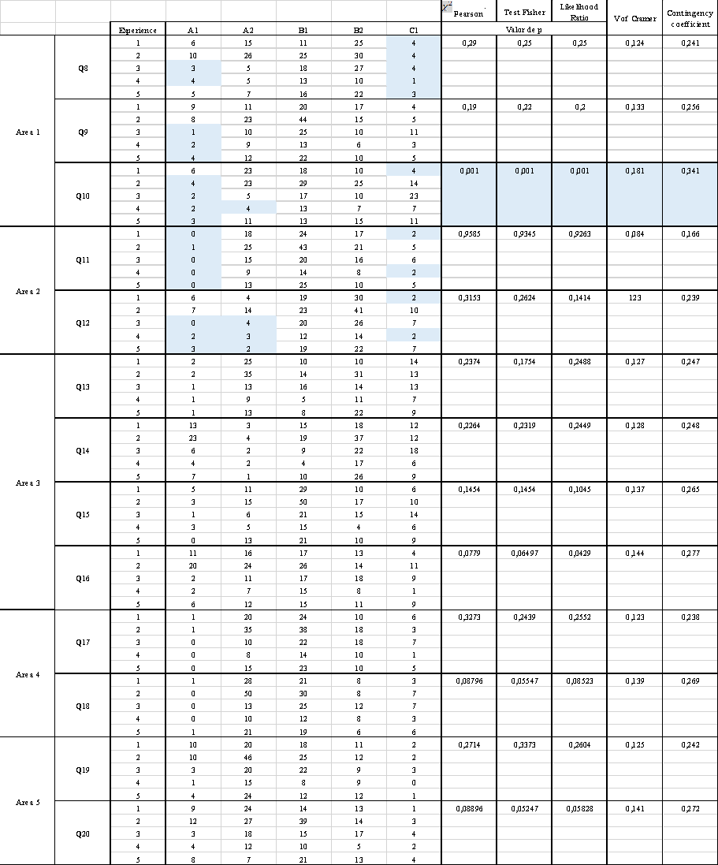

*Table 19: Pearson's χ^2 test and Fisher's exact test with simulated p-value based on 2000 replicates, likelihood ratio, and Cramer's V statistics (0 indicates independence, 1 indicates a perfect relationship between the factors) for the association between competences and years of experience in the five areas.

Source: own elaboration

In all, there is no statistical evidence to determine an association between gender and years of experience with performance levels in each of the evaluated competencies across different areas.

In conclusion for the analysis of TDC, none or a few surveyed teachers are in the basic or advanced level of TDC. It implies that most teachers possess a base of knowledge that allows them to continue growing in their competence. A significant portion of teachers belong to the intermediate level (B1-B2), as in the studies carried out by Paz et al. (2022) and Roa et al. (2021). According to the Digcompedu descriptors, it means that teachers take their time to select and incorporate the appropriate digital tools into pedagogical strategies. A training methodology should provide them with criteria that enable them to make better decisions. The SAMR Framework (Puentedura, 2006) for integrating technology into education may serve as a reference because it defines levels in this incorporation process. Teachers may improve the use of digital tools by substituting or augmenting them. Another may substitute an activity in face-to-face instruction in the virtual environment but with the same effects and intention and a better functional result.

On the other hand, teachers may transform digital tools by modifying and redefining them. Using TIC allows for redesigning and creating new learning activities, even inconceivable ones. Training programs and methodologies should incentivize teamwork with colleagues to be updated with new developments and become a source of inspiration for other teachers.

Although teachers recognize that they use digital technologies for collaborative learning (45%) and create digital resources (44%), they manifest that using online collaborative learning environments could be enhanced. Web-based instruction should be administered using an LMS platform like Moodle and integrate other teamwork resources like blogs, wikis, and video conference tools where students may construct knowledge cooperatively. Numerous studies have proved the effectiveness of LMS platforms in fostering students' collaborative learning and English Language Learning (Kataoka et al. 2018; Terzioğlu & Mustafa 2022; Truong, 2021; Lyashenko & Hidarovna-Frolova, 2014).

Concerning the competencies in each of the areas, in the "Teaching and Learning" area, "self-regulated Learning" competence got the lowest score, while "Teaching and Guidance" was the highest. It implies that teachers use technology to guide and support students' learning outside the classroom. Still, they need to increase the use of technology to stimulate students' learning strategies, dealing with planning, monitoring, and reflecting on their learning process. A Web-based Learning methodology needs to provide spaces for students to self-assess their performance during the learning trajectory by addressing the strategies with weaknesses and strengthening those that are properly working.

In the "Facilitating Learners' Digital Competence" area, the "Information and Media Literacy" and "Digital Communication and Collaboration" competencies had the lowest average scores among all. It reveals that teachers need to incentivize students' abilities to find information in digital environments, organize, process, analyze, and interpret it. It also demands creating a critical sense to evaluate the credibility and reliability of information sources. It implies that the intended methodology includes moments when students are instructed about strategies for trustful searches and moments where students communicate the sources they used to assess the reliability and provide feedback for further inquiries.

Regarding "Digital Communication and Collaboration," English teachers must incorporate learning activities, assignments, and assessments that encourage students to use digital technologies effectively and responsibly with communication, collaboration, and civic participation aims. The new Web-Learning methodology has to embrace these three objectives by creating opportunities for students to transcend the mere information function of learning and move to make concrete links with their classmates and their nearest community. Emerging Community-Based Pedagogy principles in the Social Justice Teacher Education (SJTE) framework could be incorporated into the learning model, where students and teacher-learners plan their learning based on satisfying classroom and local community problems. Students and teacher-learners need to decide which TDC to develop based on the realities of the context they want to transform. Sharkey et al. (2016), say that

an example of teacher learning could be how they use a new concept, such as CBPs, to design and enact a social activity particular to their professional contexts and how it might change their actions and interactions in the home communities of their schools. (p. 2)

Results show that no statistical evidence demonstrates that genre and years of teaching experience have an incidence on the level of digital competence. It denotes that participants engaging in the Web-Based Learning methodology implementation stage may be in the same groups altogether. A proposed methodology should contribute to differentiated learning instruction, where each learner targets to develop specific competence goals according to their own levels and classroom needs.

Finally, some of this study’s limitations have to do with the length of the questionnaire which included, besides the Teachers’ Digital Competence dimension, other two dimensions related to the use of technology and the use of blogs for English Teaching. For further research, it would be better to limit the number of question items. Besides, some teachers were reluctant to answer the online questionnaire via email. The researchers had to visit schools and approach teachers at ELT National events to make personal requests. The data analysis was time-consuming since studies in the area of Language Teaching that do interpretative analysis through multinomial portions of variables were not found.

**4.1.2 Results of the Use of Digital Tools for English Teaching**

This section presents the results of the third dimension of the exploratory questionnaire, which assesses teachers’ use of digital tools for ELT (items 30 to 50). The instrument is an adaptation of Alakrash and Razak's (2021) Likert scale with five options of answers for each of the proposed statements, going from “Totally agree” to “Totally disagree”

**4.1.2.1 Objective and Research Questions**

The main objective of this dimension in the exploratory questionnaire is to inquire on the digital tools that teachers use the most and the least for the development of language skills.

RQ 1: Which are the digital tools teachers use the most for the development of each language skill (listening, reading, vocabulary, speaking, and writing)

RQ 2: Which are the digital tools teachers use the least for the development of each language skill (listening, reading, vocabulary, speaking and writing)

**4.1.2.2 Methods of Analysis**

This quantitative analysis uses different statistical techniques to determine the answers to the proposed research questions. The percentage of answers for each question in the two described dimensions was calculated using Quesenberry and Hurts (1964) confidence intervals of 95%. Answers for the Likert scale question type were represented using heat diagrams and bars. Averages and standard deviations were calculated for each digital tool used to develop each skill. A question with an average of 3 indicates a neutral use of the digital tool, an average greater than three indicates that the tool is used quite a bit, and an average less than 3 indicates little use.

**4.1.2.3 Software**

The data analysis was conducted using the statistical software R version 4.3.1. The Likert package version 1.3.5 and ggplot2 version 3.4.0 were utilized to generate graphs and descriptive statistics. The analyses were performed with a significance level or error rate of 5%.

**4.1.2.4 Results of Use of Digital Tools for English Teaching**

RQ 1: Which are the digital tools teachers use the most for the development of each language skill (listening, reading, vocabulary, speaking and writing)

**Table**

*Analysis of….*

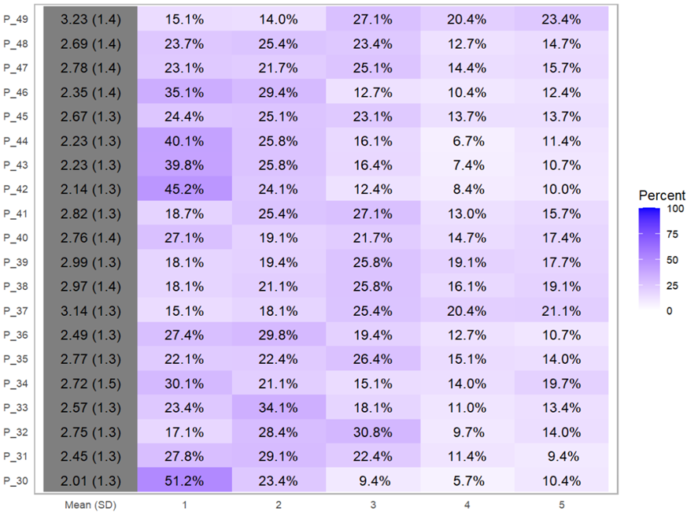

Source: own elaboration

According to the analysis using…. questions corresponding to items 36, 46, 31, 42, 44, 43, and 30 were under a mean of 2.5 or a percentage higher than 57% of answers inside the options of “Agree” and “Totally agree.” It means that the most frequently used resources for English teaching are: YouTube (75%) and English newspapers (57%) for listening skills, online applications (57%) for speaking skills, games such as crossword and word puzzles (69%) to practice vocabulary, the use of flashcards and online dictionaries (66%) for vocabulary acquisition, and the use of websites (65%) for reading skills.

**Table**

*Analysis of…*

| **Pregunta** | **Media** | **D.E** | **Pregunta** | **Media** | **D.E** |
| --- | --- | --- | --- | --- | --- |
| **P_49** | **3,2** | **1,4** | **P_45** | **2,7** | **1,3** |
| **P_37** | **3,1** | **1,3** | **P_33** | **2,6** | **1,3** |
| **P_39** | **3,0** | **1,3** | **P_32** | **2,8** | **1,3** |
| **P_38** | **3,0** | **1,4** | **P_36** | **2,5** | **1,3** |
| **P_34** | **2,7** | **1,5** | **P_46** | **2,4** | **1,4** |
| **P_40** | **2,8** | **1,4** | **P_31** | **2,5** | **1,3** |
| **P_47** | **2,8** | **1,4** | **P_42** | **2,1** | **1,3** |
| **P_35** | **2,8** | **1,3** | **P_43** | **2,2** | **1,3** |
| **P_41** | **2,8** | **1,3** | **P_44** | **2,2** | **1,3** |
| **P_48** | **2,7** | **1,4** | **P_30** | **2,0** | **1,3** |

RQ 2: Which are the digital tools teachers use the least for the development of each language skill (listening, reading, vocabulary, speaking and writing)

Questions 37, 38, 39, and 49 obtained a mean over 3,0 or a percentage higher than 35% inside the options of “Disagree” and “Totally Disagree” It means that the least used digital technologies are applications for voice recognition like Busuu (41%), Grammarly and Grammar Checker (37%) for writing skills, the use of chat rooms (35%) to incentivize writing skills, and the use of applications like Newsella (44%) for reading comprehension skills. Digital tools to improve writing skills tend not to be used.

**4.1.3 Results of the Use of Blogs**

This section presents the results of the second dimension of the exploratory questionnaire, which assesses teachers’ use of blogs (items 22 to 29). The instrument is an adaptation of Fernandes’ (2017) data collection instrument.

**4.1.3.1 Objective and Research Questions**

The main objective of this dimension in the exploratory questionnaire is to determine how teachers first knew about blogs and to ascertain the experience teachers have on the use and design of blogs.

RQ 1: How did teachers first know about blogs?

RQ 2: What experience do teachers have in the use and design of blogs?

**4.1.3.2 Methods of Analysis**

This quantitative analysis uses different statistical techniques to determine the answers to the proposed research questions. The percentage of answers for each question in the two described dimensions was calculated using Quesenberry and Hurts (1964) confidence intervals of 95%. Answers for the Likert scale question type were represented using heat diagrams and bars. Averages and standard deviations were calculated for each digital tool used to develop each skill. A question with an average of 3 indicates a neutral use of the digital tool, an average greater than three indicates that the tool is used quite a bit, and an average less than 3 indicates little use.

**4.1.3.3 Software**

The data analysis was conducted using the statistical software R version 4.3.1. The Likert package version 1.3.5 and ggplot2 version 3.4.0 were utilized to generate graphs and descriptive statistics. The analyses were performed with a significance level or error rate of 5%.

**4.1.3.4 Results of Use of Blogs’ Analysis**

RQ 1: How did teachers first know about blogs?

The Confidence Intervals of Quessenberry-Hurts showed a 95% confidence interval for this item. Teachers knew about the use of blogs for educational purposes mainly through academic events inside and outside their educational institutions. Few of them (0%) knew about the existence of blogs by means of web platforms of website like Moocs or webinars.

**Figure**

*Results for how teachers knew about blogs*

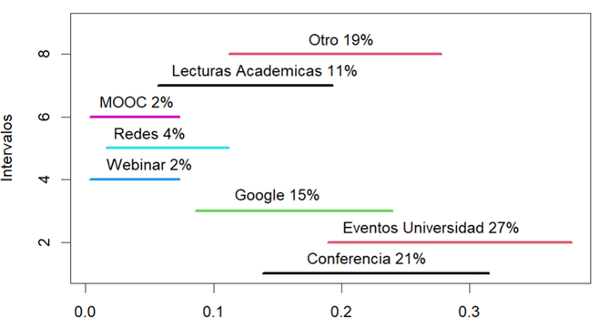

Source: own elaboration.

RQ 2: What experience do teachers have in the use and design of blogs?

To answer these questions, there were considered the results of these four questions: Have you ever used blogs in your teaching work?, how often do you use blogs in class?, have you created any Edublog or blog for teaching English as a Foreign Language? How many blogs have you created for this purpose? What kind of blogs have you created?

**Figure**

*Have you ever used blogs in your teaching work?*

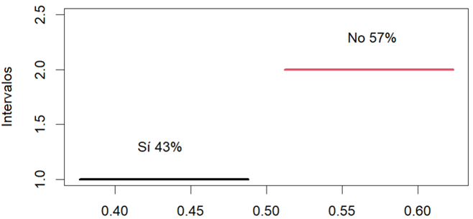

Source: own elaboration

The results show that there is a tendency in the teachers to consider that they have not used blogs for teaching purposes

**Figure**

*How many blogs have you created?*

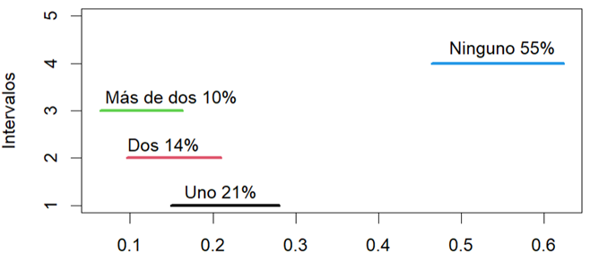

Source: own elaboration

Most of the teachers have not created blogs (any 55%), although a big proportion consider that they have created at least one blog.

**Figure**

*What kind of blogs have you created?*

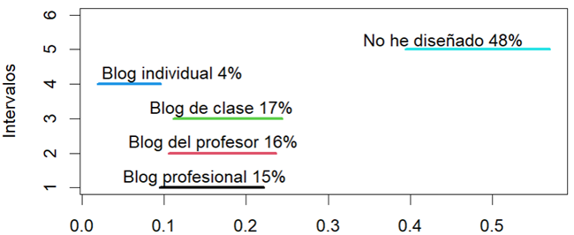

Source: own elaboration

A big proportion of teachers (48%) have not designed a blog in their lives, while another proportion considers that they have designed blogs with different purposes.

In conclusion, teachers get acquainted with the use of blogs for the first time in academic activities organized by their programs or educational institutions where they work (27%). The next highest proportion indicates that they also know about this in seminars, and conferences they attend for professional development (21%).

49% of the educators do not use blogs in their teaching, 57% do not create them, and only 5% use them. Of that 52% percentage of teachers who said that have created blogs, 10 % have created more than two blogs, and 35% have created less than two. Of most of those created blogs, 15 % are class blogs, 16% are teachers’ or students’ blogs resulting from training courses, 17% are blogs where the teacher is the administrator, and 17% are blogs where students are co-authors.

**4.1.5 Results of the Use of Blogs**

**4.2 Results of study: How effective is the WBLDD in TCD and the use of digital tools for ELT?**

**4.2.1 Results of Teachers’ Digital Competence**

**4.2.2 Results of the Use of Digital Tools for English Teaching**

**4.2.3 Assessment of WBLDD**

**4.2.4 Assessment of LMS**

# References

Acr, A. & Kayaoglu, M. N. (2020). MOODLE as a Potential Tool for Language Education under the Shadow of COVID-19. *Eurasian Journal of Educational Research*, 20(90), 1–16. <https://doi.org/10.14689/EJER.2020.90.4>

Acuña, E. (2004). Análisis de datos categóricos. *Departamento de Matemáticas Universidad de Puerto Rico-Mayagüez*.

Agélii G, A., Gronlund, Å. & Viberg, O. (2019). Disseminating digital innovation in school – leading second-order educational change. *Educ Inf Technol* 24, 3021–3039 <https://doi.org/10.1007/s10639-019-09908-0>

Akbana, Y. E., Rathert, S. & Ağçam, R., (2021). Emergency remote education in foreign and second language teaching. *Turkish Journal of Education*, 10(2), 97-124. https://doi.org/10.19128/turje.865344

Alakrash, H. M. & Razak, N. A. (2021). Technology-Based Language Learning: Investigation of Digital Technology and Digital Literacy. *Sustainability.* 13. 12304. 10.3390/su132112304.

[Alarcón, R., Jiménez-Pérez, E., & Vicente-Yagüe Jara, M. I. (2020). Development and validation of the DIGIGLO, a tool for assessing the digital competence of educators: A tool to assess digital competence of educators. British Journal of Educational Technology, 51. https://doi.org/10.1111/bjet.12919](https://doi.org/10.1111/bjet.12919)

Albero-Posac, S. (2019). Using Digital Resources for Content and Language Integrated Learning: A Proposal for the ICT-Enrichment of a Course on Biology and Geology. *Research in Education and Learning Innovation Archives* , 22 , 11-28. doi:<http://dx.doi.org/10.7203/realia.22.14112>

Al-Qallaf, C.L., & Al-Mutairi, A.S. (2016). Digital literacy and digital content supports learning: The impact of blogs on teaching English as a foreign language. *Electron. Libr., 34*, 522-547.

Alsaied, H. I. K. (2016). Use of blackboard application in language teaching: Language teachers' perceptions at KAU. *International Journal of Applied Linguistics and English Literature*, *5*(6), 43-50.

Álvarez, G. (2012). New technologies in the university context: The use of blogs for developing students’ reading and writing skills [Nuevas tecnologías en el contexto

universitario: el uso de blogs para desarrollar las habilidades de lectura y escritura de los estudiantes]. *Revista de Universidad y Sociedad del Conocimiento (RUSC)*, 9(2), 185-198. <https://n9.cl/9k89t>

Álvarez, G. & Bassa, L. (2013). TIC y aprendizaje colaborativo: el caso de un blog de aula para mejorar las habilidades de escritura de los estudiantes preuniversitarios.*Revista de Universidad y Sociedad del Conocimiento (RUSC)*, 10(2), 5-19. http://www.redalyc.

org/articulo.oa?id=78028681002

Angus Bachanan, R. (2020). History of Technology. Britannica. <https://www.britannica.com/technology/history-of-technology>.

Arslan, A. (2023). A Systematic Review of Blogging Practices in Teaching EFL/ES. *Croatian Journal of Education.* Vol.25; No.2. <https://doi.org/10.15516/cje.v25i2.4721>

Ansarian, L. & Teoh, M. (2018). *Problem-based Language Learning and Teaching: An Innovative Approach to Learn a New Language*. Singapore: Springer.

Arias, J. & Martin, R. (2015). *Problem-based e-learning (ABP) using synchronous virtual teaching*. New York: Nova Science Publishers, Inc.

Arías Masa, J., Martín Espada, R., Gutiérrez-Esteban, P., Delicado Puerto, G., Cubo Delgado, S., Alonso-Díaz, L. & Yuste Tosina, R. (2019). Synchronous Virtual Classrooms in Problem-Based Learning to Mentor and Monitor Students in Higher Education. *Universities in the Networked Society: Cultural Diversity and Digital Competences in Learning Communities*, 133-154. https://link.springer.com/chapter/10.1007/978-3-030-05026-9_8

Arnold, K. H. (2012). Didactics, Didactic Models and Learning. In: Seel, N.M. (eds) Encyclopedia of the Sciences of Learning. Springer, Boston, MA. <https://doi.org/10.1007/978-1-4419-1428-6_1833>.

Aşıksoy, G. (2018). ELT students’ attitudes and awareness towards the use of Web 2.0 technologies for language learning. *Journal of Language and Linguistic Studies*, *14*(2), 240–251. <https://dergipark.org.tr/en/download/article-file/650555>

Attwell, G. (2010). Context and the design of Personal Learning Environments. Presented at the PLE2010 Conference, Barcelona, Spain. http://www.pontydysgu.org/2010/07/context-and-the-design-of-personal-learningenvironments/

Badiou, A. (2007). The Event in Deleuze. *Parrhesia. A Journal of Critical Philosophy*. No. 2. <http://parrhesiajournal.org/parrhesia02/parrhesia02_badiou02.pdf>

Balboni, P. (2006). *Intercultural Communicative Competence: a Model*. Documents in Language Teaching Methodology. Perugia: Guerra Edizioni.

Baralt, M. & Morcillo, J. (2017). Task-based language teaching online: A guide for teachers. *Language Learning & Technology*, 21(3), 28–43. <http://llt.msu.edu/issues/october2017/baraltmorcillogomez.pdf>

Behar, P. (2011). Constructing Pedagogical Models For E-learning. *International Journal of Advanced Corporate Learning (iJAC), 4*(3), 16-22. Kassel University Press GmbH. <https://www.learntechlib.org/p/45571/>.

Bergström, P. (2012). Designing for the unknown: Didactic design for process-based assessment in technology-rich learning environments.

Bergström, P. & Mårell-Olsson, E. (2018). Power and control in the one-to-one computing classroom: students’ perspectives on teachers’ didactical design. *Seminar.net*, *14*(2), 160–173. https://doi.org/10.7577/seminar.2972g

Blake, R. (2018). La ELAO en el marco del enfoque por tareas. En: Fernández Juncal, C. y N. Hernández Muñoz (eds.) Vías de transformación en la enseñanza de lenguas con mediación tecnológica. *Círculo de lingüística aplicada a la comunicación* 76, 67-80. <http://dx.doi.org/10.5209/CLAC.62498>

Borgdorff, H. (2006). The debate on research in the arts. [www.ips.gu.se/](http://www.ips.gu.se/) digitalAssets/1322/1322713_the_debate_on_research_in_the_arts.pdf. 3, 4

Busetti, E., Dettori, G., Forcheri, P. & Ierardi, M. G. (2007). A pedagogical approach to the design of learning objects for complex domains. *International Journal of Distance Education Technologies*, *5*(2) 1+. <https://link.gale.com/apps/doc/A167255254/AONE?u=anon~8bd9c85e&sid=googleScholar&xid=9402bd3e>

Byram, M., Gribkova, B. & Starkey, H. (2002). *Developing the intercultural dimension in language teaching: A practical introduction for teachers*. Language Policy Division, Directorate of School, Out-of-School and Higher Education, Council of Europe.

Cabero-Almenara, J., Gallego-Pérez, O., Puentes Puente, Á. & Jiménez Rosa, T. (2018). La “Aceptación de la Tecnología de la Formación Virtual” y su relación con la capacitación docente en docencia virtual. *EDMETIC, Revista de Educación Mediática y TIC*, 7(1), 225-241. doi: <https://doi.org/10.21071/edmetic.v7i1.10028>

Cabero-Almenara, J., Gutiérrez-Castillo, J.-J., Palacios-Rodríguez, A. & Barroso-Osuna, J. (2020). Development of the Teacher Digital Competence Validation of DigCompEdu Check-In Questionnaire in the University Context of Andalusia (Spain). *Sustainability*, *12*(15), 6094. MDPI AG. <http://dx.doi.org/10.3390/su12156094>

Cabero-Almenara, J. & Palacios-Rodríguez, A. (2020). Marco Europeo de Competencia Digital Docente «DigCompEdu». Traducción y adaptación del cuestionario «DigCompEdu Check-In». *Edmetic*, *9*(1), 213-234. <https://www.uco.es/ucopress/ojs/index.php/edmetic/article/view/12462/11154>

Cabero-Almenara, J., Gutiérrez-Castillo, J., Barroso-Osuna, J., & Rodríguez-Palacios, A.

(2023). Digital Teaching Competence According to the DigCompEdu Framework. Comparative Study in Different Latin American

Universities. Journal of New Approaches in Educational Research, 12(2), 276-291. doi: 10.7821/naer.2023.7.1452

Cachón-Zagalaz J, Sánchez-Zafra M, Sanabrias-Moreno D, González-Valero G, Lara-Sánchez AJ and Zagalaz-Sánchez ML (2020) Systematic Review of the Literature About the Effects of the COVID-19 Pandemic on the Lives of School Children. Front. Psychol. 11:569348. doi: 10.3389/fpsyg.2020.569348

Cakmak, F. (2019). Mobile learning and mobile assisted language learning in focus. *Language and Technology*, *1*(1), 30-48. https://dergipark.org.tr/en/download/article-file/665969

Camacho Vásquez, G. (2017). The Logic of Sense incorporated to the notion of Inquiry as an Orientation for Learning: two classroom experiences. *GIST – Education and Learning Research Journal*, (14), 88–106. <https://doi.org/10.26817/16925777.369>

Candel, E. C. (2018). Experiencias TIC en la enseñanza bilingüe mediante recursos digitales musicales.  *DIM: Didáctica, Innovación y Multimedia*, 2018, Núm. 36. <https://raco.cat/index.php/DIM/article/view/335144>.

Charmaz, K. (2014). Constructing Grounded Theory. Los Angeles: Sage.

Chen, W., Tan, J.S.H. & Pi, Z. (2021). The spiral model of collaborative knowledge improvement: an exploratory study of a networked collaborative classroom. *Intern. J. Comput.-Support. Collab. Learn* 16, 7–35. <https://doi.org/10.1007/s11412-021-09338-6>

Choi, L.J. & Chung, S.J. (2021). Navigating Online Language Teaching in Uncertain Times: Challenges and Strategies of EFL Educators in Creating a Sustainable Technology-Mediated Language Learning Environment. *Sustainability*.

Chou, C. C. (2010). Student perceptions and pedagogical applications of e-learning tools in online courses. In *Web-Based Education: Concepts, Methodologies, Tools and Applications* (pp. 524-539). IGI Global.

Clavijo, A. & Ramírez, L. (2019). Las Pedagogías de la Comunidad a través de Investigaciones Locales en el Contexto Urbano de Bogotá. Bogotá, D.C.: Editorial Universidad Distrital Francisco José de Caldas. 260 P. Trabalhos em Linguística Aplicada. <https://doi.org/10.1590/010318135866315912020>

Cong-Lem, Ngo. (2018). Web-Based Language Learning (WBLL) for Enhancing L2 Speaking Performance: A Review. *Advances in Language and Literary Studies*. 9. 143. 10.7575/aiac.alls.v.9n.4p.143.

Constancio, F. G., Couras, M. F., Nogueira, D. X., Costa, J. P., Zanatta, M. D., de Sousa Júnior, R. T., Gomes, S. & Mota, N. T. (2018). Extended ADDIE Model for improved Distance Learning Courses. *2018 IEEE Frontiers in Education Conference (FIE)*, 1-5

Covadonga, R., Iniesto, F. & García-Serrano, A. (2020). Reflections on Instructional Design Guidelines from the MOOCification of Distance Education: A Case Study of a Course on Design for All. In *UXD and UCD Approaches for Accessible Education* (pp. 21-37). IGI Global.

Creswell, J.W. & Creswell, J. D. (2018) Research Design: Qualitative, Quantitative, and Mixed Methods Approaches. Sage, Los Angeles.

Cross, K. P., Barkley, E. F. & Cross, K. P. (2014). Collaborative learning techniques : A handbook for college faculty. John Wiley & Sons, Incorporated. Created from ujaen on 2022-10-18 18:57:08.

Czerwinski, A. (2017). Artifact selection. In M. Allen (Ed.), *The Sage Encyclopedia of communication research methods* (pp. 57-59). SAGE Publications, Inc, https://dx.doi.org/10.4135/9781483381411.n23

Davidson-Shivers G. V., Rasmussen K. L. & Lowenthal P. R. (2018). Overview of online instruction and Learning Environments and Communities. *Web-based learning: design implementation and evaluation* (Second). Springer. <https://doi.org/10.1007/978-3-319-67840-5>

Drajati, N.A., Rakerda, H., Sulistyawati, H., Nurkamto, J., & Ilmi, M. (2021). INVESTIGATING THE ADOPTION OF TPACK-21CL BY ENGLISH PRE-SERVICE TEACHERS IN A COVID-19 TEACHING PRACTICUM. *Indonesian Journal of Applied Linguistics*.

<https://doi.org/10.17509/ijal.v11i1.34625>.

Davis, F. D. (1989). Perceived usefulness, perceived ease of use, and user acceptance of information technology, *MIS Quarterly,* 13(3), 319-340. doi: 10.2307/249008

Deardorff, D. K. (2006). Identification and Assessment of Intercultural Competence as a Student Outcome of Internationalization. *Journal of Studies in International Education*, *10*(3), 241–266. <https://doi.org/10.1177/1028315306287002>

De Brabander, C. & Glastra, F. (2021). The unified model of task-specific motivation and teachers’ motivation to learn about teaching and learning supportive modes of ICT use. *Education and Information Technologies*. 26. 10.1007/s10639-020-10256-7.

Deleuze, G. (2001). Pure immanence: Essays on a life.

Deleuze, G. (2005). Quinta Serie del Sentido:“Novena Serie de lo Problemático”:“Vigesimoprimera Serie: del Acontecimiento. *La Lógica del Sentido*, 50-72.

De Zubiria J. (2014). Los Modelos Pedagógicos. Hacia una Pedagogía Dialogante. Bogotá: Magisterio Editorial.

Dias-Trindade, S., Moreira, J. A., & Ferreira, A. G. (2021). Evaluation of the teachers’ digital competences in primary and secondary education in Portugal with DigCompEdu CheckIn in pandemic times. Acta Scientiarum. Technology, 43(1), e56383. <https://doi.org/10.4025/actascitechnol.v43i1.56383>

Dohn, N. & Hansen, J. J. (2014, 17 July). Is learning designs something you think, do, live with, react to, or conceptualize with? Paper presented at the Designs for Learning Conference, Stockholm, Sweden.

Dooly, M., & Sadler, R. (2020). “If you don’t improve, what’s the point?” Investigating the impact of a “flipped” online exchange in teacher education. *ReCALL,* *32*(1), 4-24. doi:10.1017/S0958344019000107

Drugova, E., Zhuravleva, I., Aiusheeva, M. & Grits, D. (2021). Toward a model of learning innovation integration: TPACK-SAMR based analysis of the introduction of a digital learning environment in three Russian universities. *Education and information technologies*, *26*(4), 4925-4942. <https://doi.org/10.1007/s10639-021-10514-2>

Edwards, R., Holguín-Barrera, M. D., Ortiz, A. C. & Pérez, M. (2019). Promoting EFL Learner Autonomy in a Teacher-Centered Culture through Video-Sharing and Collaborating in Online Forums. *Latin American Journal of Content &Amp; Language Integrated Learning*, *12*(1). <https://doi.org/10.5294/laclil.2019.12.1.5>

Ellis, R. (2009). Task-based language teaching: Sorting out the misunderstandings. *International Journal of Applied Linguistics*, *19*, 221–246.

Elmabaredy, A., Elkholy, E. & Tolba, A. A. (2020). Web-based adaptive presentation techniques to enhance learning outcomes in higher education. Research and Practice in Technology Enhanced Learning, 15(1), 1–18

Elsbach, K. D. & Stigliani, I. (2018). Design thinking and organizational culture: A review and framework for future research. *Journal of Management*, *44*(6), 2274-2306.

Esteve, F., Llopis, M. Á., Viñoles Cosentino, V., & Adell, J. (2022). Digital Teaching Competence of University Teachers: Levels and Teaching Typologies. International Journal of Emerging Technologies in Learning (iJET), 17, 200-216. https://doi.org/10.3991/ijet.v17i13.24345.

Esteve, F., Castañeda, L. & Adell, J. (2018). Un Modelo Holístico de Competencia Docente para el Mundo Digital. *Revista Interuniversitaria de Formación del Profesorado*, 2018, 32.1

European Commission, Directorate-General for Education, Youth, Sport and Culture. (2019). *Key competences for lifelong learning*, Publications Office. <https://data.europa.eu/doi/10.2766/569540>

European Commission, Joint Research Centre, Redecker, C. (2017). *European framework for the digital competence of educators: DigCompEdu*, (Y, Punie, editor) Publications Office. <https://data.europa.eu/doi/10.2760/159770>

Fernandes, A. M. d. S. (2017). *Teachers’ perceptions of using blogs in EFL classes in portugal* (Order No. 28755731). Available from ProQuest Dissertations & Theses Global. (2587756439). <http://www.ujaen.debiblio.com/login?&url=https://www.proquest.com/dissertations-theses/teachers-perceptions-using-blogs-efl-classes/docview/2587756439/se-2?accountid=14555>

Fernández Morante, Carmen & López, Beatriz & Casal Otero, Lorena & León, Francisco. (2023). Teachers’ Digital Competence. The Case of the University System of Galicia. *Journal of New Approaches in Educational Research*. 12. 62. 10.7821/naer.2023.1.1139.

Ferri, F., Grifoni, P. & Guzzo, T. (2020). Online Learning and Emergency Remote Teaching: Opportunities and Challenges in Emergency Situations. *Societies*, *10*(4), 86. <https://doi.org/10.3390/soc10040086>

Freire, P. (1970). *Pedagogy of the oppressed (MB Ramos, Trans.).* New York: Continuum, 2007.

Freire, P. (2005). *Pedagogy of the Oppressed.* 30th Anniversary Edition. New York: Continuum.

Gallardo-Echenique, E., Tomás-Rojas, A., Bossio, J., & Freundt-Thurne,U. (2023). Evidence of validity and reliability of DigCompEdu CheckIn among professors at a Peruvian private university. Publicaciones, 53(2),

69–88.<https://doi.org/10.30827/publicaciones.v53i2.26817>

García-Delgado, M. Á., Rodríguez-Cano, S., Delgado-Benito, V., & Di Giusto-Valle, C. (2023). Digital Teaching Competence among Teachers of Different Educational Stages in Spain. *Education Sciences*, 13(6), 581. MDPI AG. Retrieved from <http://dx.doi.org/10.3390/educsci13060581>

García, M., Morales, M.J. y Gisbert, M. (2022). El desarrollo de la Competencia Digital Docente en Educación Superior. Una revisión sistemática de la literatura. RiiTE Revista interuniversitaria de investigación en Tecnología Educativa, 13, 173-199. <https://doi.org/10.6018/riite.543011>

García-Ruiz, R., Buenestado-Fernández, M., & Ramírez-Montoya, M.S. (2023). Assessment of Digital Teaching Competence: instruments, results and proposals. Systematic literature review. Educación XX1, 26(1), 273-301. https://doi.

org/10.5944/educxx1.33520

Gazca, L. A., Hernández, G. L. S., Ramírez, M. L. V., & Escobar, A. D. O. (2020). Diagnóstico de competencias docentes en saberes digitales para profesores de educación superior. México: Red Iberoamericana de Academias de Investigación AC. Red IBAI.

Giroux, H. A. (1992). *Border crossings: cultural workers and the politics of education*. New York ; London :Routledge.

Ghouali, K. & Ruiz C. R. (2021). Towards a Moodle-Based Assessment of Algerian EFL Students’ Writing Performance. *Porta Linguarum* 36, junio 2021, 231-248. DOI: 10.30827/portalin.v0i36.17866

Gluchmanova, M. (2022). Online language teaching and evaluation of engineering students. Information Technologies and Learning Tools. 90. 76-88. 10.33407/itlt.v90i4.4937.

Godin, D. & Zahedi, M. (2014) Aspects of Research through Design: A Literature Review, in Lim, Y., Niedderer, K., Redström, J., Stolterman, E. and Valtonen, A. (eds.), Design's Big Debates - DRS International Conference 2014, 16-19 June, Umeå, Sweden. <https://dl.designresearchsociety.org/drs-conferencepapers/drs2014/researchpapers/85>

Gomes Junior, R. C., Silva, L. de O., & Paiva, V. L. M. de O. e. (2022). Tecnologias digitais para aprender e ensinar inglês no Brasil. *Texto Livre*, *15*, e38008. https://doi.org/10.35699/1983-3652.2022.38008

Groening, M., Brooks, J., Simon, S. & Anderson, M. (1997, 16 Feb). Homer’s Phobia (Episode 15, Season 8) [TV. Episode]

Guastii, L., Cinganotto, L., Panzavolta, S. & Garista, P., Dourmashkin, P. (2016). TEAL as an innovative teaching model Insights from “Educational Avant-Garde” Movement in Italy. *Journal of E-Learning and Knowledge Society*. 12. 10.20368/1971-8829/1130.

Hämäläinen, R., Nissinen, K., Mannonen, J., Lämsä, J., Leino, K., & Taajamo, M. (2020). Understanding teaching professionals’ digital competence: What do PIAAC and TALIS reveal about technology-related skills, attitudes, and knowledge? *Computers in Human Behavior*, 117, 106672. https://doi.org/10.1016/j.chb.2020.106672

Harjanne, P. & Tella, S. 2007. Foreign Language Didactics, Foreign Language Teaching and Transdisciplinary Affordances. In Koskensalo, A., Smeds, J., Kaikkonen, P. & Kohonen, V. (eds.) *Foreign languages and multicultural perspectives in the European context*. Dichtung – Wahrheit – Sprache. Berlin: LITVerlag, 197–225.

Haşlaman, T., Atman Uslu, N., & Mumcu, F. (2023). Development and in-depth investigation of pre-service teachers' digital competencies based on DigCompEdu: A case study. Qualitative & Quantitative Research, 13(1), 1-26. https://doi.org/10.1007/s11135-023-01674-z

Jara, R. (2021). Estrategias pedagógicas con tecnología en la enseñanza de la escritura académica universitaria: una revisión sistemática. Revista Digital de Investigación en Docencia Universitaria, 15(1), e1209. https://doi.org/10.19083/ ridu.2021.1209

Hepp K., P., Prats Fernández, M. À. & Holgado García, J. (2015). Teacher training: technology helping to develop an innovative and reflective professional profile. *RUSC. Universities and Knowledge Society Journal*, 12(2). pp. 30-43. doi <http://dx.doi.org/10.7238/rusc.v12i2.2458>

Hollander, M., & Wolfe, D. (1973). *Nonparametric Statistical Methods.* New York: John Wiley & Sons.

Hilbe, M. J. (2003) A Review of Current SPSS Products, The American Statistician, 57:4, 310-315. doi: 10.1198/0003130032495

Horton F.W. Jr. (2008). Understanding Information Literacy: A primer*. UNESCO*. https://eduq.info/xmlui/bitstream/handle/11515/17980/157020e.pdf?seq

Hosseini, Z., Hytönen, K., Kinnunen, J. (2021). Introducing technological pedagogical content design: A model for transforming knowledge into practice. *Knowledge Management & E-Learning,* 13(4), 630–645. <https://doi.org/10.34105/j.kmel.2021.13.031>

INTEF. (2017). Marco Común de Competencia Digital Docente. https://cutt.ly/cN3as9L

Jahnke, I., Bergström, P., Mårell-Olsson, E., Häll, L. & Kumar, S. (2017). Digital Didactical Designs as Research Framework: iPad integration in Nordic schools. Computers & Education. 113. 10.1016/j.compedu.2017.05.006.

Iredale, A. Stapleford, K Sheridan-Ross, J. Holbrey, CE and Tremayne, D. and Farrell, L. (2019) A review and synthesis of the use of social media in Initial Teacher Education. Technology, Pedagogy and Education. ISSN 1475-939X DOI: https://doi.org/10.1080/1475939X.2019.1693422

Jahnke, I., Marella-Olsson, E. & Norqvist, L., Olsson, A. & Norberg, A. (2014). Digital Didactical Designs – Reimagining Designs for Teaching and Learning.

Kaiser, H. F. (1974). An index of factorial simplicity. *psychometrika*, *39*(1), 31-36. https://link.springer.com/article/10.1007/bf02291575

Kalaian, S. A. (2017). Distance and Online Learning. In *Handbook of Research on Instructional Systems and Educational Technology* (pp. 23-36). IGI Global.

Karunaweera, A. S., & Lee, K. W. (2021). Measuring digital competence: An exploratory study mapping

digital competence profiles of Sri Lankan English language teachers. Asia Pacific Journal of Educators and Education, 36(1),

93–112. <https://doi.org/10.21315/apjee2021.36.1.6>

Kataoka, Y., Thamrin, A. H., Murai, J., & Kataoka, K. (2018, October). Effective use of learning management system for large-scale Japanese language education. In *Proceedings of the 10th International Conference on Education Technology and Computers* (pp. 49-56). https://dl.acm.org/doi/abs/10.1145/3290511.3290564

Kavaliauskienė, G. & Anusienė, L. (2009). English for Specific Purposes: Podcasts For Listening Skills. Coactivity/Santalka, 17(2) 28-37. doi: 10.3846/1822-430X.2009.17.2.28-37

King de Ramirez, C. (2021). Global Citizenship Education Through Collaborative Online International Learning in the Borderlands: A Case of the Arizona–Sonora Megaregion. *Journal of Studies in International Education,* 25(1), 83–99. <https://doi.org/10.1177/1028315319888886>

Kohnke, A., Lucas, B., Foung, D., & Zou, D. (2023). Microlearning: A new normal for flexible teacher professional development in online and blended learning. *Education and Information Technologies*, 1-24. https://doi.org/10.1007/s10639-023-11964-6.

Krippendorff, K. (2007). Design research, an oxymoron?. In R. Michel (Ed.), Design research now: Essays and selected projects (pp. 67-80). Zürich: Birkhäuser Verlag. http://repository.upenn.edu/ asc_papers/45

Kumaravadivelu, B. (1994). The postmethod condition:(E) merging strategies for second/foreign language teaching. *TESOL quarterly*, *28*(1), 27-48.

Kumaravadivelu B. (2003). *Beyond methods: macrostrategies for language teaching*. Yale University Press.

Lai Wah, L. & Hashim, H. (2021). Determining pre-service teachers’ intention of using technology for teaching english as a second language (Esl). *Sustainability*, *13*(14), 7568

Lastra, S., Durán, N. & Acosta, D. (2018). Community based pedagogy as an eye–opening for pre-service teachers’ initial connections with the school curriculum. *Colomb. Appl. Linguistic*. J., 20(2), pp. 209-229

Lázaro-Cantabrana, J. L., & Gisbert-Cervera, M. (2015). Elaboració d’una rúbrica per avaluar la competència digital del docent. *Universitas Tarraconensis. Revista de Ciències de l'Educació*, (1), 48-63. https://raco.cat/index.php/UTE/article/view/357013/448940

Leal, M. M. & León, M. R. (2017). La innovación y mejora docente a través del aprendizaje por problemas y la tutorización. In: *El aprendizaje basado en problemas como experiencia de innovación y mejora docente universitarias* (pp. 35–54). Madrid: Editorial sintesis, S.A.

Lee, K. W. & James, C. C. (2018). Exploring a Transformative Teacher Professional Development Model to Engender Technology Integration in the 21st Century ESL Language Classrooms. *International Journal of Computer-Assisted Language Learning and Teaching* (IJCALLT), 8(4), 13-31. <http://doi.org/10.4018/IJCALLT.2018100102>

Levy, M. (1997). CALL: Context and conceptualization. Oxford: Oxford University Press.

Lim, T. M. & Yunus, M. M. (2021). Teachers’ Perception Towards the Use of Quizizz in the Teaching and Learning of English: A Systematic Review. *Sustainability* 2021, 13, 6436.

Long, M. H. (2015). *Second language acquisition and task-based language teaching*. West Sussex, UK: Wiley Blackwell.

Long, M. L. & Kobayashi, K. H. (2019). Task-Based Language Learning. *The Cambridge Handbook of Language Learning* (Cambridge Handbooks in Language and Linguistics). Cambridge: Cambridge University Press. doi:10.1017/9781108333603

Ludwig, C. & Tassinari, M. (2021). *Foreign language learner autonomy in online learning environments: the teachers’ perspectives. Innovation in Language Learning and Teaching*. 1-18. 10.1080/17501229.2021.2012476.

Luengo Caballero, S. (2014). *El aprendizaje basado en problemas en la educación primaria: implementación en el aula*. Bachelor Degree Final Essay. Universidad de Extremadura.

Lyashenko, M. S., & Hidarovna-Frolova, N. (2014). LMS projects: A platform for intergenerational e-learning collaboration. Education and Information Technologies, 19, 495–513.

Mackey, A. & Gass, S. M. (2005). *Second language research: Methodology and design.* Lawrence Erlbaum Associates Publishes. <https://doi.org/10.4324/9781315750606>

Marqués, P. (2014). Competencias docentes en la Era Internet (v. 6.0).<https://bit.ly/2rZBrLP>

Martín-Párraga, L., Llorente-Cejudo, C., & Barroso-Osuna, J. (2023). Self-Perception of Digital Competence in University Lecturers: A Comparative Study between Universities in Spain and Peru According to the DigCompEdu Model. Societies, 13(6), 142. MDPI AG. Retrieved from <http://dx.doi.org/10.3390/soc13060142>

McGriff, S. J. (2000). Instructional system design (ISD): Using the ADDIE model. *Retrieved June*, *10*(2003), 513-553.

Merriam-Webster. (n.d.). *Diccionario Merriam-Webster.com*. https://www.merriam-webster.com/dictionary/technology

Mishra, P. & Koehler, M. J. (2006). Technological pedagogical content knowledge: A framework for teacher knowledge. *Teachers College Record,* 108(6), 1017–1054.

Morata-Garrido, N., José Luis, O., & González-Valero, G. (2023). Development of EFL Teachers’ Digital Competence in the Adoption of Blended Learning. *Language Related Research*, 14(5), 1-25. URL: <http://lrr.modares.ac.ir/article-14-69269-en.html>

Moreira, J. A., Henriques, S., De Fátima Goulão, M., & Barros, D. (2017). Digital learning in higher education: A training course for teaching online - Universidade Alberta, Portugal. Open praxis, 9(2), 253-263

Muammar, S., Hashim, K. F. B., & Panthakkan, A. (2023). Evaluation of digital competence level among educators in UAE Higher Education Institutions using Digital Competence of Educators (DigComEdu) framework. Education and information technologies, 28(3), 2485–2508. <https://doi.org/10.1007/s10639-022-11296-x>

Matviyenko O. V., Pershukova O. O., Vasyukovych O. M., & Kudina V. V. (2022). The Use of Reference Internet Resources in Teaching Aviation English to Representatives of the Digital Generation*. Information Technologies and Learning Tools*, 87(1), 199–217.

Moorhouse, B. L., & Yan, L. (2023). Use of Digital Tools by English Language Schoolteachers. *Education Sciences*, *13*(3), 226. <https://doi.org/10.3390/educsci13030226>

Mosquera Gende, I. (2023). Perspectiva docente sobre el aprendizaje de inglés con herramientas digitales: implicaciones emocionales y actitudinales. Tejuelo, 38, 13-42. Doi: https://doi.org/10.17398/1988-8430.38.13

Murrell P. (2001). *The community teacher: A new framework for effective urban teaching*. New York, NY: Teachers College Press.

Nguyen, N. (2021). A study on satisfaction of users towards learning management system at International University – Vietnam National University HCMC. *Asia-Pacific Management Review*.

Nonaka, I. & Takeuchi, H. (1995). The Knowledge-Creating Company: How Japanese Companies Create the Dynamics of Innovation. Oxford University Press, New York.

Ocaña, A. O. (2013). *Modelos pedagógicos y teorías del aprendizaje*. Ediciones de la U.

Oguz, A. A. & Aybars, T. (2018). Using the inquiry-based learning approach to enhance student innovativeness: a conceptual model, Teaching in Higher Education. doi: 10.1080/13562517.2018.1516636

Othman, N. & Shah, M. (2013). Problem-Based Learning in the English Language Classroom. English Language Teaching. 6. 10.5539/elt.v6n3p125.

Özel, A. (2013). The Use of the Internet and Web 2.0 Tools Among EFL Instructors. Akdeniz University, The Instıtute of Educational Sciences Foreign Language Teaching Department. Master Thesis, Antalya

Panke, S. (2019). Design Thinking in Education: Perspectives, Opportunities and Challenges. *Open Education Studies*, *1*(1), 281-306. <https://doi.org/10.1515/edu-2019-0022>

Pascual, Daniel. (2019). Learning English With Travel Blogs: A Genre-Based Process-Writing Teaching Proposal. *Profile Issues in Teachers` Professional Development*, *21*(1), 157-172. <https://doi.org/10.15446/profile.v21n1.71253>

Paz, L. E., Gisbert, M., & Usart, M. (2022). Competencia digital docente, actitud y uso de tecnologías digitales por parte de profesores universitarios. *Pixel-Bit*. https://recyt.fecyt.es/index.php/pixel/article/view/91652

Pedaste, M., Mäeots, M., Siiman, L.A., de Jong, T., van Riesen, S.A.N., Kamp, E.T., Manoli, C.C., Zacharia, Z.C. & Tsourlidaki, E. (2015). Phases of inquiry-based learning: Definitions and the inquiry cycle. *Educational Research Review, 14*(1), 47-61. Elsevier Ltd. <https://www.learntechlib.org/p/197430/>.

Pérez López, E., & Yuste Tosina, R. (2023). La competencia digital del profesorado universitario durante la transición a la enseñanza remota de emergencia . Revista de Educación a Distancia (RED), 23(72). <https://doi.org/10.6018/red.540121>

Perna, C. B. L., Delgado, H. O. K., & Silva, A. D. C.. (2021). SUCCESSFUL DIGITAL RESOURCES TO ENHANCE ENGLISH LESSONS. *Ilha Do Desterro*, *74*(3), 445–461. https://doi.org/10.5007/2175-8026.2021.e80739

Pham, T. T. (2022). Promoting Students’ Autonomy in Online Classes: A Study on First-Year Non-English Major Students at Thuongmai University. *AsiaCALL Online Journal*, *13*(2), 42-59. <https://doi.org/10.54855/acoj.221323>

Pinto-Santos, A. R., George Reyes, C. E., & Cortes F., O. F. (2022). Training and educational innovation: An evaluative perspective of the digital teaching competence. *International Journal of Emerging Technologies in Learning* (iJET), 17(07), 38–53.

Puentedura, R. (2006). Transformation, technology, and education.

Puentedura, R. (2014). *Learning, technology, and the SAMR model: Goals, processes, and practice.* <http://www.hippasus.com/rrpweblog/archives/2014/06/29/LearningTechnologySAMRModel.pdf>.

Quesenberry, C. P., & Hurst, D. C. (1964). Large sample simultaneous confidence intervals for multinomial proportions. Technometrics, 6(2), 191–195. https://www.tandfonline.com/doi/abs/10.1080/00401706.1964.10490163

Rauth, I., Köppen, E., Jobst, B. & Meinel, C. (2010). Design thinking: an educational model towards creative confidence. In *DS 66-2: Proceedings of the 1st international conference on design creativity (ICDC 2010)*.

Reinhardt, J. (2019). Social media in second and foreign language teaching and learning: Blogs, wikis, and social networking. *Language Teaching,* *52*(1), 1-39. doi:10.1017/S0261444818000356

Jiang, Leying & Lu, Jingjing. (2019). Blended Learning Using Video Blogs in Teaching English as a Second Language— A Case Study of International Trade Practice Course. *Journal of Language Teaching and Research.* 10. 1117. 10.17507/jltr.1005.27.

Richards, J. C. & Rodgers, T. S. (2014). *Approaches and methods in language teaching*. Cambridge university press.

Rioseco Pais, M., Silva Quiroz, J., & Carrasco-Manríquez, C. (2023). Development of Digital Competences in Students of a Public State-Owned Chilean University Considering the Safety Area. Education Sciences, 13(7), 710. MDPI AG. http://dx.doi.org/10.3390/educsci13070710

Roa, K. R., Torres, C. G. V. R., Rincón, L. J. G., & Ortiz, E. G. O. (2021). El docente en la era 4.0: una propuesta de formación digital que fortalezca el proceso de enseñanza y aprendizaje. *Revista Virtual Universidad Católica del Norte*, (63), 126-160. http://34.231.144.216/index.php/RevistaUCN/article/view/1262/1637

Rodrigues, A. L. (2020). Digital technologies integration in teacher education: the active teacher training model. *Journal of E-Learning and Knowledge Society,* 16(3), 24-33. <https://doi.org/10.20368/1971-8829/1135273>

Rønning, F. (2021). Opportunities for language enhancement in a learning environment designed on the basis of the theory of didactical situations. *ZDM Mathematics Education* 53, 305–316. <https://doi.org/10.1007/s11858-020-01199-x>

Rosa A. & Montero I. (1990). The Historical Context of Vygotsky’s work: A Sociocultural Approach. *Vygotsky and Education. Instructional Implications and Applications of Sociocultural Psychology*. United States: Cambridge University Press.

Rubio-Gragera, M., Cabero-Almenara, J., & Palacios-Rodríguez, A. (2023). Digital Innovation in Language Teaching—Analysis of the Digital Competence of Teachers according to the DigCompEdu Framework. *Education Sciences*, 13(4), 336.

Ruckynski,  J.  (2011).  Using the  Simpsons in  EFL  Classes. *English Teaching Forum*. Volume 49. Number 1. Pp 8-17

Salem, A. A. M. (2019). Learning in a sheltered online scaffolding environment (SOSE). *Educ Inf Technol* 24, 2503–2521.

Sánchez-Caballé, A., & Esteve-Mon, F. M. (2022). Digital teaching competence of university teachers: A comparative study at two European universities. Australasian Journal of Educational Technology, 38(3), 58–69. <https://doi.org/10.14742/ajet.7408>

Sánchez Calderón, S. (2020). Learning English through ICT tools. Sevilla, Wanceulen Editorial. <https://elibro.net/es/ereader/ujaen/175833?page=12>.

[Santos, A., Chinkes, E., Carvalho, M., & Solórzano, C. (2023). The digital competence of academics in higher education: Is the glass half empty or half full? International Journal of Educational Technology in Higher Education, 20. https://doi.org/10.1186/s41239-022-00376-0](https://doi.org/10.1186/s41239-022-00376-0)

Santos, T. (2007) A Day at the Fair Lesson Plan. English Teaching Forum. No. 3. <https://americanenglish.state.gov/files/ae/resource_files/07-45-3-h.pdf>

Santos, Cassio & Pedro, Neuza & Mattar, Joao. (2021). Assessment of the proficiency level in digital competences of higher education professors in Portugal. *Educação (UFSM*). 46. 37

Savery, J. R. & Duffy, T. M. (1995). Problem based learning: An instructional model and its constructivist framework. *Educational technology*, *35*(5), 31-38.

Sharkey, J. (2012). Community-based pedagogies and literacies in language teacher education: promising beginnings, intriguing challenges. *Íkala, Revista de Lenguaje y Cultura*, *17*(1), 9-13. <http://www.scielo.org.co/scielo.php?script=sci_arttext&pid=S0123-34322012000100001&lng=en&tlng=en>.

Sharkey, J., Clavijo Olarte, A. & Ramírez, L. M. (2016). Developing a Deeper Understanding of Community-Based Pedagogies With Teachers: Learning With and From Teachers in Colombia. *Journal of Teacher Education*, 67(4), 306–319. <https://doi.org/10.1177/0022487116654005>

Shelton, C. (2018). An ecological model for university faculty members’ thinking about technology*. Journal of Computing in Higher Education*. Doi 10.1007/s12528-018-9168-2

Shi, Z., Luo, G. & He, L. (2017). Mobile-assisted Language Learning Using WeChat Instant Messaging. *International Journal of Emerging Technologies in Learning (iJET)*, *12*(02), pp. 16–26. <https://doi.org/10.3991/ijet.v12i02.6681>

Smith, J. A., & Johnson, R. B. (2021). Checking Digital Competence Formation of Foreign Language Future Teachers Using Game Simulators*. Journal of Language Education,* 15(2), 123-137.<https://www.researchgate.net/publication/364037373_CHECKING_DIGITAL_COMPETENCE_FORMATION_OF_FOREIGN_LANGUAGE_FUTURE_TEACHERS_USING_GAME_SIMULATORS>

Silva-Quiroz, J., Canales-Reyes, R., & Garrido-Miranda, J. (2022). Assessment of Digital Competencies in Initial Teacher Training in Chile: What Does the Research Say? In Lecture Notes in Educational Technology (pp. 163-189). (Lecture Notes in Educational Technology). Springer Science and Business Media Deutschland GmbH. https://doi.org/10.1007/978-981-19-1738-7_9

Silva, J., Usart, M., & Lázaro-Cantabrana, J. (2019). Teacher's digital competence among final year Pedagogy students in Chile and Uruguay. [Competencia digital docente en estudiantes de último año de Pedagogía de Chile y Uruguay] Comunicar, 27(61), 31-40. https://doi.org/10.3916/C61-2019-03

Songkram, N. & Chootongchai, S. (2020). Effects of pedagogy and information technology utilization on innovation creation by SECI model*. Educ Inf Technol* 25, 4297–4315. <https://doi.org/10.1007/s10639-020-10150-2>

Stefaniak, J. & Xu, M. (2020). An Examination of the Systemic Reach of Instructional Design Models: a Systematic Review. *TechTrends* 64, 710–719. <https://doi.org/10.1007/s11528-020-00539-8>

Suhendi, A. (2018). Constructivist learning theory: The contribution to foreign language learning and teaching. *KnE Social Sciences*, 87-95.

Tabatabaee, Y., Motallebzadeh, K., Ashraf, H. & Baghaei, P. (2018). Continuing Professional Development Strategies: A Model for the Iranian EFL Teachers’ Success. *SAGE Open*. <https://doi.org/10.1177/2158244018764234>

Tarchi, C., Brante, E., Jokar, M. & Manzari, E. (2022). Pre-service teachers’ conceptions of online learning in emergency distance education: How is it defined and what self-regulated learning skills are associated with it?. Teaching and Teacher Education. 113. 103669. 10.1016/j.tate.2022.103669.

Taquez, H., Rengifo, D., & Mejía, D. (2017). Diseño de un instrumento para evaluar el nivel de uso y apropiación de las TIC en una institución de educación superior. https://recursos.educoas.org/sites/default/files/5030.pdf

Terzioğlu, Y., & Kurt, M. (2022). Elevating English language learners’ speaking fluency and listening skill through a learning management system. SAGE Open, 12(2).

Thomas M. & Reinderst H. (2010) Deconstructing Tasks and Technology. *Task-Based Language Learning and Teaching with Technology*. London: Continuum.

Torres Barzabal, M. L., Martínez Gimeno, A., Jaén Martínez, A., & Hermosilla Rodríguez, J. M. (2022). La percepción del profesorado de la Universidad Pablo de Olavide sobre su Competencia Digital Docente: [Pablo de Olavide University teaching staff’s perception of their Digital Teaching Competence]. Pixel-Bit. Revista De Medios Y Educación, 63, 35–64. <https://doi.org/10.12795/pixelbit.91943>

Souza Pinto, A. C. N., & Menezes, V. (2019). Research on language, technology and English language teaching in the northern region of Brazil: implications for teacher education. *Texto Livre*, *12*(2), 80–97. https://doi.org/10.17851/1983-3652.12.2.80-97

Torres-Flórez, D., & Diaz-Betancour, D. M. (2021). El panorama de los profesores universitarios respecto a sus competencias digitales en Colombia. Clío América, 15(29), 666-675.

Truong, H. N. (2021). Students’ perception towards the use of Moodle-based LMS in learning speaking skill at tertiary level. Proceedings of the AsiaCALL

United Nations Educational, Scientific and Cultural Organization. (2018, 15 March). Digital Skills Critical Form Jobs and Social Inclusion. <https://shar.es/af2qhT>

Universidad del Tolima. (2002, 7 de febrero). Por el cual se definen las modalidades para optar por el título de pregrado. Consejo Académico. <http://administrativos.ut.edu.co/images/Estudiantes/opciones_de_grado/ACA_007_de_2002_GRADOS_modalidad_de_grado.pdf>

Üzüm, B., Akayoglu, S., & Yazan, B. (2020). Using telecollaboration to promote intercultural competence in teacher training classrooms in Turkey and the USA. *ReCALL*, *32*(2), 162-177. https://www.cambridge.org/core/journals/recall/article/abs/using-telecollaboration-to-promote-intercultural-competence-in-teacher-training-classrooms-in-turkey-and-the-usa/5E96C0CFB61012B9FE12A84F3DB6E62E

Vázquez-Cano, E., Martín-Monje, E. & Castrillo de Larreta-Azelain, M. D. (2016). Analysis of PLEs' Implementation under OER Design as a Productive Teaching-Learning Strategy in Higher Education. A Case Study at Universidad Nacional de Educación a Distancia. *Digital Education Review*, *29*, 62-85.<https://files.eric.ed.gov/fulltext/EJ1106187.pdf>

Velandia Rodriguez, C. A., Mena-Guacas, A. F., Tobón, S., & López-Meneses, E. (2022). Digital Teacher Competence Frameworks Evolution and Their Use in Ibero-America up to the Year the COVID-19 Pandemic Began: A Systematic Review. *International Journal of Environmental Research and Public Health*, *19*(24), 16828. <https://doi.org/10.3390/ijerph192416828>

Velásquez, R. E. (1995). Preguntar la escuela. *Unidad Coordinadora de Prevención Integral. Serie Prevenir es Construir Futuro*. Alcaldía Mayor de Bogotá.

Vogt, M. & Echevarría J. (2006). 99 Ideas and Activities for Teaching English to Learners with the SIOP Model. USA: Pearson.

Wang, X. & Zhang, W. (2022). Improvement of Students’ Autonomous Learning Behavior by Optimizing Foreign Language Blended Learning Mode. *SAGE Open*. <https://doi.org/10.1177/21582440211071108>

Ward, T. B. (2004). Cognition, creativity, and entrepreneurship. *Journal of business venturing*, *19*(2), 173-188.

Wilson, D. & Alaniz, K. (2015). Coaching for technology integration: A peer partnership approach. In *Society for Information Technology & Teacher Education International Conference* (pp. 1409-1414). Association for the Advancement of Computing in Education (AACE). <https://www.learntechlib.org/primary/p/150580/>.

Wu, B. (2018). Construction of Ecological Teaching Model for College English Course under the Background of Internet plus. *Educational Sciences: Theory & Practic*e, 18(6), 3515-3521. <http://dx.doi.org/10.12738/estp.2018.6.261>

Wulandari M. & Almendo T. (2021). *Technology for English Language Learning*. Yogyakarta: Sanata Dharma University Press.

Yin, Z., Jiang, X., Lin, S. & Liu, J. (2022). The impact of online education on carbon emissions in the context of the COVID-19 pandemic–Taking Chinese universities as examples. *Applied Energy*, *314*, 118875. https://www.sciencedirect.com/science/article/pii/S0306261922003051

Yuksel, I. (2022). The effect of Moodle-integrated learning platform on ELT pre-service teachers’ general pedagogical knowledge. *International Journal of Technology in Education* (IJTE), 5(2), 235-248. <https://doi.org/10.46328/ijte.283>

Zheng, R. (2008). Understanding the underlying constructs of Webquests. In *Handbook of research on instructional systems and technology* (pp. 752-767). IGI Global.

Zimmer, W. K. & Matthews, S. D. (2022). A virtual coaching model of professional development to increase teachers' digital learning competencies. *Teaching and Teacher Education*, *109*, 103544. <https://www.sciencedirect.com/science/article/abs/pii/S0742051X21002699>

# Appendixes

**Appendix A.** Cabero-Almenara and Palacios-Rodríguez Questionnaire (2020)

# Competencia digital docente

| **1. Compromiso profesional** | | | |
| --- | --- | --- | --- |
| **Competencia** | **Ítem** | **Indicador** | **Nivel** |
| ***A. Comunicación organizacional*** | Uso sistemáticamente diferentes canales digitales para mejorar la comunicación con el alumnado, las familias y mis compañeros/as. Por ejemplo: correos electrónicos, aplicaciones de mensajería tipo WhatsApp, blogs, el sitio web de la escuela… | Raramente uso canales de comunicación digital. | A1 |
| Uso canales de comunicación digital básicos. Por ejemplo, el correo electrónico. | A2 |
| Combino diferentes canales de comunicación. Por ejemplo: el correo electrónico, el blog de clase, el sitio web del centro… | B1 |
| Selecciono, ajusto y combino sistemáticamente diferentes soluciones digitales para comunicarme de manera efectiva. | B2 |
| Reflexiono, discuto y desarrollo proactivamente mis estrategias de comunicación. | C1 |
| **B. Colaboración profesional** | Uso tecnologías digitales para trabajar con mis compañeros/as dentro y fuera de mi organización educativa. | Rara vez tengo la oportunidad de colaborar con otros compañeros/as. A1 | A1 |
| A veces intercambio materiales con compañeros/as. Por ejemplo: vía pendrive, correo electrónico… | A2 |
| Entre compañeros, trabajamos juntos en entornos de colaboración o usamos unidades compartidas. | B1 |
| Intercambio ideas y materiales con profesores externos a mi organización. Por ejemplo, en una red de profesores en línea | B2 |
| Creo materiales de forma colaborativa con otros profesores en una red en línea. | C1 |
| ***C. Práctica reflexiva*** | Desarrollo activamente mi competencia digital docente. | Rara vez tengo tiempo para trabajar en mi competencia digital docente. | A1 |
| Mejoro mi competencia a través de la Reflexión y la experimentación | A2 |
| Uso distintos recursos para desarrollar mi competencia digital docente. | B1 |
| Discuto con mis compañeros/as cómo usar las tecnologías digitales para innovar y mejorar la práctica educativa. | B2 |
| Ayudo a mis compañeros/as en el desarrollo de sus estrategias de enseñanza con tecnología digital. | C1 |
| **D. Formación digital** | Participo en cursos de formación online. Por ejemplo: cursos online de la administración, MOOCs, webinars... | Es algo que todavía no he considerado. | A1 |
| Todavía no, pero estoy interesado en ello. | A2 |
| He participado en 1 o 2 cursos online de formación docente. | B1 |
| He participado en más de 2 cursos online de formación docente. | B2 |
| Frecuentemente participo en todo tipo de cursos online que mejoran mi formación como docente. | C1 |
| **2. Recursos digitales** | | | |
| **A. Selección** | Utilizo diferentes sitios de internet (páginas web) y estrategias de búsqueda para encontrar y seleccionar una amplia gama de recursos digitales | Rara vez utilizo internet para encontrar recursos. | A1 |
| Uso motores de búsqueda (por ejemplo, Google) y/o plataformas educativas para encontrar recursos educativos. | A2 |
| Evalúo y selecciono los recursos digitales que encuentro en función de su idoneidad para mi grupo de alumnos. | B1 |
| Comparo los recursos utilizando una serie de criterios relevantes para mi práctica educativa. Por ejemplo: calidad, ajuste pedagógico, diseño e interactividad… | B2 |
| Asesoro a compañeros/as sobre recursos digitales adecuados y estrategias de búsqueda de los mismos. | C1 |
| **B. Creación y modificación** | Creo mis propios recursos digitales y modifico los existentes para adaptarlos a mis necesidades como docente | No creo mis propios recursos digitales. | A1 |
| Creo fichas de actividades con el ordenador para luego imprimirlas. | A2 |
| Creo presentaciones de diapositivas digitales. Por ejemplo: Power Point, Prezi… | B1 |
| Creo y modifico diferentes tipos de recursos digitales. | B2 |
| Configuro y adapto recursos complejos e interactivos. | C1 |
| **C. Administración, intercambio y protección** | Protejo el contenido sensible de forma segura. Por ejemplo: exámenes, calificaciones, datos personales… | No necesito hacer eso, porque el centro educativo se encarga de esto. A1 | A1 |
| Evito almacenar datos personales electrónicamente. A2 | A2 |
| Protejo algunos datos personales. B1 | B1 |
| Protejo con contraseña los archivos con datos personales. B2 | B2 |
| Protejo exhaustivamente los datos personales. Por ejemplo: combinando contraseñas difíciles de adivinar, cifrando archivos, realizando actualizaciones frecuentes de software… | C1 |
| **3. Pedagogía digital** | | | |
| **A. Enseñanza** | Considero cuidadosamente cómo, cuándo y por qué usar las tecnologías digitales en clase, para garantizar que se aproveche su valor añadido. | No uso o raramente uso la tecnología en clase. | A1 |
| Hago un uso básico del equipo disponible. Por ejemplo: equipo de audio, televisión, proyector, pizarra digital… | A2 |
| Uso una gran variedad de estrategias digitales en mi enseñanza. | B1 |
| Uso herramientas digitales para mejorar sistemáticamente la enseñanza. | B2 |
| Uso herramientas digitales para implementar estrategias pedagógicas innovadoras. | C1 |
| **B. Guía** | Superviso las actividades e interacciones de mis alumnos en los entornos de colaboración en línea que utilizamos. | No uso entornos digitales con mis alumnos. | A1 |
| No superviso la actividad de los estudiantes en los entornos en línea que utilizamos. | A2 |
| De vez en cuando los reviso y tengo en cuenta. | B1 |
| Regularmente superviso y analizo la actividad en línea de mis alumnos. | B2 |
| Regularmente intervengo con comentarios para motivador o corregir la actividad en línea de mi alumnado. | C1 |
| **C. Aprendizaje colaborativo** | Cuando mis alumnos trabajan en grupos o equipos, usan tecnologías digitales para adquirir y documentar conocimientos. | Mis alumnos no trabajan en grupos. | A1 |
| No me es posible integrar las tecnologías digitales en el trabajo grupal. | A2 |
| Aliento a los estudiantes que trabajan en grupos a buscar información en línea o a presentar sus resultados en formato digital. | B1 |
| Cuando trabajan en grupos, siempre pido que utilicen Internet para encontrar información y presentar sus resultados en formato digital. | B2 |
| Mis alumnos intercambian y crean conocimiento en forma conjunta en un espacio de colaboración en línea. Por ejemplo: blog de clase, plataforma virtual, wiki… | C1 |
| **D. Aprendizaje autodirigido** | Uso tecnologías digitales para permitir que los estudiantes planifiquen, documenten y evalúen su aprendizaje por sí mismos. Por ejemplo: pruebas de autoevaluación, portfolio digital, blogs, foros... | No es posible en mi ambiente de trabajo. | A1 |
| Mis alumnos reflexionan sobre su aprendizaje, pero no con las tecnologías digitales. | A2 |
| Algunas veces uso, por ejemplo, pruebas para autoevaluación. | B1 |
| Utilizo una gran variedad de herramientas digitales para permitir que los alumnos planifiquen, documenten o reflexionen sobre su aprendizaje. | B2 |
| Integro sistemáticamente diferentes herramientas digitales para permitir que los alumnos planifiquen, monitoreen y reflexionen sobre su progreso. | C1 |
| **4. Evaluación y retroalimentación** | | | |
| **A. Estrategias de evaluación** | Uso estrategias de evaluación digital para monitorizar el progreso de los estudiantes. | No superviso el progreso de los estudiantes. | A1 |
| Superviso el progreso de los estudiantes regularmente, pero no con medios digitales. | A2 |
| A veces uso herramientas de evaluación digital. Por ejemplo: un cuestionario, pruebas tipo test online… | B1 |
| Uso una gran variedad de herramientas digitales para evaluar y monitorizar el progreso de los estudiantes. | B2 |
| Utilizo sistemáticamente una gran variedad de herramientas digitales para evaluar y monitorizar el progreso de los estudiantes. | C1 |
| **B. Análisis de evidencias y pruebas** | Analizo todos los datos disponibles para identificar al alumnado que necesita apoyo adicional. “Datos” incluye: participación de los estudiantes, desempeño, calificaciones, asistencia, actividades e interacciones sociales en entornos en línea... El “alumnado que necesita apoyo adicional” es: aquel en riesgo de abandono escolar, bajo rendimiento, trastorno de aprendizaje, necesidades específicas de aprendizaje o que carece de habilidades transversales (habilidades sociales, verbales o de estudio). | Estos datos no están disponibles y/o no es mi responsabilidad analizarlos | A1 |
| Solo analizo datos académicamente relevantes. Por ejemplo: desempeño, calificaciones… | A2 |
| Considero datos sobre la actividad y el comportamiento del alumnado para identificar a los estudiantes que necesitan apoyo adicional | B1 |
| Regularmente examino todas las evidencias disponibles para identificar a los estudiantes que necesitan apoyo adicional | B2 |
| Analizo sistemáticamente los datos, identifico al alumnado con necesidad de apoyo adicional e intervengo de manera oportuna. | C1 |
| **C. Retroalimentación y planificación** | Uso tecnologías digitales para proporcionar retroalimentación (feedback) efectiva. | La retroalimentación no es necesaria en mi entorno de trabajo. | A1 |
| Proporciono comentarios a los estudiantes, pero no en formato digital. | A2 |
| A veces utilizo formas digitales de proporcionar comentarios. Por ejemplo: puntuaciones automáticas en cuestionarios en línea, comentarios o "me gusta" en entornos en línea | B1 |
| Utilizo una gran variedad de formas digitales de retroalimentación | B2 |
| Uso sistemáticamente medios digitales para proporcionar retroalimentación | C1 |
| **5. Empoderar a los estudiantes** | | | |
| **A. Accesibilidad e inclusión** | Cuando propongo tareas digitales, considero y abordo posibles problemas como el acceso igualitario a los dispositivos y recursos digitales; problemas de compatibilidad o nivel bajo de competencia digital del alumnado. | No suelo proponer tareas digitales. | A1 |
| Mi alumnado no tiene problemas con el acceso y uso de la tecnología digital. | A2 |
| Adapto la tarea para minimizar las dificultades. | B1 |
| Discuto posibles obstáculos con los estudiantes y propongo soluciones. | B2 |
| Soy flexible con las tareas digitales, permito variedad. Por ejemplo: adapto la tarea, discuto soluciones, ofrezco formas alternativas para completar la tarea… | **C1** |
| **B. Diferenciación y personalización** | Uso tecnologías digitales para ofrecer al alumnado oportunidades de aprendizaje personalizadas. Por ejemplo: asignación de diferentes tareas digitales para abordar las necesidades de aprendizaje individuales, tener en cuenta las preferencias e intereses.... | En mis clases, todos los estudiantes deben hacer las mismas actividades | A1 |
| Proporciono a los estudiantes recursos digitales adicionales. | A2 |
| Proporciono actividades digitales opcionales para el alumnado que tenga un nivel más avanzado o que necesita refuerzo | B1 |
| Siempre que es posible, uso tecnologías digitales para ofrecer oportunidades de aprendizaje diferenciadas | B2 |
| Adapto sistemáticamente mi enseñanza para vincularla con las necesidades, preferencias e intereses individuales de aprendizaje de los estudiantes. | **C1** |
| **C. Participación activa del alumnado** | Uso tecnologías digitales para que el alumnado participe | En mis clases no es posible involucrar activamente al alumnado. | A1 |
| Involucro a los estudiantes activamente, pero no con las tecnologías digitales. | A2 |
| En mis clases, uso estímulos digitales motivadores. Por ejemplo: videos, animaciones, dibujos animados… | B1 |
| Mis estudiantes se involucran con los medios digitales en mis clases. Por ejemplo: actividades en línea, juegos, concursos, aplicaciones… | B2 |
| Mi alumnado utiliza sistemáticamente las tecnologías digitales para investigar, discutir y crear conocimiento. | **C1** |
| **6. Facilitar la competencia digital de los estudiantes** | | | |
| **A. Información y alfabetización mediática** | Enseño al alumnado cómo evaluar la confiabilidad de la información buscada en línea y a identificar información errónea y/o sesgada. | Esto no es posible en mi asignatura o ambiente de trabajo | A1 |
| De vez en cuando les recuerdo que no toda la información en línea es confiable. | A2 |
| Les enseño a discernir entre fuentes confiables y no confiables | B1 |
| Discuto con los estudiantes cómo verificar la exactitud de la información | B2 |
| Discutimos exhaustivamente cómo la información se genera y puede distorsionarse | C1 |
| **B. Comunicación y colaboración digital** | Propongo tareas que requieren que los estudiantes usen medios digitales para comunicarse y colaborar entre sí o con una audiencia externa. | Esto no es posible en mi asignatura o ambiente de trabajo | A1 |
| Solo en raras ocasiones se requiere que mis estudiantes se comuniquen o colaboren en línea | A2 |
| Mis alumnos utilizan comunicación digital y cooperación principalmente entre ellos | B1 |
| Mis estudiantes utilizan formas digitales para comunicarse y cooperar entre sí y con una audiencia externa | B2 |
| Programo tareas sistemáticas que permiten a los estudiantes ampliar sus habilidades comunicativas comunicándose entre sí y con audiencias externas | C1 |
| **C. Creación de contenido digital** | Propongo tareas que requieren que los estudiantes creen contenido digital. Por ejemplo: videos, audios, fotos, presentaciones, blogs, wikis.... | Esto no es posible en mi asignatura o ambiente de trabajo | A1 |
| Esto es difícil de implementar con mis alumnos | A2 |
| A veces, como una actividad divertida | B1 |
| Mis alumnos crean contenidos digitales como parte integral de su aprendizaje | B2 |
| Es una parte integral de su aprendizaje y sistemáticamente incremento el nivel de dificultad para desarrollar más sus habilidades. | **C1** |
| D. Uso responsable y bienestar | Enseño al alumnado cómo comportarse de manera segura y responsable en línea. | Esto no es posible en mi asignatura o ambiente de trabajo. | A1 |
| Les informo que deben tener cuidado al transmitir información personal en línea | A2 |
| Explico las reglas básicas para actuar de forma segura y responsable en entornos en línea | B1 |
| Discutimos y acordamos reglas de conducta en línea. | B2 |
| Desarrollamos sistemáticamente reglas sociales para el alumnado en los diferentes entornos digitales que usamos | C1 |
| E. Solución digital de problemas | Animo al alumnado a usar las tecnologías digitales de manera creativa para resolver problemas concretos. Por ejemplo, superar obstáculos o retos emergentes en su proceso de aprendizaje.. | Esto no es posible con mis alumnos debido al ambiente de trabajo | A1 |
| Rara vez tengo la oportunidad de fomentar la resolución digital de problemas de los estudiantes | A2 |
| Ocasionalmente, siempre que surge una oportunidad | B1 |
| A menudo experimentamos con soluciones tecnológicas a problemas concretos | B2 |
| Integro sistemáticamente tareas para la resolución digital de problemas de forma creativa | C1 |

**Appendix B. Use of Blogs in EFL Class**

Adapted from: Fernandes, A. M. d. S. (2017). Teachers’ Perceptions of Using Blogs in EFL Classes in Portugal (Tesis doctoral). Instituto Politécnico de Leiria, Portugal. Asesor: Daubney, M. Número de orden: AAI28755731.

*¿Cómo se enteró por primera vez de los blogs como un herramienta educativa?*

En un seminario, conferencia u otro tipo de evento de desarrollo profesional

En una actividad académica que organizó el programa o la universidad.

A través de Google u otro motor de búsqueda.

En un webinar.

A través del uso de redes sociales, tales como Facebook o Twitter.

En un MOOC (Massive Open Online Course)

A través de lecturas académicas.

En otro contexto.

*¿Ha utilizado blogs alguna vez para su labor docente ?*

Si.

No.

*¿Con qué frecuencia utiliza los blogs en sus clases?*

Todas las semanas en el semestre académico.

1-3 veces por semestre.

1-3 veces por año.

Nunca

*¿Ha creado algún edublog o un blog para propósitos de enseñanza del inglés como lengua extranjera?*

Si.

No.

*¿Cuántos edublogs o EFL blogs ha creado?*

Uno.

Dos.

Más de dos.

Ninguno.

*¿Qué tipo de blogs ha diseñado? Seleccione la opción que mejor describa sus blogs.*

Un blog profesional o blog de tutor, con información del curso y recursos para sus estudiantes.

Un blog del profesor o blog del estudiante, creado a partir de un curso de desarrollo profesional.

Un blog de clase, en el que usted es el administrador y sus estudiantes son co autores.

Un blog de clase que incorpora los blogs individuales de sus estudiantes.

No he diseñado blogs.

*Seleccione, según su criterio, las 3 razones más importantes para crear blogs.*

Para propósitos de aprendizaje colaborativo.

Para incentivar la autonomía de los estudiantes.

Para tener una audiencia.

Para incentivar la practica de speaking/listening sobre temas expuestos en el blog.

Para propósitos de llevar un portafolio digital.

Para llevar el aprendizaje fuera del aula de clase y desarrollar habitos de lectura y de escritura.

Como una alternativa a las formas tradicionales de evaluación.

Para compartir recursos, planes de clase e ideas.

Para motivar a los estudiantes.

Para desarrollar competencias digitales.

*Seleccione, según su criterio, 3 razones por las cuales los profesores no crean blogs para sus clases.*

La creación de blogs implica inversión de demasiado tiempo.

Los profesores tienen que atender muchas responsabilidades de su jornada laboral.

Muchos de los profesores carecen de confianza para crear y administrar sus blogs.

No hay soporte tecnológico en la Universidad.

Los profesores no tienen el suficiente entrenamiento en el uso de las tecnologias de la información y la comunicación.

Las clases tienen muchos alumnos y lo profesores pueden tener dificultades para el manejo del curso si permiten que sus estudiantes utilicen los blogs.

Los hábitos de lectura y escritura están cambiando; los profesores son escépticos acerca de invertir tiempo y esfuerzo creando y administrando blogs.

Muchas instituciones no tienen buena conexión de internet que permita a los profesores utilizar herramientas tecnológicas/plataformas para la enseñanza y el aprendizaje, y mucho menos para la creación de blogs.

**Appendix C.**Use of digital technologies for ELT. Alakrash y Razak (2021)

Adaptapted: Alakrash, Hussien Mohamad, and Norizan Abdul Razak. “Technology-Based Language Learning: Investigation of Digital Technology and Digital Literacy.” Sustainability (Basel, Switzerland) 13.21 (2021): 12304–. Web.

 Marque la mejor opción para cada habilidad en el uso de las tecnologias digitales para la enseñanza del inglés. Use la siguiente escala e incluya comentarios donde considere necesario.

1.     Totalmente en desacuerdo

2.     En desacuerdo

3.     Ni de acuerdo ni en desacuerdo

4.     De acuerdo

5.     Totalmente de acuerdo

| **USO  DE HERRAMIENTAS DIGITALES PARA LA ENSEÑANZA DE LA HABILIDAD DE ESCUCHA** | | | | | |
| --- | --- | --- | --- | --- | --- |
| **Ítem** | **1** | **2** | **3** | **4** | **5** |
| 30. Utilizo "YouTube" /Netflix" para mejorar las habilidades de escucha en mis estudiantes. |  |  |  |  |  |
| 31.Instruyo a mis estudiantes para que miren canales de noticias en inglés con el fin de mejorar sus habilidades de escucha. |  |  |  |  |  |
| 32.Utilizo audio libros para mejorar las habilidades de escucha en mis estudiantes. |  |  |  |  |  |
| 33. Utilizo podcast y audios de la radio para mejorar las habilidades de escucha en mis estudiantes. |  |  |  |  |  |
| **USO DE TECNOLOGÍAS DIGITALES PARA LA ENSEÑANZA DE LA HABILIDAD DE HABLA** | | | | | |
| 34. Uso aplicaciones, tales como Skype, Zoom o Google Meet, para practicar la habilidad de habla con mis estudiantes. |  |  |  |  |  |
| 35. Incentivo a mis estudiantes para que interactúen con hablantes nativos, a través de Internet o utilizando sitios web. |  |  |  |  |  |
| 36. Uso la aplicaciones en línea para mejorar las habilidades de habla en mis estudiantes.  37. Uso aplicaciones de reconocimiento de voz, tales como Busuu, para mejorar la pronunciación de mis estudiantes. |  |  |  |  |  |
| **USO DE TECNOLOGÍA DIGITALES PARA LA ENSEÑANZA DE LA HABILIDAD DE ESCRITURA** | | | | | |
| 38. Utilizo  plataformas, tales como "Grammarly" y "Grammar Checker", para ayudar a mis estudiantes a mejorar sus habilidades de escritura. |  |  |  |  |  |
| 39.Motivo a mis estudiantes para que escriban en inglés en chat rooms, mensajes de correo electrónico o mensajes instantáneos. |  |  |  |  |  |
| 40.Utilizo herramientas de escritura colaborativa, tales como Google Docs, para compartir  con mis estudiantes sus composiciones escritas. |  |  |  |  |  |
| 41.Utilizo aplicaciones digitales, tales como Duolinguo, para mejorar las habilidades de escritura de mis estudiantes. |  |  |  |  |  |
| **USO DE TECNOLOGIAS DIGITALES PARA LA ADQUISICIÓN DE VOCABULARIO** | | | | | |
| 42.Utilizo jugos en línea, tales como crucigramas y sopas de letras, para favorecer la adquisición de vocabulario con mis estudiantes. |  |  |  |  |  |
| 43.Utilizo tarjetas ilustradas en linea (flashcards) para ayudar a mis estudiantes a aprender nuevo vocabulario. |  |  |  |  |  |
| 44.Utilizo diccionarios en línea para ayudar a mis estudiantes a adquirir nuevo vocabulario. |  |  |  |  |  |
| 45.Utilizo libros en línea (e-books) con mis estudiantes para aprender nuevo vocabulario. |  |  |  |  |  |
| **USO DE TECNOLOGÍAS DIGITALES PARA LA ENSEÑANZA DE LA HABILIDAD DE LECTURA** | | | | | |
| 46.Utilizo sitios web para desarrollar las habilidades de lectura en mis estudiantes. |  |  |  |  |  |
| 47. Utilizo libros en linea (e-books) con mis estudiantes para mejorar sus habilidades de lectura. |  |  |  |  |  |
| 48. Pido a mis estudiantes que lean revistas y periódicos en línea para mejorar sus habilidades de lectura.  49. Uso aplicaciones en linea, tales como Newsella, para mejorar la comprensión lectora de mis estudiantes. |  |  |  |  |  |

**Appendix D***.* WBLDD Assessment for students and facilitators

Evalúe cada uno de los momentos del Diseño Didáctica Basado en la Web, de 1 a 5, en términos de su contribución al desarrollo de la Competencia Digital Docente y la incorporación de la tecnología a la enseñanza del inglés. Utilice la siguiente escala.

Altamente efectivo

Muy efectivo

Efectivo

Moderadamente efectivo

Inefectivo

| **Learning moment** | **Activities** | **Weight (1-5)** | | | | | **Comments** |
| --- | --- | --- | --- | --- | --- | --- | --- |
| **1** | **2** | **3** | **4** | **5** |
| Launch | El momento denominado "LAUNCH" logré activar mi interés en el aprendizaje desde el mismo inicio |  |  |  |  |  |  |
| Launch | El momento denominado "LAUNCH" logré conectar el nuevo saber con experiencias anteriores y saberes previos. |  |  |  |  |  |  |
| Inquire | En el momento denominado "INQUIRE" tuve la oportunidad de formular de preguntas de manera individual. |  |  |  |  |  |  |
| Inquire | En el momento denominado "INQUIRE" pude formar de grupos de interés de acuerdo a las preguntas formuladas individualmente. |  |  |  |  |  |  |
| Inquire | En el momento denominado "INQUIRE" planee la búsqueda de la información. |  |  |  |  |  |  |
| Search | En el momento denominado "SEARCH" hice construcción del saber mediante la búsqueda personal de la información y la publicación en los PLE (Personal Learning Environments) |  |  |  |  |  |  |
| Share 1 | Durante el momento denominado "SHARE 1" hice la presentación grupal del conocimiento construido en los equipos de trabajo. |  |  |  |  |  |  |
| Share1 | Durante el momento denominado "SHARE 1" participé en el debate para clarificar dudas. |  |  |  |  |  |  |
| Plan | Durante el momento de nominado "PLAN" tuve oportunidad de planear estrategias para incorporar la tecnología al aula de clase |  |  |  |  |  |  |
| APPLY | Durante el momento denominado "APPLY" tuve la oportunidad de aplicar el plan en el aula de clase. |  |  |  |  |  |  |
| SHARE 2 | Durante el momento denominado "SHARE 2" hice la presentación grupal de los resultados de la aplicación del plan. |  |  |  |  |  |  |
| REFLECT | Durante el momento denominado "REFLECT" tuve la oportunidad de evaluar el proceso de aprendizaje mediante el test de autoevaluación, la evaluación del Diseño didáctico y la plataforma LMS. |  |  |  |  |  |  |
|  | El Diseño Didáctico Basado en la Web es una metodología de ocho momentos de aprendizaje fundamentado en teorías pedagógicas. Evalúe su efectividad en el desarrollo de Competencias específicas del Marco de Competencia Digital Docente -Digcompedu- |  |  |  |  |  |  |
|  | El Diseño Didáctico Basado en la Web es una metodología de ocho momentos de aprendizaje fundamentado en teorías pedagógicas. Evalúe la efectividad del del Diseño en la incorporación de la tecnología a la enseñanza del inglés. |  |  |  |  |  |  |

Comentarios Finales:

________________________________________________________________________________________________________________________________________________________

**Appendix E.** Self-Assessment form

Auto evalúe su desempeño en los ocho momentos del Diseño Didáctico Basado en la Web. Utilice la siguiente escala. Incluya comentarios donde lo considere pertinente.

1.     Muy bajo

2.     Bajo

3.     Regular

4.     Bueno

5.     Muy bueno

| **Momento de aprendizaje** | **Declaración del rendimiento** | **Valoración (1-5)** | | | | | **Comentarios** |
| --- | --- | --- | --- | --- | --- | --- | --- |
| **1** | **2** | **3** | **4** | **5** |
| Launch | En el momento denominado “Launch” hice conexiones del nuevo saber con mis conocimientos previos. |  |  |  |  |  |  |
| Inquire | En momento denominado “Inquire” pude formular preguntas de manera individual |  |  |  |  |  |  |
| En momento denominado “Inquire” participé en grupos de interés para compartir las preguntas formuladas de manera individual. |
| Search | En el momento denominado “Search” realicé mi propia búsqueda de información |  |  |  |  |  |  |
| En el momento denominado “Search” publiqué la información consultada en mi PLE (Personal Learning Environment) |
| En el momento denominado “Search” visité los PLE (Personal Learning Environment) de mis compañeros de grupo |  |  |  |  |  |  |
| Share | En el momento denominado “Share 1” participé activamente con mi grupo en la presentación de los resultados de la búsqueda de información |  |  |  |  |  |  |
| Plan | En el momento denominado “Plan” contribuí con mis ideas en la elaboración del plan de aplicación del proyecto a la comunidad y/o el salón de clase. |  |  |  |  |  |  |
| Apply | En el momento denominado “Apply” realicé todas las actividades asignadas en el plan de aplicación a la comunidad y/o el salón de clase. |  |  |  |  |  |  |
| Share 2 | En el momento denominado “Share 2” participé activamente con mi grupo en la presentación de los resultados de la aplicación. |  |  |  |  |  |  |
| Reflect | En el momento denominado “Reflect” realicé la reflexión personal y la evaluación del curso. |  |  |  |  |  |  |

Comentarios Adicionales: ____________________________________________________________________________________________________________________________________________________________

**Appendix F.** Learning Management System Assessment

Evalúe la plataforma de Administración del Aprendizaje (LMS) Moodle Tu Aula Media. Utilice la siguiente escala. Incluya comentarios donde considere necesario.

1.     Totalmente en desacuerdo

2.     En desacuerdo

3.     Ni de acuerdo ni en desacuerdo

4.     De acuerdo

5.     Totalmente de acuerdo

| **System Content** | | | | | | |
| --- | --- | --- | --- | --- | --- | --- |
| **Code** | **Statement** | **Scale** | | | | |
| **1** | **2** | **3** | **4** | **5** |
| SC1 | Estoy satisfecho(a) con el sistema de anuncios cuando hay una nueva carga de archivos. |  |  |  |  |  |
| SC2 | El sistema de anuncios me ayuda a tener acceso, de manera ágil, a los nuevos archivos cargados en la plataforma. |  |  |  |  |  |
| SC3 | Todos los archivos cargados en la plataforma están organizados de una manera que permite un fácil acceso. |  |  |  |  |  |
| **Instruction information** | | | | | | |
| II1 | Siento que utilizar la plataforma LMS es fácil. |  |  |  |  |  |
| II2 | Me toma bastante tiempo familiarizarme con la plataforma LMS. |  |  |  |  |  |
| II3 | La información en las instrucciones es clara y detallada. |  |  |  |  |  |
| II4 | Puedo recibir apoyo de manera ágil cuando tengo problemas relacionados con el software. |  |  |  |  |  |
| II5 | Pude utilizar de manera fácil la plataforma LMS desde la primera vez. |  |  |  |  |  |
| II6 | Siento que todas las funciones se ejecutan sin problemas. |  |  |  |  |  |
| II7 | Las pautas de instrucciones son muy claras para los nuevos usuarios. |  |  |  |  |  |
| II8 | Todas las pautas están diseñadas en una estructura fácil de entender. |  |  |  |  |  |
| **Interaction** | | | | | | |
| INT1 | La interacción alumno-alumno es demasiado conveniente. |  |  |  |  |  |
| INT2 | Las discusiones del curso en línea ocurren sin problemas. |  |  |  |  |  |
| INT3 | Pude aprender más de mis compañeros de curso que utilizando la plataforma LMS. |  |  |  |  |  |
| INT4 | INT 4. Siento que es fácil de seguir la discusión grupal en línea. |  |  |  |  |  |
| INT5 | La interacción entre los alumnos y el tutor es fácil. |  |  |  |  |  |
| INT6 | Siento que hacer preguntas, de manera directa a mis tutores, es fácil a través de la plataforma LMS. |  |  |  |  |  |
| INT7 | Las discusiones grupales con los tutores son efectivas a través de la plataforma LMS. |  |  |  |  |  |
| INT8 | Siento que es fácil el intercambio de ideas con los tutores. |  |  |  |  |  |
| INT9 | Me parece conveniente que mis amigos compartan material a través de LMS |  |  |  |  |  |
| INT10 | Pude encontrar ágilmente la  información que ha sido cargada en la plataforma. |  |  |  |  |  |
| INT11 | No tuve dificultades para realizar las tareas en línea asignadas a través de la plataforma. |  |  |  |  |  |
| INT12 | Pude filtrar datos para encontrar el material necesitado en esta plataforma LMS. |  |  |  |  |  |
| **Technology Quality** | | | | | | |
| TQ1 | Siento que toda la información es fácil de entender y fácil de usar. |  |  |  |  |  |
| TQ2 | Siento que el diseño tecnológico me permite tener una conexión de tiempo flexible. |  |  |  |  |  |
| TQ3 | Siento que el diseño tecnológico me permite acceso flexible a la plataforma. |  |  |  |  |  |
| TQ4 | Todas las funciones en la plataforma LMS están diseñadas de manera atractiva. |  |  |  |  |  |
| TQ5 | La disposición de la plataforma está diseñada de una manera que facilita la ubicación de información que ha sido publicada hace tiempo. |  |  |  |  |  |
| TQ6 | La LMS está diseñada en una estructura fácil de usar. |  |  |  |  |  |
| **Perceived Learning Management System Usefulness** | | | | | | |
| LMSU1 | Esta plataforma es realmente útil para mi aprendizaje. |  |  |  |  |  |
| LMSU2 | Esta plataforma LMS afecta de manera significativa los resultados de mi aprendizaje. |  |  |  |  |  |
| LMSU3 | This LMS helps me to easily get approach to announcements. Esta plataforma LMS me ayuda a tener fácil acceso a los anuncios. |  |  |  |  |  |
| LMSU4 | Esta plataforma LMS me asiste efectivamente en la elaboración de las tareas. |  |  |  |  |  |
| **Perceived Students’ Satisfaction** | | | | | | |
| SS1 | Siento que esta LMS   sirve bien para mi requisito de estudio. |  |  |  |  |  |
| SS2 | SS2. Me siento satisfecho con esta plataforma LMS |  |  |  |  |  |
| SS3 | SS3. Considero que no hay nada que mejorar en esta plataforma LMS. |  |  |  |  |  |

Comentarios Adicionales: ____________________________________________________________________________________________________________________________________________________________

**Appendix G.** Intellectual Property Registration

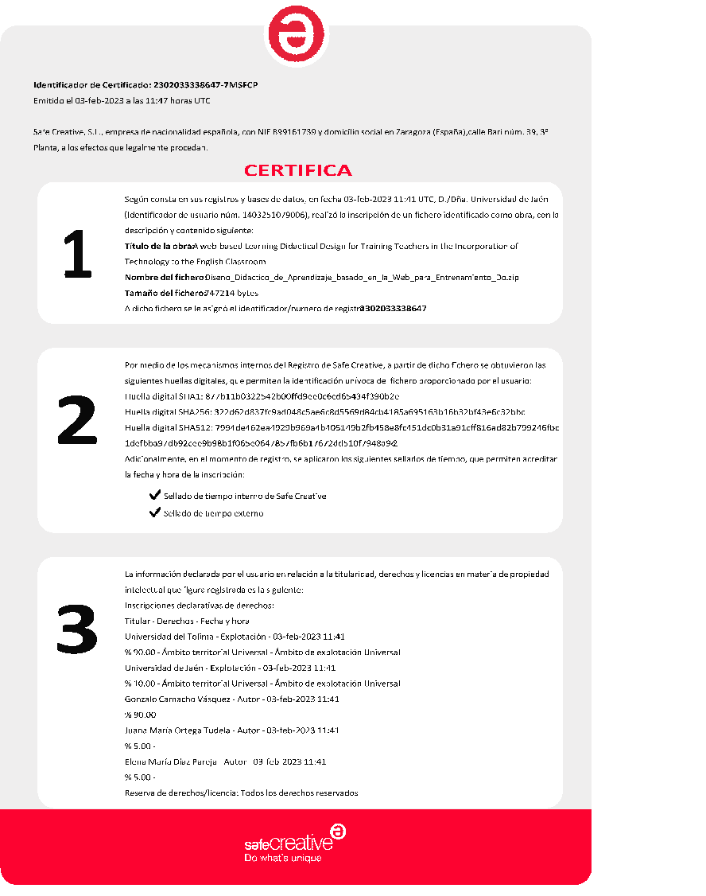

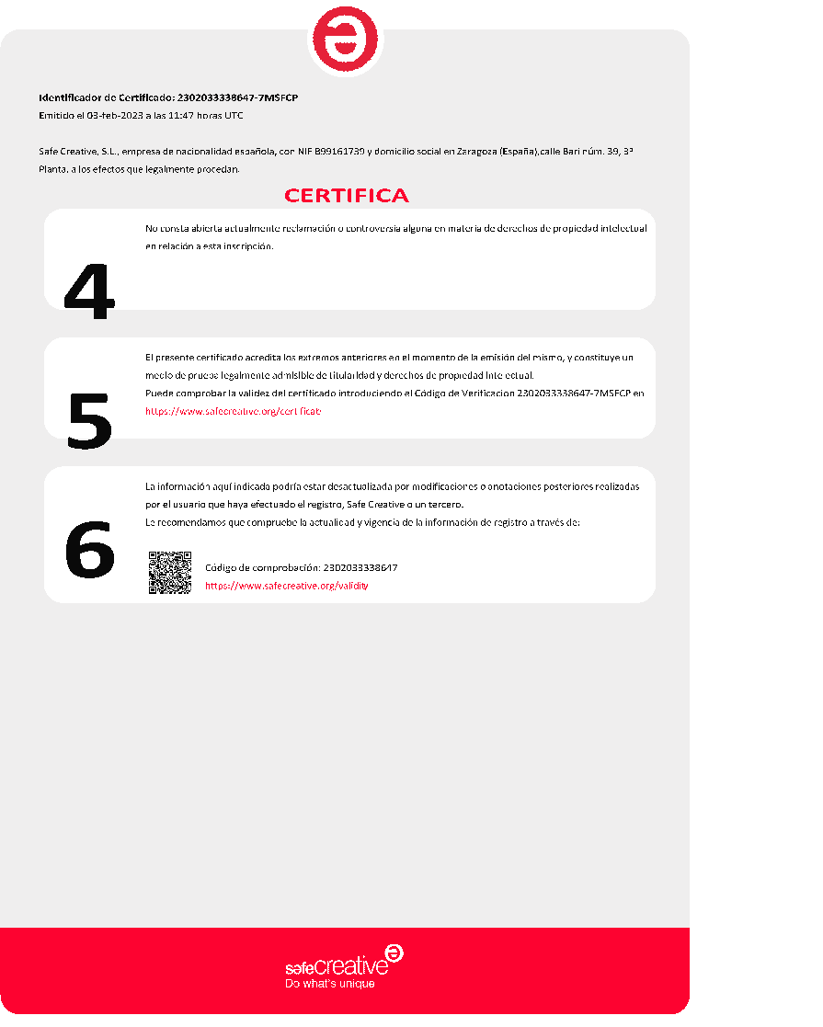

**Appendix H.** Microcurriculo Diplomado Course. Universidad del Tolima

|  | **PROCEDIMIENTO DETERMINACIÓN DE LINEAMIENTOS CURRICULARES MICROCURRÍCULO** | Página 3 de 3 |
| --- | --- | --- |
| Código:FO-P02-F04 |
| Versión:02 |
| Fecha Aprobación**:** 21-10-2021 |

1. **Información general**

| **FECHA DE MODIFICACIÓN Y AJUSTE CURRICULAR** | Enero 23 de 2023 | **FECHA CREACIÓN** | ☐enero 23 de 2023 |
| --- | --- | --- | --- |

| **FACULTAD** | Ciencias de la Educación |
| --- | --- |
| **DEPARTAMENTO** | Español-Inglés |
| **PROGRAMA** | Licenciatura en Lenguas Extranjeras con Énfasis en Inglés |

Identificación del curso

| **CÓDIGO** |  |
| --- | --- |
| **NOMBRE** | **MÓDULO 2**: Competencias Digitales Docentes en el Desarrollo de habilidades receptivas del idioma (40 horas de trabajo online – 20 de trabajo offline) |
| **SEMESTRE (Nivel)** |  |

| **MODALIDAD DEL PROGRAMA** | **PRESENCIAL** |  |
| --- | --- | --- |
| **DISTANCIA** |  |
| **VIRTUAL** | **x** |
| **DUAL** |  |
| **HIBRIDO** |  |

| **Tipo** | Teórica-Práctica | **Componente** | Optativa |
| --- | --- | --- | --- |
| **Calificación** | Cuantitativa | **Modalidad** | Distancia |

| **INTENSIDAD HORARIA** | **SEMANALES** | | | **SEMESTRALES** | | **CRÉDITOS** |
| --- | --- | --- | --- | --- | --- | --- |
| **Presencial** | **Independiente** | **THS** | **Semanas** | **THP** |
| 40 horas sesiones sincrónicas | 20 horas trabajo independiente | 60 | 6 |  |  |
| **THS:** Total de horas de actividad académica. **THP:** Total horas de actividad semestre (THS x  semanas de clase). | | | | | | |

| VALIDABLE |  |
| --- | --- |
| HOMOLOGABLE |  |
| ASIGNATURA | TEÓRICA |
| PRÁCTICA |
|  | TEÓRICO- PRÁCTICA |

| PRERREQUISITOS | Aplica |
| --- | --- |
| No aplica |

| **PRERREQUISITOS** | **CÓDIGO** | **ASIGNATURA** |
| --- | --- | --- |
|  |  |
|  |  |

1. **Justificación**

El módulo 2 busca que los docentes desarrollen competencias digitales docentes específicas en el Marco de Referencia del DigCopEdu, de acuerdo a las necesidades de su contexto, para el desarrollo de las habilidades, sub-habilidades y estrategias de receptivas.

Definición de la habilidad de escucha

Wilson (2008), afirma que el objetivo primordial del “listening” es la obtención de información y el placer, aunque hay otras razones, tales como la empatía, la evaluación y la crítica

Para Tyagi (2013), el “listening” es una modalidad del lenguaje, una de las cuatro habilidades de un idioma (listening, Reading, speaking y writing). Implica una intervención activa del individuo, la existencia de un emisor, un mensaje y un receptor. También es definido como un proceso psicológico de recibir, atendiendo a la construcción de sentido que implica una respuesta mediante lenguaje articulado a mensajes verbales y no verbales

Nunan (2015), dice que mientras el listening y el Reading proveen input, son diferente. Cuando escuchamos tenemos que capturer los sonidos del aire antes que se evaporen, con la lectura podemos pausar, reflexionar y releer.

* El “listening”comprende los siguientes aspecto claves:
* Discriminación de sonidos
* Reconocimiento de palabras y comprensión de su significado
* Identificación de grupos gramaticales de palabras.
* Identificación de expresiones y grupo de expresiones con sentido completo
* Conexión de señales no lingüísticas y paralingüísticas
* Uso del conocimiento de base para predecir y confirmar el significado
* Recordar palabras e ideas centrales.
* Estrategias para el desarrollo de la escucha
* Top-down y bottom-up activities

Están basadas en el que escucha. El receptor apela al conocimiento acerca del tema en discusión, la situación o contexto, el tipo de texto y el lenguaje. Este conocimiento del contexto activa una serie de expectativas que ayudan al receptor a interpreta lo que escucha y anticipar lo que seguirá. Las estrategias top-down incluyen:

Escuchar para entender la idea principal

* Predecir
* Inferir
* Resumir

Bottom-up strategies

David Nunan (2015) concibe las siguientes estrategias:

* Predicting : effective listeners think about what they will hear.
* Inferring : It is useful for learners to “listen between the lines.”
* Monitoring : Good listeners notice what they do and don’t understand.

Clarifying: Efficient learners ask questions (What does _____ mean? You mean _____? ) and give feedback ( I don’t understand yet ) to the speaker.

* Responding : Learners react to what they hear.
* Evaluating : They check on how well they have understood.

Sub-habilidades

Están basadas en el texto. El receptor obtiene el sentido del mensaje de la combinación de sonidos, palabras, y la gramática que crea el significado. Las estrategias de Bottom-up incluyen:

| **Skill** | **Subskills** | **Strategies** | **Activities**  **Digital resources’ wheel** |
| --- | --- | --- | --- |
| Listening  Receptive skill | Listening for the gist  Listening for specific information  Listening for details  Listening for attitudes  Extensive listening  Listening for individual sounds  Listening for discourse patterns/language items  Inferring information  Predicting  Monitoring  Clarifying  Responding  Evaluating | SUMMARIZING: Story maps, mind maps  Answering comprehension Questions  Reviewing  Brainstorming  Building background  Paraphrasing | Listening to podcast, songs, news reports, airport announcements, phone calls, movie scenes, conversations  Gallery walk  Fill in a chart/map/table  Digtogloss  Fill in a chart/map/table  Make a Venn diagram  Make a Flow chart  Make a bubble map  Make a tree map  Anticipation/Reaction guide  Get what I say  Anticipation/Reaction guide  Split Page Note Taking  Filling a plot chart |

* Definición de la habilidad de lectura

De acuerdo a Urquhart and Grabe (2009:14), la lectura es un proceso que consiste en recibir e interpretar información en una lengua a través del medio impreso. Johnson (2008:3) define la lectura como una práctica en el uso de textos para crear significado.

David Nunan (2015), dice que tradicionalmente la lectura, como la escucha, es considerada como una habilidad pasiva. Sin embargo. La lectura y la escucha no deben ser consideradas como “habilidades pasivas” sino como “habilidades receptivas” Las dos implican el uso de procesos de pensamiento complejos y avanzados. La diferencia está en que mientras en la escucha las palabras de van con el viento, en la lectura permite al lector volver al escrito, revisar las oraciones, las palabras hasta estar satisfecho(a) con la comprensión.

| Skill | Subskills | Strategies | Activities  Digital resources’ wheel |
| --- | --- | --- | --- |
| Reading  (receptive skills) | Skimming  Scanning  Predicting  Inferring – Reading between lines  Intensive Reading  Extensive Reading | SUMMARIZING: Story maps, mind maps  Answering comprehension Questions  Reviewing  Brainstorming  Building background  Paraphrasing | Reading: stories, ads, timetables, posters, emails, letter, messages, cartoons, graffities, lyrics, recipes, news reports.  Jigsaw Reading  Gallery Walk  Fill in a chart/map/table  KWL chart  Backwards book walk  Show your point (Go to your corner)  The insert method  Personal online dictionary  Make a Venn diagram  Make a Flow chart  Make a bubble map  Make a tree map  Corners vocabulary  Surprise book to predict content  Charades  Pictionary  Idioms match up  SQP2RS  Anticipation/Reaction guide  Split Page Note Taking  Filling a plot chart  Fill the gaps  Song cards |

1. **Articulación con proyecto de investigación o extensión y proyección social**

El diplomado en sus diferentes módulos contribuye al fortalecimiento de la CDD, contempladas en las Habilidades y competencias del siglo XXI para los aprendices del nuevo milenio en los países de la OCDE, en lo que respecta a las dimensiones de la información y la comunicación:

La explosión informativa desencadenada por las TIC requiere nuevas habilidades de acceso, evaluación y organización de la información en entornos digitales. Al mismo tiempo, en aquellas sociedades donde el conocimiento tiene un papel central, no es suficiente con ser capaz de procesar y organizar la información, además es preciso modelarla y transformarla para crear nuevo conocimiento o para usarlo como fuente de nuevas ideas. (Instituto de Tecnologías Educativas, Gobierno de España. p. 7)

De igual manera, el Diplomado apunta a los objetivos a los objetivos 1 y 4 del Desarrollo Sostenible de la ONU o la Agenda Estratégica 2019-2024 del Consejo de Europa (Organización de Naciones Unidas, 2022). El objetivo 1 hace referencia a poner fin a la pobreza en todas sus formas en todo el mundo. La ciudad de Ibagué, la cual es la capital del Departamento del Tolima ocupa el tercer puesto entre las ciudades con mayor desempleo en Colombia, según las cifras del DANE en su más reciente comunicado de prensa (Departamento Administrativo Nacional de Estadística, 2022).

El alto desempleo acarrea problemas de inseguridad, violencia y drogadicción entre otros. Entrenar a los docentes y futuros docentes en el uso de la tecnología, necesariamente afecta el interés por el aprendizaje en sus estudiantes, como lo han demostrado estudios como el de Bhushan (2020):

Learning of a second language is possible with three preconditions—presence of language faculty, exposure or access and learner motivation. Motivation (energy, willingness, perseverance, interest, enjoyment) is the most important parameter because the other two preconditions become relevant if the learner is motivated to learn a language. Positive motivation toward the language being learnt always promotes effective learning. (p. 204)

De este modo el uso de la tecnología en la enseñanza afecta el interés de los estudiantes, y por ende mejora los niveles de involucramiento en las actividades, el desarrollo de la autonomía y, como efecto cascada, el aprendizaje.

De otra parte, el planteamiento del problema de investigación atiende a las habilidades transversales en América Latina y el Caribe para el ciudadano en el siglo XXI, planteados por el BID (Banco Interamericano de Desarrollo). Llevar la enseñanza y el aprendizaje al nivel digital, incentiva la adquisición del conjunto de destrezas denominadas las 4Cs: Colaboración, pensamiento crítico, comunicación y creatividad (Mateo-Díaz et al., 2019). La metodología propuesta mediante los pasos del modelo pedagógico alberga en su esencia estas cuatro dimensiones al apelar a principios del aprendizaje basado en proyectos, el aprendizaje basado en la indagación, el Constructivismo y el Aprendizaje por descubrimiento.

En lo que se refiere a la competencia lingüística y comunicativa de docentes y estudiantes que involucra el proyecto, a nivel internacional, el Índice de Competencia en el inglés, EPI (English Proficiency Index) del EF (Education First, s.f.) muestra que Colombia en el año 2021 ocupó el puesto 81 entre 112 naciones no angloparlantes, pasando de un nivel muy bajo en el año 2020, a nivel bajo en el 2021. En Latinoamérica Colombia ocupa el puesto 17 entre 20 naciones. Una de las posibles causas de estos resultados es el bajo nivel de inglés de los docentes.

Los resultados de las pruebas estatales (Saber 11) en el área de inglés tampoco son alentadores. El informe de Entidad territorial Certificada (Ministerio de Educación Nacional, 2020) para el departamento del Tolima indica que el rendimiento de los estudiantes en el área de inglés está por debajo de la media nacional y con una tendencia a la baja. En el 2017, las Instituciones Educativas de Ibagué obtuvieron un promedio de 46/100, en el 2018 de 47/100, en el 2019 de 45/100 y en el 2020 de 43/100.

Existe una necesidad de generar proyectos de investigación que apunten a mejorar los indicadores de desempeño de los estudiantes en el aprendizaje del inglés a nivel internacional y nivel nacional. Como se ha manifestado anteriormente, la implementación de una metodología interactiva mediada por TIC para capacitar a los docentes en el uso de recursos de la Web 2.0 para la enseñanza del idioma, hace posible la inclusión de profesores que viven en regiones remotas, los prepara para incentivar el aprendizaje en sus alumnos y los expone a hablantes del inglés con registros nativos, lo que mejoraría su competencia comunicativa e intercultural.

1. **Competencias y resultados de aprendizaje**

El Diplomado desarrolla las competencias establecidas en el DigCompEdu:

El área 1 se centra en el entorno profesional general, es decir, en el uso que el profesorado hace de las tecnologías digitales en las interacciones con colaboradores y colaboradoras, alumnado, familia y demás personas interesadas, para su desarrollo profesional y en beneficio de toda la organización.

* El área 2 se centra en las capacidades necesarias para utilizar, generar y compartir los recursos digitales de forma eficiente y responsable para el aprendizaje.
* El área 3 estudia el uso de las tecnologías digitales para la enseñanza y el aprendizaje.
* El área 4 se refiere al uso de estrategias digitales para mejorar la evaluación.
* El área 5 trata del potencial de las tecnologías digitales para la enseñanza y las estrategias de enseñanza basadas en los alumnos.
* El área 6 detalla las competencias pedagógicas específicas necesarias para el fomento de la competencia digital del alumnado.

El marco DigCompEdu describe seis etapas en las que el profesorado desarolla habitualmente sus competencias digitales, de ese modo ayudando a identificar las etapas en las que se encuentran y decidir los pasos a seguir para mejorar su competencia.

Principiante (A1) y Explorador (A2) → el profesorado asimila nueva información y desarrollan prácticas digitales básicas.

Integrador (B1) y Experto (B2) → el profesorado aplica, difunde y estructura las prácticas digitales.

Líder (C1) y Predador (C2) → el profesorado comparte conocimiento, cuestiona y desarrolla nuevas prácticas.

| Competencias | | Resultados de aprendizaje |
| --- | --- | --- |
| Ser – Afectiva | Potencializa competencias digitales docentes del marco DigcompEdu de acuerdo a necesitades didácticas del aula de clases.  Reconoce la importancia de la incorporación de recursos TIC al proceso formativo de los docentes y de los estudiantes.  Auto evalúa el uso que hace de los recursos digitales en la enseñanza del inglés para desarrollar su competencia digital | Reflexiona sobre su desempeño en el desarrollo del módulo mediante el diligenciamiento de la autoevaluación para detectar áreas con fortalezas y áreas susceptibles de mejora |
| Saber – cognitiva | Define lo que significa las habilidades receptivas sus sub-habilidades y estrategias.  Da razón de las competencias específicas del DigCompEdu que necesita potencializar para afectar la didáctica de la enseñanza del inglés de acuerdo a las necesidades del aula | Presenta de manera oral los resultados de su indagación respecto a la habilidad de escucha o de lectura con el fin de construir conocimiento colectivo sobre el tema y dar sentido al uso de TIC como estrategia didáctica. |
| Saber hacer – Pedagógica | Accede, navega y utiliza las herramientas de aprendizaje personal y colaborativo de la plataforma Moodle.  Pone en juego áreas y competencias del marco DigCompEdu de acuerdo a necesidades didáctica de su aula de clase.  Auto evalúa su desempeño personal en el desarrollo del módulo mediante:   * La autoevaluación de desempeño de los docentes en formación (Anexo 2) * La autoevaluación de competencias específicas del Marco DigCompEdu (Anexo 5) * El uso de TIC en el desarrollo de habilidades del inglés (Anexo 6) | Planea una lección basada en la habilidad de escucha o lecturae incorporando recursos digitales con base en las necesidades de sus alumnos  Lleva a cabo la lección planeada teniendo en cuenta los aprendizajes alcanzados con el fin de evidenciar su progreso en la incorporación de TIC a la enseñanza del inglés  Presenta evidencias de la enseñanza al grupo de profesores para identificar fortalezas y áreas de mejora. |

1. **Estructura temática**

| **Pregunta problema** | **Saberes/contenidos** | **Medios educativos** | **Duración** |
| --- | --- | --- | --- |
| What is “listening”?  How is “listening” related to the other skills?  What is underneath the listening skill? (subskills)  What strategies can help to improve listening comprehension? | Definitions of “listening”  Relation of “listening” with other skills  Listening subskills  Listening strategies | Wilson J.J. (2008) How to teach Listening. England: Pearson Education Limited | 10 horas |
| What is “reading”?  How is “reading” related to the other skills?  What is underneath the reading skill? (subskills)  What strategies can help to improve reading comprehension? | Definitions of “reading”  Relation of “reading” with other skills  Reading subskills  Reading strategies |  | 10 horas |
| Which competences from the DigCompEdu may I potentialize in the development of receptive skills?  Which subskills can the development of specific competences in the DIgComEDu improve?  What didactic strategies can I use to improve receptive skills in the classroom?  What adaptations to these classrooms’ strategies should I do to integrate technology? | Listening/reading web-based resources  Strategies to develop listening/reading in the classroom  Strategies to develop listening/reading incorporating technology  Listening/reading-based lesson planning | Websites  Google Scholar  Data bases  Provided bibliography | 10 horas |
| How to plan a lesson based on “listening/reading”? | Listening/reading-based lesson planning formats and learning moments | Lesson plan templates  Video of lesson plan demonstration | 10 horas |
| How would a lesson that use or adapt digital resource be in order to enable listening /reading development?  What can I improve from my lesson plan? | Feedback on lesson planning  Lesson plan delivery and video recording  Presentation of video clip  Group feedback  Personal reflection  LMS and WBLDD assessment | TikTok  Youtube  Filmora  Lesson plan templates  Assessment forms | 10 oras |

**6. Estrategia didáctica**

El diplomado pone en juego el Diseño Didáctico Basado en la Web (Web-Based Learning Didactic Designed - WBLDD) formulado por el profesor Gonzalo Camacho Vásquez.

El WBLDD es una propuesta metodológica de ocho momentos de aprendizaje para el entrenamiento de docentes en la incorporación de las TIC al ELT, con sesiones online y offline y sólidos fundamentos teóricos y atendiendo al desarrollo de la CDD.

Los momentos del Diseño Didáctico en el presente módulo

| **Learning moments** | **Activities** | **Time** |
| --- | --- | --- |
| **Launch 1 (online)** | Course teacher demonstrates a receptive skills-based lesson that incorporates digital resources/technology and the corresponding competence from the Dig compEdu that is fostered. | 2 hours |
| **Inquire 1 (online)** | Teacher learners formulate problems questions based on the experience in the “Launch”. Course teacher leads teacher learners to formulate question dealing with:   1. The nature of listening and reading, subskills, strategies and activities. 2. The procedures to teach listening and reading (strategies, lesson planning). 3. The specific competences from the DigCompEdu Framework and the digital resources to foster these competences.   Teacher learners make groups of interests for the three categories of questions | 2 hours |
| **Search 1 (offline)** | Teacher learners look for information for the questions in the group category they belong, and post the information in their PLEs.  Teacher learners visit each other PLE, read the information, make comments and provide feedback to their peers.  Teacher learners organize the information and plan a strategy to share with the whole class | 5 hours of independent work |
| **Share 1 (online)** | Interest groups take turns to present the information to the group. (After each presentation, the class provides feedback and participate in the online debate  The class provides feedback)  Teachers’ learners participate in the online debate with questions and comments about the new learning. | 3 hours per category  The nature of receptive skills (3 hours)  Procedures to teach listening (3 hours)  Specific competences of the framework (3 hours)  12 hours |
| **Lunch 2 (online)** | Course teacher demonstrates the use of one or more digital resources from the wheel to develop receptive skills. | 2 hours |
| **Inquire 2 (online)** | Teacher learners formulate questions inspired in the launch activities: How can I use “Lyrics.com” for my students to practice listening? How can I incorporate “Miro” to enhance listening/reading comprehension?  The course teacher presents the classification of digital tools per skills in the wheel. Teacher learners visit the wheel and select digital resources they would like to explore, and according to their selection and questions, make interests groups. | 2 hours |
| **Search 2 (offline)** | Teacher learners look for information for the questions in the group category they belong, and post the information in their PLEs.  Teacher learners visit each other PLE, read the information, make comments and provide feedback to their peers.  Teacher learners organize the information and plan a strategy to share with the whole class: How the selected resource works, the possible use of the resource for listening and reading practice, the possible activities I can plan by incorporating the resource to my lessons. | 8 hours of independent work |
| **Share 2 (online)** | Interest groups take turns to present the information to the group. After each presentation, the class provides feedback.  Teachers’ learners participate in the online debate with questions and comments about the new learning.  A guest speaker that is expert in the topic may be invited at this term. | 8 hours |
| **Plan (online)** | Course teacher makes a wrap up activity to treat aspects of receptive skills and use of resources that may have not been discussed previously.  Course teacher presents the lesson plan of the demonstration he/she did at the beginning of the module | 2 hours |
| **Apply (offline and online)** | Teacher learners work individually to plan the receptive skills-based lesson that incorporates digital resources and develop the specific competences from the DigCompEdu, according to the need of each teacher’s classroom.  Teacher learners hold an online session with the course teachers to provide feedback about the lesson plan.  Teacher learners make adjustments to the plan.  Teacher learners deliver the lesson in their classroom and prepare evidence to be shared with the class (2 minutes long video clip) | 12 hours of independent work |
| **Share (online)** | Teacher learner present their videos to the class.  Guest experts may be invited to provide feedback and assessment. | 9 hours |
| **Reflect (offline and online)** | Teacher learners reflect upon their experience and share impression with the class  Teacher learners assess their performance in the module (Appendix D) and the development of their DigCompEdu specific competence (Appendix A) and the use of ICT resourse to develop ELT (Appendix B) | 1 hour |

1. **Mecanismos de evaluación de los aprendizajes**

La evaluación de los módulos del diplomado es de tipo cualitativa, definiendo como criterio el estar “apto” o “no apto” para continuar en el siguiente módulo. La determinación se toma en consenso con el docente en formación teniendo en cuenta que debe haber cumplido de manera satisfactoria, y entregando los trabajos en las fechas estipuladas con el 60% de las tareas asignadas.

Las siguientes actividades pueden ser tomadas como evidencia del aprendizaje

* Entrega a satisfacción de las tareas asignadas.
* Desarrollo de actividades de práctica demostrables con el respectivo producto
* Elaboración de trabajos individuales publicados en el la LMS y en los PLEs
* Elaboración de productos digitales (tutoriales, videos, posters, infografías, mapas conceptuales e interactivos etc)
* Elaboración y presentación del video de aplicación al final de los módulos 2 al 5
* Participación informada en las sesiones online.
* Diligenciamiento y socialización de las rúbricas y test de inicio y final de módulo y/o curso.

Se tendrán en cuenta en la evaluación final de cada módulo:

1. La autoevaluación de desempeño de los docentes en formación (Anexo 2)
2. La autoevaluación de las competencias del Marco DigCompEdu (Anexo 5)

Además, se tendrá en cuenta al final del módulo 3 y del módulo 5:

1. La evaluación de la metodología del curso (Anexo 3)
2. La evaluación de la plataforma LMS (Anexo 4)

**Nota:** estos criterios de evaluación se plantearán y se determinarán en consenso con los estudiantes y quedarán consolidados en el acuerdo pedagógico, igualmente se colocará el porcentaje (si se requiere) que quedará consignado en dicho acuerdo.

El docente puede proponer otros de acuerdo con la naturaleza y objeto del espacio.

1. **Bibliografía (básica y recomendada)**
2. **Observaciones**

**Appendix I**. Sample Unit Plan

**Web-based didactic design unit plan**

Dates:

MCER LEVEL: B1

Learning outcomes:

Students will be able to put into practice the learned vocabulary and language expressions in the presentation of a video to link the content with his/her community.

Students will be able to narrate events of the American Civil War/famous historical American people/music through blog entries, oral or written reports to integrate content and language.

| **Stage** | **Activity** | **Time** | **Resources** |
| --- | --- | --- | --- |
| LAUNCH -online- | 1.Pre-watching questions:  The teacher asks the following questions:  Have you seen the Simpsons?  How did you like this series?  Do you know when it was first on air?  Who are the creators?  2. Students visit the Britannica page, they try to answer the top questions and take the Britannica quiz  2. Build Background  Students answer the mentimeter survey  <https://www.menti.com/ne9xvixf8j>  3. Watching 1  Students see the episode with no stops, and take notes.  4. Watching 2  Students see the episode again and write questions in their notebooks about:  -American Civil Wars  -Famous people in the episode  -Music in the episode  -Sexual differences  5. Students write their questions in individual boards in the Jamboard.  6. Students visit each other’s’ boards and use sticky notes to make comments and correct possible grammar mistake | 10’  15’  25’  25’  25’  20’  20’ | Video conference platform  Mentimeter survey  Homer’s Phobia  Groening et al (1997, Feb. 16).  <https://www.britannica.com/topic/The-Simpsons>  Jam Board |
| INQUIRE -online- | 1.The teacher encourages students to make groups according to the following topics:  -American Civil Wars  -Famous people in the episode  -Music in the episode  -Sexual differences  2.Students join in teams, read again the questions that each of them formulated, and select the ones for the search.  3. Students organize the search stage by assigning individual tasks | 20’  30’ |  |
| SEARCH -offline- | 1.Students use different sources to find information for the chosen questions  2. Each students creates an entry in the PLE and published the information  3. Students visit their team members’ PLEs, read the loaded information and make comments. Students may also provide corrective feedback for language.  4. Students join in teams and prepare the presentation of findings using a multimedia resource | 3 days | Students’ PLEs  Multimedia resources: Power point, video, movie maker. |
| SHARE -online- | 1. Interest teams present the multimedia to the class. 2. Students participate in the video conference to make comments about the presentation, clarify possible doubts and debate possible issues. | 40’  20’ | Video conference platform |
| PLAN -offline- | 1. Students join in teams again. It could be the same teams or different ones. Students discuss strategies to impact the community with the new knowledge constructed. Think, for instance, in a campaign to educate people about gay people rights. 2. Students upload the planning guide in the LMS platform 3. The teachers assign times for team tutorials about the plan 4. Students make the adjustment to the plan according to feedback provided in the tutorial session. | 3 days | Guide for the planning  LMS |
|  | Online tutorial in teams | 1 day |  |
| APPLY -offline- | 1. Students in each team, apply the plan and get evidences of their work (pictures, videos, surveys, interviews) 2. Students join in teams and prepare a multimedia to present the results | 5 days | Resource in the planning guides  Multimedia resources: video, presentation templates (power point, Prezi, genially etc) |
| SHARE -online- | Students present in teams the results to the class in an event organized by the teacher with the help of team leaders | 40’ | Video conference platform |
| REFLECT -Online- | 1.Students assess their personal performance by using the self-assessment form.  If this is the final project of the unit or module, students fill in the Course Assessment form and the LMS Assessment survey  2. Students fill in the forms in the LMS.  3.Students participate in the final debate to discuss results of the course/unit/modules |  | Self-assessment forms  Course assessment form (if apply)  LMS Assessment survey (if apply) |

**Appendix J.** Rubric to assess oral presentations

**Rubric to assess oral presentation (sharing moments)**

**presentation (multimedia recording) 5 4 3 2 1 0**

-use of digital tools

-volume

-quality of image

**Language skills 5 4 3 2 1 0**

-correct usage

-appropriate vocabulary and grammar

-understandable (rhythm, intonation, accent)

-spoken loud enough to hear easily

**Organization of presentation 5 4 3 2 1 0**

-clear objectives

-logical structure

-signposting

**Mastery of the subject 5 4 3 2 1 0**

-pertinence and quality of information

-depth of commentary

-spoken, not read

-able to answer questions

**Team work 5 4 3 2 1 0**

-participation of all team members

-coordination

-ability to solve unexpected problems

**Overall impression 5 4 3 2 1 0**

-very interesting / very boring

-pleasant / unpleasant to listen to

-very good / poor communication

**TOTAL SCORE _______ / 30**

**Appendix K.** Guide For Planning

**Problem question(s):** How respectful of sexual differences and sexual inclinations our community is?

**Context:** Students, parents, teachers of 9th grade, Colegio La Sagrada Familia, Ibague.

**Objectives:** To find out how respectful of sexual differences our school community is.

To put on a campaign to foster sexual differences’ respect

**Tasks:**

1. Administer an online test to the target population.
2. Analyze and graph the results.
3. Organize a campaign to foster sexual differences respect.
4. Put on the campaign and take evidence.

**Resources:**

1. Sexual differences’ test in Google Forms.
2. Guest speaker for talks online, support from school counselor.
3. Workshop with parents.
4. Survey to know the effects of the campaign.

**Time:** 3 weeks.

**Expected results:**

Students, teachers and parents will know how respectful they are towards sexual differences and in which area is necessary to work for a better sensibilization.

Students, teachers and parents will be aware of the importance of respecting sexual differences and sexual rights.

**Appendix L**. Rubric to Assess Final Videos

**Rubric to assess final video (application moment)**

**Name(s): _______________________________________________________________________**

**Digcompedu competences developed: __________________________________________**

**Digital tools used: ____________________________________________________________**

**Date: _______________________________________________________**

**Multimedia recording 5 4 3 2 1 0**

-use of digital tools

-volume

-quality of image

**Language skills 5 4 3 2 1 0**

-correct usage

-appropriate vocabulary and grammar

-understandable (rhythm, intonation, accent)

-spoken loud enough to hear easily

**Organization of video 5 4 3 2 1 0**

-clear objectives

-logical structure

-signposting

**Mastery of the subject 5 4 3 2 1 0**

-pertinence and quality of information

-depth of commentary

-spoken, not read

-able to answer questions

**Capacity to integrate digcompedu 5 4 3 2 1 0**

**Competencies**

-One or more competences are involved

-Awareness of competencies developed

**Overall impression 5 4 3 2 1 0**

-very interesting objectives were accomplished

- objectives were partially accomplished

- there is no evidence of DigcompEdu competencies’ development

**TOTAL SCORE _______ / 30**

**Final comments:**